1. Motivate

When have you been surprised by what someone was able to accomplish?
- our choir memorized their music
- the high school marching band won at contest
- our team won the state championship
- on a fishing trip we caught our limit
- the neighbor fixed my car’s problem
- the student who struggled in high school ended up a PhD
- handicapped person competed in para-Olympics and got the gold medal
- kid I knew in high school as a goof off ended up being a champion race car driver

2. Transition

Sometimes people we had doubts about turned out pretty good.
- We shouldn’t write them off, but value their potential
- God values all life and we should too.
A video introduction to the lesson is available. View at https://watch.liberty.edu/media/t/1_4mcjxznv If you have no wi-fi where you teach, best to download to your computer from https://tinyurl.com/859f5tdc
3. Bible Study

3.1 God Values Us

Listen for how well God knew David.

Psalm 139:1-6 (NIV) O LORD, you have searched me and you know me. 2 You know when I sit and when I rise; you perceive my thoughts from afar. 3 You discern my going out and my lying down; you are familiar with all my ways. 4 Before a word is on my tongue you know it completely, O LORD. 5 You hem me in--behind and before; you have laid your hand upon me. 6 Such knowledge is too wonderful for me, too lofty for me to attain.

What words and phrases did the psalmist use to describe the extent of God’s knowledge about him?
- God knows what he was doing - sitting, rising, going, speaking,
- when he was doing it
- even knew his thoughts
- familiar with all his ways, knew him completely
- knew what he was going to say before he said it

How did the psalmist respond to his awareness of the Lord’s vast knowledge about him?
- he was amazed
- such knowledge was “too wonderful” for him
- it was too lofty to attain

How is it both frightening and comforting to realize how completely you are known by God?
Frightening | Comforting
- scary that God knows our thoughts  - we rarely want anyone to know our thoughts  - some people could begin to feel that God is controlling them, if He can know what we are going to do before we do it | - God is watching over me  - He protects me from getting into situations that would be harmful  - He loves me enough to watch over me … even with everyone else  - someone better be watching over me, I need all the watching I can get

What is most amazing is that with all He knows about you and me, He still loves us!!!
If you wad up and trample a $100 bill like a piece of paper trash, it is still valuable. Why?
- even though crumpled, it is still worth $100
- the government still says it has worth – no matter the condition

Consider that this concept can be applied to how our culture treats people that it considers expendable, worth throwing away. What kind of people do certain parts our culture feel are expendable, even wish they would just go away?
- the poor, the homeless
- unwanted pregnancies
- elderly who are unable to care for themselves
- people who disagree with us
- those with severe mental and/or emotional problems

God sees and knows all these people just like He knew the Psalmist.
- God considers them valuable! He loves them each.
- God’s grace restores all who repent and seek His forgiveness.
- God is always with us.
- He is mindful of our daily schedules, activities, and thoughts.

3.2 God Is with Us

Listen for the scope of God’s presence.

Psalm 139:7-10 (NIV) Where can I go from your Spirit? Where can I flee from your presence? 8 If I go up to the heavens, you are there; if I make my bed in the depths, you are there. 9 If I rise on the wings of the dawn, if I settle on the far side of the sea, 10 even there your hand will guide me, your right hand will hold me fast.

With what extreme descriptors does he describe the omnipresence of the Lord?
- up to the heavens
- down in the depths (high or low in location)
- early in the morning
- late in the day (anywhere in the dimension of time or from east to west)

What confidence does the psalmist express in the Lord who is ever present?
- wherever he is, whenever it happens, whatever is happening …
- God’s hand will guide him
- God’s right (His strong) hand will hold him fast

How does God's presence with you everywhere and at all times make a statement about how He views human life, about His regard for you?
- He is interested in us
- He watches over us no matter where we are
- He sees us geographically everywhere, no matter where we go
- He shows His concern for our future

What were some times in your life when you especially needed to feel the presence of God?

- loneliness
- depression
- illness
- despair over family problems
- worry over finances
- danger

Why is that assurance of God's presence sometimes hard to find?
- we are not focusing on God
- we are like Peter, walking on the water and focusing on the “waves around us”
- we have not been communicating with God through prayer, through His word
- we are not “tuned in” to the reality of God's presence
- we have been doing something that we did not want to acknowledge God's presence – we would be ashamed

What can you do to increase the awareness of God's constant presence in your life?
- spend time with Him
- reading His Word
- memorizing Scripture which God brings to our mind at strategic times
- practice the presence of God – looking for His workings in you life, “sightings”

3.3 God Created Us, Has A Plan for Each of Us

Listen for a hidden place where God is at work.

Psalm 139:13-16 (NIV) For you created my inmost being; you knit me together in my mother's womb. 14 I praise you because I am fearfully and wonderfully made; your works are wonderful, I know that full well. 15 My frame was not hidden from you when I was made in the secret place. When I was woven together in the depths of the earth, 16 your eyes saw my unformed body. All the days ordained for me were written in your book before one of them came to be.

How did the psalmist describe God’s involvement in human life?
- creation
- knit us together in mother’s womb
- we might think now about how different kinds of tissues “know” to develop in certain ways … bones, skin, organs, nerves
- fearfully and wonderfully made
- what excellent design, engineering of the human body

How do these verses affirm and encourage us to see value in all human life?
- we are not just a collection of cells
- not just a random jumble of tissue
- the fetus is a marvel of God’s engineering and design
- mechanical, electrical, chemical systems all working together
- all that develops within the womb at the correct rate and sequence – God is making it happen

So what should characterize our treatment of others … the unborn, the sick, poor, disabled, and elderly, in light of the fact that we are all fearfully and wonderfully made?
- God values them
- so should we
- they are worth our attention, our help
- God does not marginalize them, we cannot either
- God does not treat them as if they are a burden … neither can we

What has our society lost in devaluing human life?
- lost potential great people by aborting babies
- lost the sense of how important God values life – he sacrificed His life for us
- lower our attitudes about our own worth
- lower attitudes about potential of children we do have … in some families children are seen as a liability rather than the promise or possibility that God intends
- increases attitudes of selfishness, reduces selflessness

How can believers today embrace life's value in a world that devalues life?
- pray faithfully for children, grandchildren
- pray for those tempted to abort an unwanted child
- pray for those who have done so, that they will know God's forgiveness
- be involved in reaching out with the Gospel to people who do not have spiritual life
Use the last page as a handout so your learners can take home the application points of this week’s lesson.
Application
Confess.
- Ask the Lord to search your heart and reveal areas where you have thought less of others due to physical, intellectual, age, or social differences.
- Confess this to the Lord who is ready to forgive.

Encourage.
- Encourage those around you who face physical or mental challenges, feel insignificant because of their age, or are slighted by others because of race or social status.
- Remind them that God loves them and has a plan for their lives.
- Spend time listening to their stories, and display the love of Christ.

Speak Up.
- Speak up for those who cannot speak up for themselves.
- This is especially needed in our culture that condones abortion, the killing of unborn children.
- Get involved by supporting a local crisis pregnancy center. Learn more at psalm139project.org .
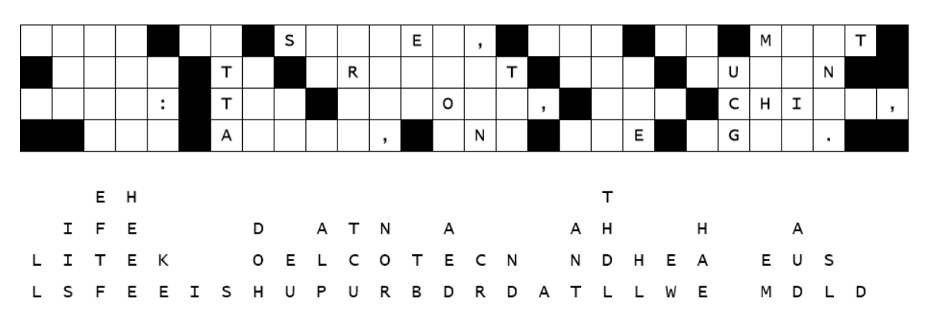
Would you believe it, my decoders slipped up again. They were so excited to get back to their new Play Station games, they were not careful to use the correct adhesive to paste the letters to the decoding form for the secret message from the Ziboda embassy. Luckily, they slid straight down. Focus first on the columns where only one letter is missing. Then look at the two and three letter words to figure out which letters make a reasonable word. When you finish the decoding, forward the message to your representatives in your state legislature. Help and more Family Activities available at https://tinyurl.com/859f5tdc

