1. Motivate

Consider some of these quotations about money:

- If all the rich people in the world divided up their money among themselves there wouldn't be enough to go around. Christina Stead
- Save a little money each month and at the end of the year you'll be surprised at how little you have. Ernest Haskins
- Money frees you from doing things you dislike. Since I dislike doing nearly everything, money is handy. Groucho Marx
- If you can count your money, you don't have a billion dollars. J. Paul Getty
- I have enough money to last me the rest of my life, unless I buy something.
Jackie Mason
- The safest way to double your money is to fold it over and put it in your pocket. Kin Hubbard
- A billion here, a billion there, pretty soon it adds up to real money. Senator Everett Dirksen
- Money can't buy friends, but it can get you a better class of enemy. Spike Milligan

2. Transition

The way we use our money makes a statement about our views of God
- Today we will look at the discipline of giving.
- We are called to respond to God’s goodness through a tithe of our incomes.

3. Bible Study

3.1 Rejecting God

Listen for past rebellion.

Malachi 3:6-7 (NIV) "I the Lord do not change. So you, O descendants of Jacob, are not destroyed. [7] Ever since the time of your forefathers you have turned away from my decrees and have not kept them. Return to me, and I will return to you," says the Lord Almighty. "But you ask, 'How are we to return?'

What was the basis for hope in God?
- God does not change
- You, the descendants of Jacob are not destroyed

How had Israel sinned against God in the past?
- Turned away from God’s decrees
- Did not keep God’s laws
- did not know how to return to God

What kinds of things cause believers to stray from God?
- temptations of the flesh
- temptations for material things
- desire for power
- laziness

Picture all of us in a circle around a Bible setting on a table. One by one we symbolically turn our backs on God’s Word. How would actually turning away from Scripture make a person feel alone?
- we reject God’s communication to us
- we cut ourselves off from what God wants us to know
- it would keep the Holy Spirit from speaking to us through Scripture
- it would show our rejection of God and anything He wants to say to us
- it would show our contempt for God

God tells His people to return to Him. Now we all turn back towards the Bible on the table. Regardless of what you do, you can turn back to God and to obeying Him. How does it this knowledge make you feel?
- undeserving
- thankful
- in awe
- you have a desire to not rebel ever again
- you feel ashamed about hurting God

3.2 Obedience to God

Listen for who was robbed.

Malachi 3:8-10a (NIV) “Will a man rob God? Yet you rob me. "But you ask, 'How do we rob you?' "In tithes and offerings. 9 You are under a curse--the whole nation of you--because you are robbing me. 10 Bring the whole tithe into the storehouse, that there may be food in my house.

What was one overt manifestation of their defiance of God’s instructions?
- robbing God
- fail or refuse to submit tithes and offerings to God
- result is to be under a curse
- as individuals and ultimately as a nation

What exhortation and instruction did He give concerning the tithes and offerings?
- bring the whole tithe into the “storehouse”
- give all of the 10% of your income and give it to God
- give even more offering, beyond the 10%, as you are able

Why is obedience in the area of giving so challenging?
- we spend all we have
- we live in a materialistic culture
- we feel that all the “stuff” we accumulate gives us status, gives us pleasure
- in order to give tithes and offerings to God, we must deny ourselves the pleasure and status we desire
- many of us are selfish, not generous
- or our generosity is motivated by wanting to look good before others

How is the way we use our money a thermostat for our spiritual lives?
- shows what/who is important in our lives
  - how we spend it
  - how we obtain it
- if we hoard it, we are selfish
- if we squander it, we are not good stewards
- demonstrates who is in charge of our lives (God or ourselves or even someone else)
- demonstrates what/who is motivating us
- demonstrates what our motives are

How is tithing a demonstration of faith?
- when a person gives God 10%, he is trusting God to make the remaining 90% sufficient
- shows our trust in God's providing enough
- demonstrates how we view the ownership of our resources
- shows that we do not depend on ourselves, we depend on God

Why does this (or any) kind of faith please God?
- that's what God tells us
- Hebrews 11:6 (NIV) And without faith it is impossible to please God,
- Romans 5:1-2 (NIV) Therefore, since we have been justified through faith, we have peace with God through our Lord Jesus Christ, [2] through whom we have gained access by faith into this grace in which we now stand.
- We are confessing our own inability to please Him
- we are throwing ourselves on His grace and mercy

3.3 Obedience Is Blessed by God

Listen for a promise.

Malachi 3:10b-12 (NIV). Test me in this," says the LORD Almighty, "and see if I will not throw open the floodgates of heaven and pour out so much blessing that you will not have room enough for it. 11 I will prevent pests from devouring your crops, and the vines in your fields will not cast their fruit," says the LORD Almighty. 12 "Then all the nations will call you blessed, for yours will be a delightful land," says the LORD Almighty.

In the bringing of the tithe, what did the Lord challenge the people to do in relationship to Him?
- test me on this
- let me prove to you that tithing, giving is the right thing, a good thing to do
- watch how I will bless you when you give your tithes with an attitude of worship and faith

What do you think God meant by "Test me in this"?
- God challenges our faith
- He made the promise, it's our part to claim the promise
- It is a direct challenge … almost like a money back guarantee
- He is saying you won't experience the blessing unless you give the whole tithe

What did the Lord promise to do?
- open the floodgates of heaven
- pour much blessing
- so much that they will not have room for it
- protect their crops from pestilence
- other nations will see how they are blessed
- they will be known as a “delightful land”

Why are we sometimes reluctant to put God to this kind of test?
- we might not be convinced God still works in this way
- we are too tight fisted, too selfish with our resources
- I like having all this stuff and I need more
- I think God doesn’t realize just how tight my resources are
- how can I tithe when I don’t have enough money to pay the bills I have

What would you think of a church that offered a money back guarantee on tithing for a 3 month period? God actually says “Test me on this” in the passage.
Check out https://tinyurl.com/ycvwlkyu
Good Idea | Bad Idea
- probably no one would ask for it back  - it is in the spirit of what the passage says  - it could help some people start tithing who had not done so before | - could result in a lawsuit  - might be considered too gimmicky  - needs to be presented in the correct context

⇨ The point is, we should respond in faith to God’s goodness through a tithe of our incomes.

Use the last page as a handout so your learners can take home the application points of this week’s lesson.

Application
Start.
- Begin now to return a full ten percent of your income to God’s work.
- Experience the blessings that come from obedience to God’s Word.
- Trust Jesus with this decision.

Stick.
- If you are already a tither, determine to stay the course and dedicate your obedience to God’s continued blessing.
- Share your conviction with others and encourage them to begin tithing.

Strengthen.
- Pray about giving beyond a tithe, increasing your generosity to others and for the work of the kingdom of God.
- A greater offering provides a greater blessing for others.
- Take the challenge.
Wish I could see more of my friends Lincoln, Hamilton, Jackson, Grant, and Franklin in the offering plate! Seriously, folks … if you want more Family Activities on giving, check out
https://tinyurl.com/y8utwqsq

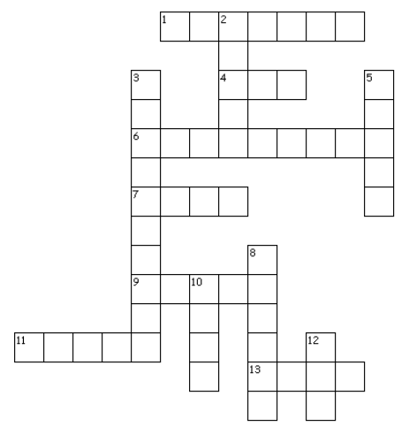
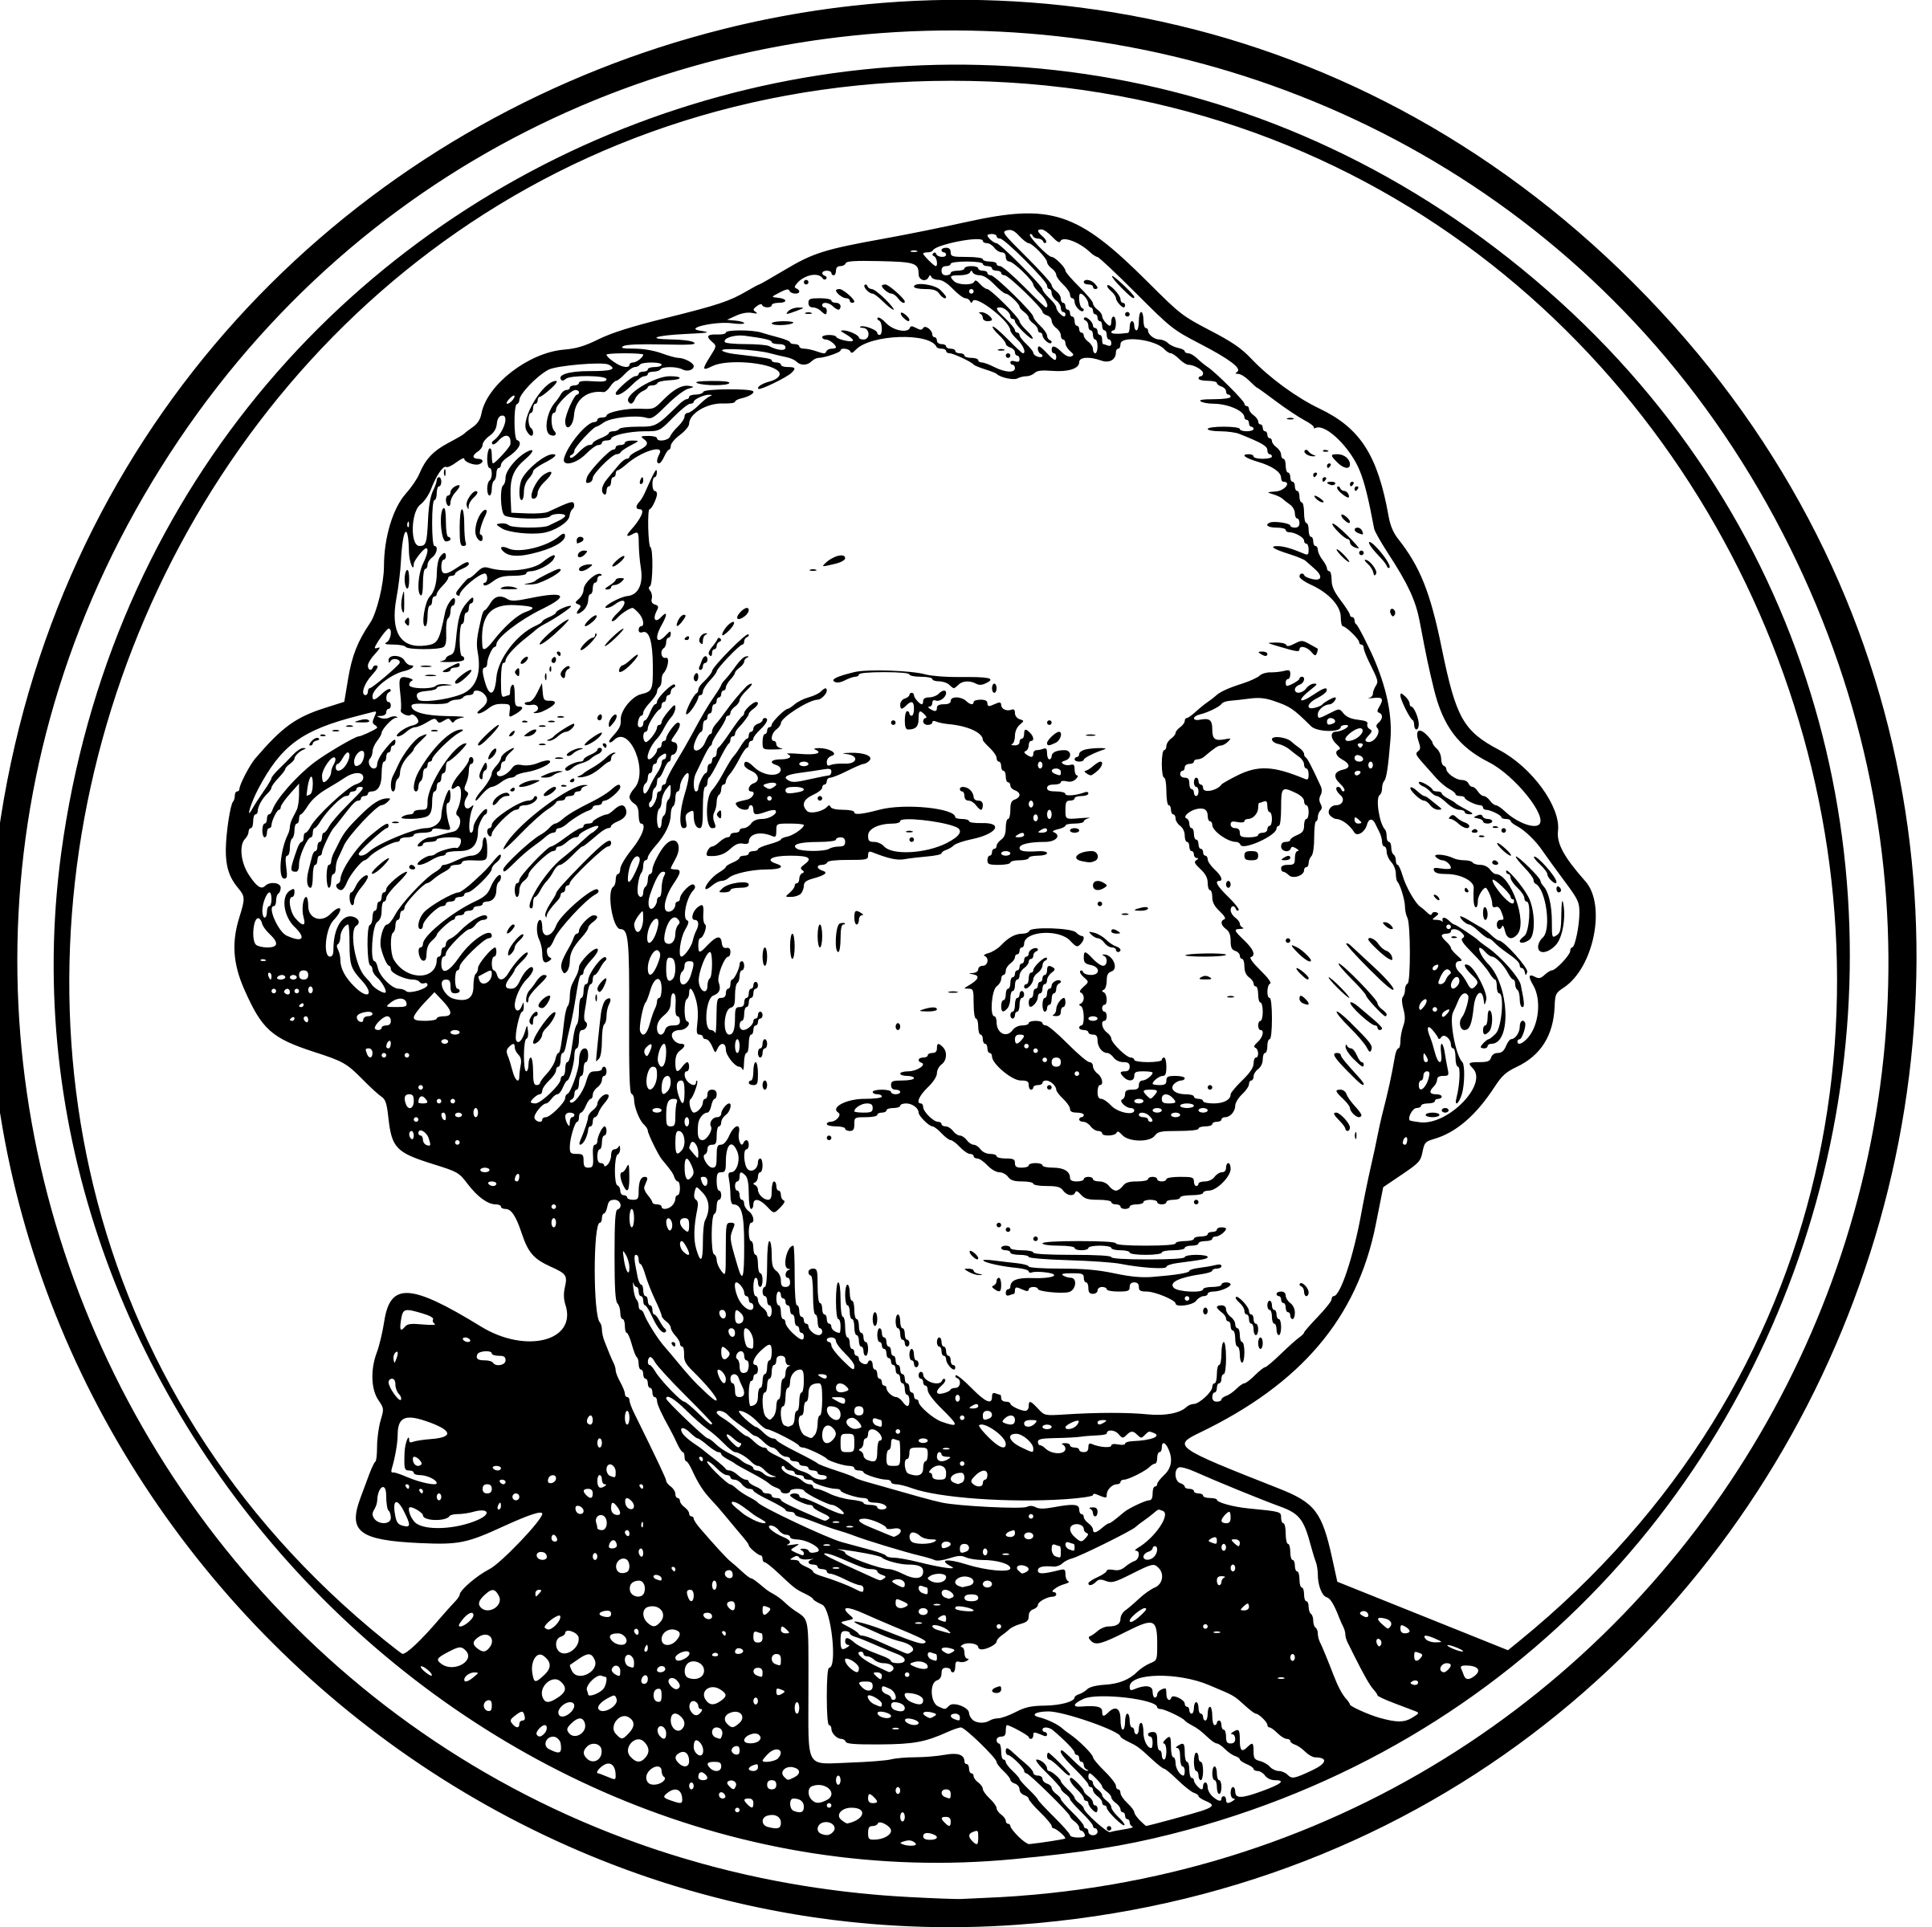
Tithing Crossword
Malachi 3:7-12 (NIV)
Across
1. They had turned away from these
4. Yet, you _?_ me
6. They robbed god in tithes and _?_
7. Food will not _?_ before it's ripe
9. What should they bring to the storehouse?
11. These are growing in the fields
13. Blessings that there is not _?_ to store

Down
2. You are under a _?_
3. God promises to open these
5. Will be prevented from devouring crops
8. Return to me and I will _?_ to you
10. _?_ me in this
12. _?_ are we to return?

