1. Motivate

What activity or event are you looking forward to in the next few weeks?
- end of school
- spring
A video introduction is available for this lesson. View at https://watch.liberty.edu/media/t/1_ojvdlod3 If you have no
Wi-Fi where you teach, best to download to your computer from https://tinyurl.com/4vy75u6u
- start of a garden
- graduation
- vacation
- visit by grandparents
- siblings/kids home from college
- going to a sports event
- a wedding
- summer camp

2. Transition

We all have milestone events in life that we look forward to with both excitement and some trepidation.
- The one milestone event that faces every person in the world is the Second Coming of Jesus Christ.
- Today we study the reality that Jesus will return to establish His eternal kingdom.

3. Bible Study

3.1 Signs of Christ’s Return

Listen for Q and A.

Matthew 24:3-8 (NIV) As Jesus was sitting on the Mount of Olives, the disciples came to him privately. "Tell us," they said, "when will this happen, and what will be the sign of your coming and of the end of the age?" 4 Jesus answered: "Watch out that no one deceives you. 5 For many will come in my name, claiming, 'I am the Christ,' and will deceive many. 6 You will hear of wars and rumors of wars, but see to it that you are not alarmed. Such things must happen, but the end is still to come. 7 Nation will rise against nation, and kingdom against kingdom. There will be famines and earthquakes in various places. 8 All these are the beginning of birth pains.

What questions did the disciples ask Jesus upon hearing Him speak about the destruction of the temple?
- when will this destruction happen?
- what will be the sign of your coming?
- what sign or signs will indicate the end of the age?

What did He caution them to avoid?
- being deceived
- people who claim to be the Messiah

What were some ways in which people could be deceived to think the end of time was near?
- news of wars,
- rumors of wars
- international wars
- famines
- earthquakes

Jesus said these things are like “labor pains” that precede a birth. What can encourage us amidst Jesus’ warnings that things are going to get a lot worse?
- it means Jesus is coming sooner and sooner
- God is with us – the Holy Spirit will empower us, guide us
- He is in control

How does talk of the end times motivate us to live a holy life?
- want to be ready for Christ’s return
- want to be working towards bringing others to Jesus
- want our own lives to be in right relationship to God at all times

At the same time, how can we become sidetracked by discussion of the end times?
- in the extreme, people have sold or abandoned property, dressed in white robes and climbed on their rooftops to wait for the rapture
- trying to discover specific signs or dates
- there are other, more important things for us to be involved in … reaching people with the gospel

How is it helpful that Jesus didn’t give us a specific time or date for His return?
- like school assignments, we would procrastinate
- we are challenged to believe God’s Words
- it’s a matter of living by faith

3.2 Jesus Will Visibly Return

Listen for true signs of Jesus’ return.

Matthew 24:29-32 (NIV) "Immediately after the distress of those days "'the sun will be darkened, and the moon will not give its light; the stars will fall from the sky, and the heavenly bodies will be shaken.' 30 "At that time the sign of the Son of Man will appear in the sky, and all the nations of the earth will mourn. They will see the Son of Man coming on the clouds of the sky, with power and great glory. 31 And he will send his angels with a loud trumpet call, and they will gather his elect from the four winds, from one end of the heavens to the other. 32 "Now learn this lesson from the fig tree: As soon as its twigs get tender and its leaves come out, you know that summer is near.

Why will no one miss Christ’s return?
- sun dark, moon dark (less light to reflect)
- stars falling (asteroids?)
- astronomical events – “heavenly bodies shaken”
- Jesus will appear in the sky, coming on clouds
- He will come with power and great glory
- loud trumpet call

The verse says all nations will mourn. What do you think that means?
- they will be upset, worrying
- they will realize the Truth of what they have been denying
- afraid of judgment

What about those who are God’s people through Jesus?
- the angels will gather God’s people from all directions
- believers (both dead and alive) will be assembled

What lesson can be learned from a fig tree budding in spring?
- in the spring trees begin to sprout
- we see buds and leaves come out
- that tells us that summer is coming
- different species of trees require a certain number of days of cold weather below a certain temperature … then when it becomes warm enough, they begin to grow new leaves
- similarly, the earth will have undergone the period specified by God from when Jesus left to when He returns

Based on these verses, how would you describe Jesus’ return?
- momentous
- earth shaking
- some people will be glad and excited
- others will realize it with dread and fear
- it is a certain thing … not just a myth
How could you use this passage to talk to a nonbeliever about Jesus Christ?
- Jesus is coming again
- we want to be ready
- there will be a point at which we no longer have a choice … certainly at death, but also if we are still alive when He returns

In what specific ways does this passage encourage you to pray?
- for the spread of the Kingdom of God – the Church, right now
- to live a life that is pleasing to God
- for people who need to accept Christ as Savior
- for the end of the current spread of evil

3.3 Be prepared for Christ’s Return

Listen for how to be ready.

Matthew 24:42-44 (NIV) "Therefore keep watch, because you do not know on what day your Lord will come. 43 But understand this: If the owner of the house had known at what time of night the thief was coming, he would have kept watch and would not have let his house be broken into. 44 So you also must be ready, because the Son of Man will come at an hour when you do not expect him.

What life principle does Jesus give concerning His return?
- keep watch, always be ready
- it could happen at any time

How does He illustrate that principle?
- keeping your house safe from a thief
- be ready all the time, take precautions
- watch, anticipate the event, don’t be caught unawares

What makes Jesus' return seem distant and unreal to many people?
- hasn't happened in 2000 years
- maybe it happened and we missed it
- if it's going to happen, there's lots of prophecy that hasn't yet occurred
- nothing I can do that affects the outcome one way or the other
- maybe we're interpreting it wrong

What other events in your life have seemed distant and unreal and yet they have eventually taken place?
- find the right marriage partner
- have that new baby (or grandbaby)
- you (or your child) finally get that college degree
- the kids finally move out!

As you anticipated Christmas or a visit by relatives or the end of school, how did it affect your day-to-day life?
- think often of the coming event
- behave yourself so you receive hoped for gifts, got to participate in planned events
- get everything else taken care of so you could devote yourself full time to the anticipated event

How would an alert believer live his or her life differently in anticipation of Christ's return? What is involved in getting ready?
- thoughts often include the anticipation of His coming (like anticipating Christmas)
- make preparations, "cleaning up"
- set life in order
- remind other people of the impending event
Use the last page as a handout so your learners can take home the application points of this week’s lesson.
- be involved in communicating the gospel message to others
- make careful choices about what you do, where you go
Application
Pray.
- Thank Jesus for the promise of returning and setting up a kingdom that is infinitely greater than this world we live in.
- Ask Him to help you live a life of wisdom and readiness.

Prepare yourself.
- Review your plans and schedule for the week .
- Consider steps you can take that show you are ready and prepared for Christ’s return.

Prepare others.
- Identify those who are not ready for Christ’s return.
- Pray and look for opportunities to either lead them into a relationship with Christ or encourage them to renew their walk with Him.

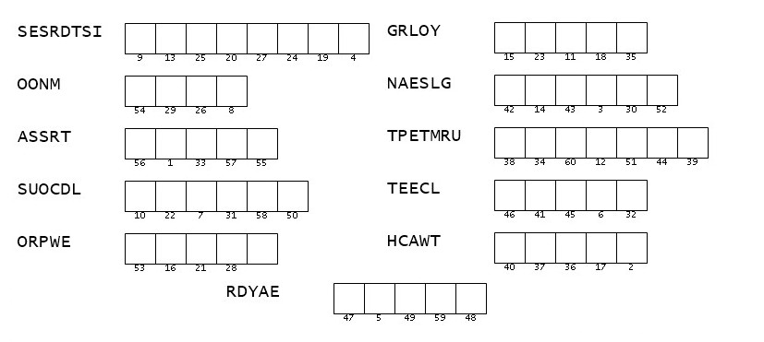Double Puzzle
It is I … the Word Ninja. We need your help to determine the message. Use the numbers below the spaces of the clue words to determine the letters that make up the message. The clue words are taken from Matthew 24:3-8,29-32,42-44 (NIV). Assistance is available at https://tinyurl.com/4vy75u6u Other intriguing Family Activities are also available.

