1. Motivate

What’s an early memory of being punished for doing something wrong?
- paddled for misbehaving
- grounded for getting home late
A video introduction is available. View at https://watch.liberty.edu/media/t/1_uhndq2tw
If you have no Wi-Fi where you teach, best to download from https://tinyurl.com/upnyjwr7
- sit at table until I ate the Brussels Sprouts
- had to write “I will not talk in class” 100 times
- mouth washed out with soap for a bad word
- running extra laps for being late to P.E.
- put in time out for sassing Mom
- had to memorize Bible verses as punishment
- sent to principal’s office
- spanked for going out on the ice on the lake

2. Transition

Some people may have had more, some less of childhood punishment.
- The reality is, we are all sinners, and on our own, we can do nothing about it.

3. Bible Study

3.1 Sin Separates Us from God

Listen for an implied accusation.

Isaiah 59:1-5 (NIV) Surely the arm of the LORD is not too short to save, nor his ear too dull to hear. 2 But your iniquities have separated you from your God; your sins have hidden his face from you, so that he will not hear. 3 For your hands are stained with blood, your fingers with guilt. Your lips have spoken lies, and your tongue mutters wicked things. 4 No one calls for justice; no one pleads his case with integrity. They rely on empty arguments and speak lies; they conceive trouble and give birth to evil. 5 They hatch the eggs of vipers and spin a spider's web. Whoever eats their eggs will die, and when one is broken, an adder is hatched.

What accusations did the people seem to be levying against the Lord?
- He is unable to rescue us
- He doesn’t even listen to our prayers
- probably not even interested in our problems

According to the prophet, what was the true cause for the breach with the Lord?
- your iniquities have separated you from God
- you have sinned so much, He has hidden his face from you
- He refuses to hear your whining
- hands stained with blood
- fingers full of guilt

How does sin separate us from God? Isn’t God’s presence everywhere? Isn’t He omnipresent?
- from fellowship with God
- from His full blessings
- from some of the benefits of His love … example of the prodigal son while away from home
- from protection from problems – God will at times allow trials to nudge us in the right direction, to correct us

What were some of the sins for which the people were guilty?
- lying
- speaking wickedness (foul language, angry words, potty-mouth)
- you do not act with justice (righteousness)
- no desire for righteousness/justice
- you think up trouble
- you act evilly

Drawing on the metaphor of a snake, what would result from their sinful practices?
- you hatch evil plans
- you spin webs of deceit
- you end up spiritually dead
- your plans result in more and more sin

What evidence do you see in this world that everyone has sinned?
- the jails are overcrowded
- in some jurisdictions laws are not prosecuted
  - they have too many law breakers to handle
  - superior officials decide they don’t agree with the law
- broken families
- epidemic of opiate related deaths – extreme substance abuse
- hate, division between political positions
- more and more violence in entertainment
- anger and hate expressed in social media

What were the circumstances when you become aware that you were a sinner?
- summer church camp
- in a revival service
- in Sunday School
- in a youth rally (Youth for Christ, Young Life, Fellowship of Christian Athletes, etc.)
- in an AWANA club
- a friend witnessed to me,
- two people from church called on our home
- heard Billy Graham preach (on TV, in person)
- almost OD’d and realized I had lost control of my life – hit bottom, had to admit being lost
- got in so much trouble I realized I needed to change somehow
3.2 Good Works Don’t Cover Sin

Listen for the adverse effects of sin.

Isaiah 59:6-8 (NIV) Their cobwebs are useless for clothing; they cannot cover themselves with what they make. Their deeds are evil deeds, and acts of violence are in their hands. 7 Their feet rush into sin; they are swift to shed innocent blood. Their thoughts are evil thoughts; ruin and destruction mark their ways. 8 The way of peace they do not know; there is no justice in their paths. They have turned them into crooked roads; no one who walks in them will know peace.

What was the point of Isaiah’s use of the spider’s web analogy?
- when we spin excuses or rationalize our sinful behavior
- turns out those excuses are just “the skin of a reason stuffed with a lie”
- the rationalizations don’t do away with the basic problem
- we end up fooling ourselves
- our sin still ultimately results in evil and violence

How does verse 7 describe the state of life of the wicked?
- their feet rush to sin
- they “shed innocent blood”
- thoughts are evil
- ruin and destruction mark their ways

What are some common ways people try to cover over their sinfulness?
- lying to cover tracks
- rationalization to self
- it’s not so bad – I’m not murdering anyone
- I’m more of a good person than a bad
- build up a reputation for doing lots of good things (a smoke screen)
- blame others … “not my fault”
- breath mints to cover smoking or drinking
- vocally decry the sins of others that are the same things I do in secret
- sneak off to do things we don’t want others to know

Consider these verses which speak to the fact that good works not the answer to the problem of our sinfulness (give some of these to learners to look up and share).
- Is. 64:6 all our righteousness is as filthy rags
- John 6:28 the “work of God” is to believe in the One He sent
- Rom 3:20 no one declared righteous by observing the Law
- Rom 9:31, 2 Israel pursued a law of righteousness, did not attain it, didn’t pursue faith
- Gal 2:16 man is not justified by observing the law, but by faith in Christ
- Gal 5:4 trying to be justified by the law, end up alienated (separated) from Christ
- Eph 2:8-9 saved by grace, not by works
- Titus 3:5 saved not because of righteous things done, but because of His mercy
- Is 57:12 I will expose your righteousness and your works, they will not benefit you

3.3 God Must Intervene

Listen for where is righteousness.

Isaiah 59:9-13 (NIV) So justice is far from us, and righteousness does not reach us. We look for light, but all is darkness; for brightness, but we walk in deep shadows. 10 Like the blind we grope along the wall, feeling our way like men without eyes. At midday we stumble as if it were twilight; among the strong, we are like the dead. 11 We all growl like bears; we moan mournfully like doves. We look for justice, but find none; for deliverance, but it is far away. 12 For our offenses are many in your sight, and our sins testify against us. Our offenses are ever with us, and we acknowledge our iniquities: 13 rebellion and treachery against the LORD, turning our backs on our God, fomenting oppression and revolt, uttering lies our hearts have conceived.

Identify the various images Isaiah employed to describe the status and feelings of those in sin.
- look for light, all is dark
- look for brightness, but walking in deep shadows
- blindness groping along and stumble
- growl in anger
- moan in misery

What makes these images an effective way to describe our lives in sin? List some examples of how people look for light but end up groping and stumbling through life?
- materialism to enjoy more possessions
- substance abuse to feel good
- greed for power … to lord it over others
- never have enough money … how much is enough? more than I have now
- fame … but it is fleeting

This lesson has emphasized the reality of our sinful condition. Let’s anticipate God’s solution to our problem.

David wrote Psalm 51:3 (NIV) For I know my transgressions, and my sin is always before me.

He continues on with verses 10-12 Create in me a pure heart, O God, and renew a steadfast spirit within me. Do not cast me from your presence or take your Holy Spirit from me. Restore to me the joy of your salvation and grant me a willing spirit, to sustain me.

For what does he pray?
As we approach the Easter season, we can look forward to the answers to David’s prayer in our own lives

- pure heart
- a renewed and steadfast spirit
- to live in God’s presence
- to have the presence of God’s Spirit
- restoration of the joy of salvation
- a willing spirit … willing to live righteously, justly

Use the last page as a handout so your learners can take home the application points of this week’s lesson.
Application
Confession.
- Admit you are a sinner who has fallen short of God’s standard.
- Confess your sin to Him and ask for forgiveness.
- He is faithful and just to forgive you.

Prevention.
- Evaluate where you are most prone to give into temptation.
- Being tempted is not sin, but it can easily lead to sin.
- Draft some safeguards to help you avoid temptation in the first place.

Accountability.
- Reach out to one or two believers (of the same gender) in whom you can confide.
- Talk through areas in which you are weak and ask them to hold you accountable and walk with you so that you will not fall into sin
Double Puzzle
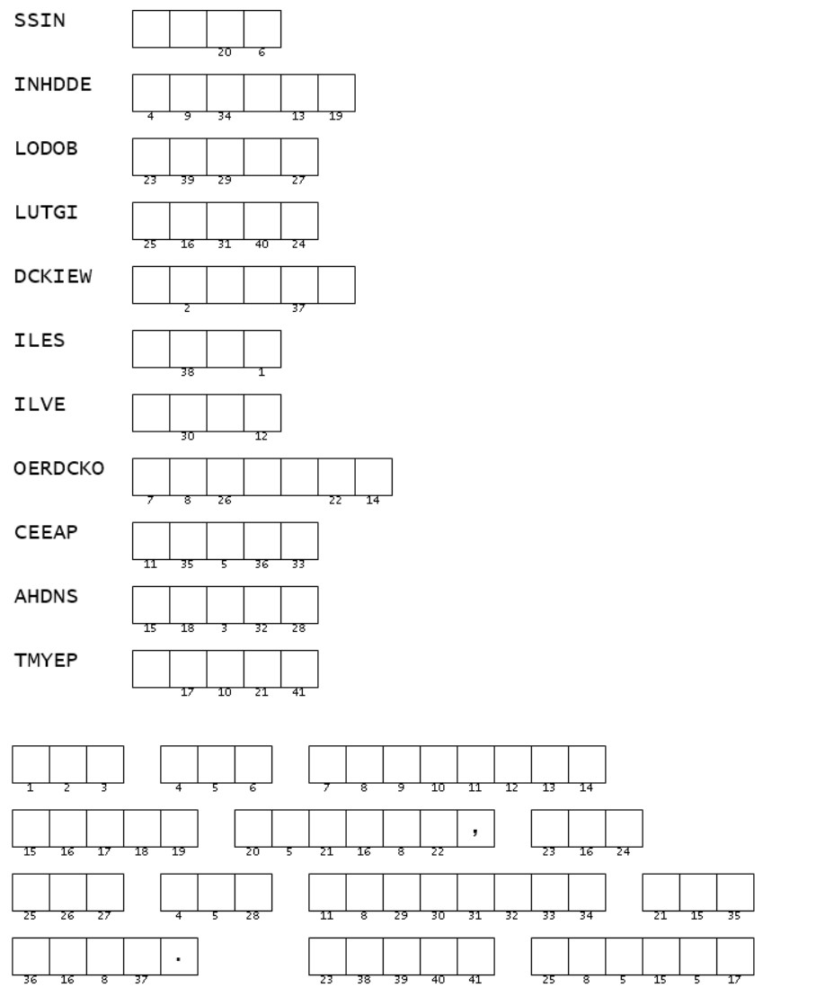
Aye cucaracha! I think you’re supposed to order the letters for the clue words on the left. They are words from Isaiah 59 ...

… OK, then you must use the numbers to figure out what goes in the blanks in the message at the bottom. The whole thing really bugs me. If you do get stuck, you can go to https://tinyurl.com/upnyjwr7 There’s more there for good Family Activities.

