1. Motivate

Who in your circle of acquaintances (family, friends, work mates) has an interesting name?
- Jack Frost
- Holly Hock I actually had students with these names
- Candy Kane
- Johnny Chocolate
- Tilly the Toe (nickname of our team’s kicker)
- Tiny (who weighs 325 lbs)
A video introduction to this Bible Study is available. View it at https://tinyurl.com/5h7b5s97 . If you do not have wi-fi where you teach, it is best to download the .mp4 file to your computer from https://tinyurl.com/2p8c7k2z
- Fuzzy (who is bald)
- Mean Joe Green (football player)

2. Transition

God’s name is nothing to laugh about.
- His name reveals His power and authority.
- It shows He is a God we can completely trust.

3. Bible Study

3.1 Approach with Awe

Listen for why Moses was afraid.

Exodus 3:1-6 (NIV) Now Moses was tending the flock of Jethro his father-in-law, the priest of Midian, and he led the flock to the far side of the desert and came to Horeb, the mountain of God. 2 There the angel of the LORD appeared to him in flames of fire from within a bush. Moses saw that though the bush was on fire it did not burn up. 3 So Moses thought, "I will go over and see this strange sight--why the bush does not burn up." 4 When the LORD saw that he had gone over to look, God called to him from within the bush, "Moses! Moses!" And Moses said, "Here I am." 5 "Do not come any closer," God said. "Take off your sandals, for the place where you are standing is holy ground." 6 Then he said, "I am the God of your father, the God of Abraham, the God of Isaac and the God of Jacob." At this, Moses hid his face, because he was afraid to look at God.

Recall Moses’ history up to now:
- Raised as son of Pharaoh’s daughter
- In defending a fellow Israelite he commits 2nd degree murder against an Egyptian
- Fearing arrest, he flees to Midian, lives there 40 years, marries daughter of a priest
- Works as a shepherd

Where and how does God miraculously appear to Moses?
- far side of the desert, Horeb
- the angel of the Lord (actually this is God, a theophany)
- appeared in flames of fire from within a bush
- bush on fire, but does not burn up
Why was Moses afraid to look at God?
- he was in awe of God
- he feared God’s power and authority
- he sensed the holiness/separateness of God in contrast to his own weakness and sinfulness

Why is this a good attitude to have?
- the fear of the Lord is the beginning of wisdom
- you realize that God is God and you are not
- it gives you a proper understanding of who is really running things
- keeps you from getting a big head
- motivates you to follow and obey God and not other influences

What are some things which distract us from tasks God wants us to take on?
- personal relationships that are not good for us
- our jobs … when we become workaholics
- materialism
- our hobbies that become all consuming (sports, crafting, entertainment)

The story seems to show that God came looking for Moses rather than Moses looking for God. In what ways does God reveal Himself to us to get our attention (other than burning bushes)?
- a sequence of circumstances or events
- life changing events (illness, loss of a loved one, job loss, etc.)
- through the preaching or teaching or study of God’s Word
- something someone (even a child) says that catches our attention and speaks especially to us

Prior to this, Moses probably thought shepherding was his new purpose or calling in life. What does this tell you about God’s plans for your life?
- they might change
- God can repurpose your life
- God sometimes has new adventures for you
- God can use you at any age (Moses was no youngster)

Why might God reserve a special call until someone is of a certain age, rather than calling you to that task as a younger adult?
- you needed the experience
- you have a different set of relationships that God can use
- you can have a different kind of influence
- there are natural “seasons” in our lives which fit certain experiences

3.2 Trust God to Do What He Says

Listen for God’s response to the people’s cries.

Exodus 3:9-12 (NIV) And now the cry of the Israelites has reached me, and I have seen the way the Egyptians are oppressing them. 10 So now, go. I am sending you to Pharaoh to bring my people the Israelites out of Egypt." 11 But Moses said to God, "Who am I, that I should go to Pharaoh and bring the Israelites out of Egypt?" 12 And God said, "I will be with you. And this will be the sign to you that it is I who have sent you: When you have brought the people out of Egypt, you will worship God on this mountain."

We read that God had heard the cry of His people in their distress. When do we need God to see us, hear us, be concerned about us, rescue us and those around us?
- family problems
- health crises
- loss of job
- natural disaster (hurricane, tornado, blizzard, fire, etc.)
- kids problems at school (academics, safety, injury, social problems)
- spiritual needs of those around us

Note God’s challenge to Moses and Moses’ response:
- I’m sending you to Pharaoh
- You must bring my people the Israelites out of Egypt
- Who am I? You want me?

Moses had two basic options … accept or reject God’s call. What would have been the consequences of each option?
Consequences: Accept God’s Call | Consequences: Reject God’s Call
- must confront Pharaoh  - endure Pharaoh’s anger  - people would end up free  - receive possession of Promised Land  - escape from enslavement  - have the honor of leading God’s people | - avoid a confrontation  - avoid angering Pharaoh  - people continue in slavery  - no escape to “land of milk and honey”  - miss out on leading God’s people  - God would raise up someone else

What are some of the fears you think Moses was feeling?
- Pharaoh is a powerful guy, I’m just one person
- I might still be a wanted person in Egypt
- my Israelite relations will not accept my leadership, I’m the guy who ran away
- or maybe my fellow Israelites probably don’t even know who I am, I’ll be coming out of nowhere

Why does God put certain challenges before us?
- He has an important task that needs doing
- His intent is that we are the “hands and feet” that carry out His plans
- He wants us to trust Him
- He wants to teach us that He will give us the wherewithal to accomplish what He calls us to
- He wants to prove to us His sufficiency
- He wants us to learn that He deserves our praise and worship
3.3 God’s Name Shows God’s Character

Listen for the revelation of God’s name.

Exodus 3:13-15 (NIV) Moses said to God, "Suppose I go to the Israelites and say to them, 'The God of your fathers has sent me to you,' and they ask me, 'What is his name?' Then what shall I tell them?" 14 God said to Moses, "I AM WHO I AM. This is what you are to say to the Israelites: 'I AM has sent me to you.'" 15 God also said to Moses, "Say to the Israelites, 'The LORD, the God of your fathers--the God of Abraham, the God of Isaac and the God of Jacob--has sent me to you.' This is my name forever, the name by which I am to be remembered from generation to generation.

How does God identify Himself to Moses, what name does He tell Moses to give? How is the name God uses significant?
- I am Who I am
- the “I am” has sent me
- remind your people that I am the God of your fathers – Abraham, Isaac, Jacob
- “The God Who IS”
- (contrasted with those deities who are not – who are not God – who do not care for you)

Jesus is likewise “The God Who IS” and is still contrasted to lots of things which try to be substitute deities or idols in our lives.
- He loves us
- He died for us and rose again
- He lives in our lives to bless us, empower us
- The idols in our lives do not!

Moses is also told he is being sent by “the God of your fathers--the God of Abraham, the God of Isaac and the God of Jacob”. Why would this be important for Moses and the people to know?
- this is not a new deity
- He has a history with your ancestors
- He worked in their lives in powerful ways
- He’s still active in this ongoing family

How does this fit in with “This is my name forever … to be remembered from generation to generation”?
- God is eternal
- He exists outside the dimension of time
- He has been at work in our past, in our present, and will be at work in our future
- He will be at work beyond our existence – in the lives of our children and grandchildren

Use the last page as a handout so your learners can take home the application points of this week’s lesson.
Application
Listen.
- Listen to God’s voice.
- Put yourself in a place where you are most likely to be able to hear Him speak.
- Prayerfully seek His guidance about how you can glorify Him.

List.
- Pause and examine your situation.
- List ways you can be God’s ambassador where you are, so that others can come to know Him.

Look.
- Discover additional opportunities to take God’s name to people outside your current influence.
- This could mean serving in your community or even going on an overseas mission trip.

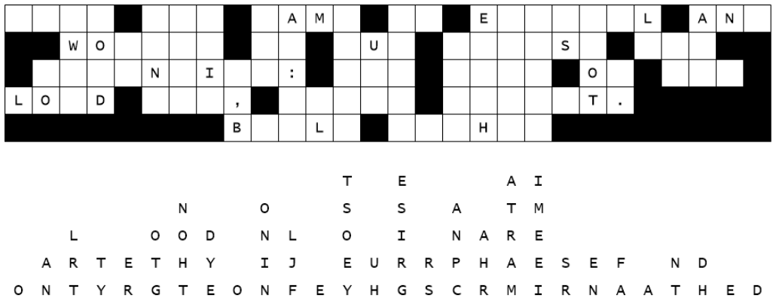
Fallen Phrases Puzzle
The Office of Unidentified Anomalous Phenomena has reported that an encrypted file has been cyber zapped by aliens causing letters to fall off the message straight down their columns. We need your help to put the message back together. Our cyber security team is gone to a middle school Christmas retreat. This is a critical message. Start with columns which have one column of missing letters. Then go on to two and three letter words and determine which letters make reasonable words. You can do this. Report back to your pastor as soon as the message is reconstructed. Technical help and other Fun Family Activities are available at https://tinyurl.com/2p8c7k2z

