1. Motivate
An introductory video is available. View it at https://watch.liberty.edu/media/t/1_odiokdin
If you have no Wi-Fi where you teach, best to download to your computer from https://tinyurl.com/472uad3b
When has ignoring a warning been a mistake?
- when the tornado siren went off
- when the speed limit sign was ignored
- when the sign said “Road Closed”
- when Mom said, “No Arguments”
- parents said “Be home by 11:30”
- the teacher said “be sure to finish by class on Friday”
- the piano teacher said “practice every day to be ready for the recital”
- the bridge said “Load limit 1500 lbs”
- “Pay by the 1st of the month or lose the car”

2. Transition

Most warnings are meant to help you avoid a problem.
- God’s instructions are exactly that.
- He warns us today, “purity in all things impacts your service for Him.”

3. Bible Study

3.1 Deep Love and Increased Service

Listen for the commendation.

Revelation 2:18-19 (NIV) 18 "To the angel of the church in Thyatira write: These are the words of the Son of God, whose eyes are like blazing fire and whose feet are like burnished bronze. 19 I know your deeds, your love and faith, your service and perseverance, and that you are now doing more than you did at first.

How does the Lord identify or describe Himself in this letter?
- He is the Son of God (in contrast to a local deity)
- eyes like blazing fire
- feet like burnished bronze

What does it mean that Christ’s eyes were "like blazing fire"?
- He sees everything
- He sees right through our façade, or fake “front”
- His gaze burns through to our souls, our deepest secrets

For what does the Lord commend the church at Thyatira?
- He knew their deeds – their good works
- aware of their love and faith
- knew of their service and perseverance
- they were growing, neither stagnant nor declining in their Christian service

What are some good things for which our church is known by people in our community?
- great music
- growing youth program
- good Bible teaching
- beautiful facilities
- a great pipe organ
- friendly, welcoming
- lots of activities for all ages
- good location
- a nice gym
- comfy pews
- plenty of good parking (the “welcome mat” to your church)

What are some ways to measure a church’s spiritual growth?
- number of baptisms each month or year
- number of mission trips
- professions of faith
- young people going into Christian ministry
- active discipling ministry
- active prayer groups
- people involved in evangelism
- outreach ministries
- number of people who faithfully tithe
- activity of men’s and women’s groups

What are some ways to foster increased spiritual growth of those who attend a church?
- discipleship classes
- witnessing training
- new Christian classes
- ongoing training for Sunday School/Small Group teachers
- preaching and teaching that encourages new steps with the Lord
- encourage participation in a variety of outreach opportunities

3.2 Purity Demonstrated through Morality

Listen for Jesus’ condemnation.

Revelation 2:20-23 (NIV) Nevertheless, I have this against you: You tolerate that woman Jezebel, who calls herself a prophetess. By her teaching she misleads my servants into sexual immorality and the eating of food sacrificed to idols. 21 I have given her time to repent of her immorality, but she is unwilling. 22 So I will cast her on a bed of suffering, and I will make those who commit adultery with her suffer intensely, unless they repent of her ways. 23 I will strike her children dead. Then all the churches will know that I am he who searches hearts and minds, and I will repay each of you according to your deeds.

For what did the Lord hold the church accountable? For what did He chastise the church?
- tolerance of a woman who was misleading church members
- people involved in immorality
- tangentially involved in idol local idol worship
What sign of mercy grace appears in verse 21?
- God gives opportunity to repent, to turn away from sin and turn to God
- as awful as these activities were, God was willing to forgive – IF the person repented
- God is willing to bless us when we don’t deserve it
- He is willing to withhold punishment we actually deserve … when we repent

What could this “Jezebel” and her adherents expect for refusing to repent?
- suffering
- intense suffering
- death – either physical or spiritual … or both

What effect would this judgment have on others?
- God does not mess around
- God searches hearts and minds
- He knows what we are doing, even we hide it from others around us

What sins do we tend to tolerate in our own lives or in the lives of our Christian friends when we should not?
- anger
- gossip
- lax in church attendance
- tolerate questionable entertainment
- not good stewards with finances

Why can we expect the Lord to act justly toward us? What dangers do we face when we refuse to respond to God or repent of our sins?
- God is righteous, just … He punishes sin
- He has taken that punishment for us
- at the same time, we should know that the principle of sowing and reaping applies
- when we sow evil, we reap certain negative results
- we can experience forgiveness from God, but must realize that we may suffer some results of our sinful actions
- for example, even after God delivers someone from substance abuse, he or she can experience physical and emotional scars

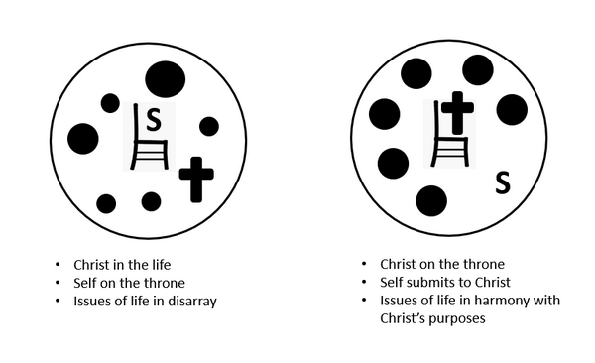What are some characteristics of a person who lives a pure life?
- displays the Fruit of the Spirit … love, joy, peace, patience, kindness, goodness, gentleness, faithfulness, self-control
- daily communication with God …
- reading and meditating on God’s Word
- speaking with God in prayer
- obedient to God’s commands
- surrendered to God’s holy Spirit

3.3 Faithful to the Gospel

Listen for words of encouragement.

Revelation 2:24-29 (NIV) Now I say to the rest of you in Thyatira, to you who do not hold to her teaching and have not learned Satan's so-called deep secrets (I will not impose any other burden on you): 25 Only hold on to what you have until I come. 26 To him who overcomes and does my will to the end, I will give authority over the nations-- 27 'He will rule them with an iron scepter; he will dash them to pieces like pottery'-- just as I have received authority from my Father. 28 I will also give him the morning star. 29 He who has an ear, let him hear what the Spirit says to the churches.

To whom does the Lord give His promises?
- those who reject the teaching of the “Jezebel” in their midst
- members who have not delved into the Satanic secrets

What value is there in choosing to remain ignorant of certain evil ideas and practices?
- hard to rid our minds of evil we might see, hear, or read about
- instead, fill your minds with good stuff
- in order to know how to recognize or deal with evil , study God’s Truth – memorize Scripture
- then when you encounter evil, the counterfeit will be obvious in contrast
- this is the danger of being exposed to the vast array of entertainment full of violence or sexual activity

What does the Lord desire believers do with what they know about Him and have received from Him?
- hold on to what you have
- do God’s will
- study the Truth God has given you
- get to know God better – daily communication with Him
- be “overcomers”
- be “more than conquerors”
- live a Christian life that is more than just “escaping hell”

When we are misled by others, what can we do to correct our mistakes? How?
- confess to God, agree with Him you have sinned
- repent, turn away from those mistakes (sins) and turn your life towards following God
- if appropriate, communicate to your friends your decision
- you should forgive, but probably not trust them the same as before
- trust God for wisdom, direction to correct your ways

What are two specific promises given to the ones who are victorious in Christ?
- we will rule with Christ
- we will be given “the Morning Star”

Use the last page as a handout so your learners can take home the application points of this week’s lesson.

Application
Commit.
- As you wake every day, even before you get out of bed, pause, and pray.
- Ask the Lord to give you the strength to live for Him and by His standards as you go through the day.

Contrast.
- Make a list of things the world says are perfectly OK to do.
- Contrast those things with what the Bible says about them.
- Dig into the Scripture and find verses that address those things.

Witness.
- If you have a friend who has embraced the world’s practices of idolatry and immorality, schedule time to visit.
- Prayerfully share with this friend the truth of the gospel and the benefits it offers over the deceptiveness of sin.
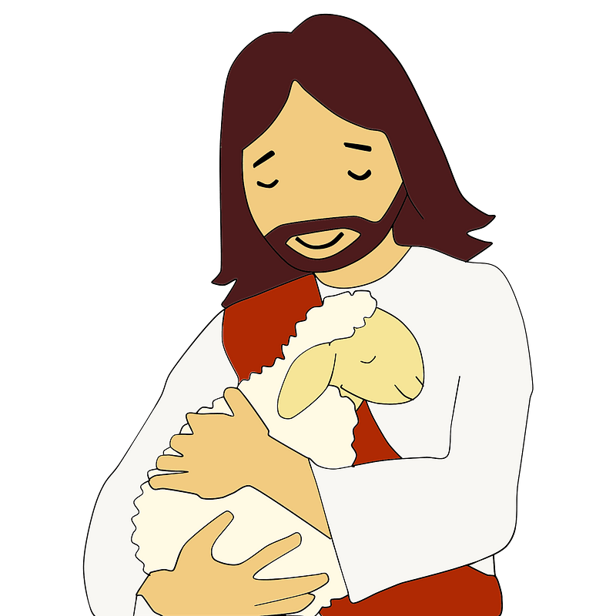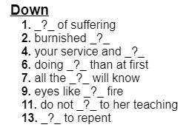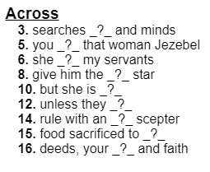
Ah-ha! The Word Ninja sees that the words and clues are taken from Rev. 2:18 – 29 (NIV). And if you’re still stuck, I’ve provided help and further Family Activities https://tinyurl.com/472uad3b

