1. Motivate

What are some things you do that you were taught by someone else?
- cooking
- teaching
- driving a car
A video introduction to the lesson is available. View it at https://watch.liberty.edu/media/t/1_b5gb1ggu If you have no wi-fi where you teach, best to download to your computer from https://tinyurl.com/5474xsrb

- wood carving
- doing math
- studying the Bible
- speaking in public
- typing
- managing my cell phone
- using a spreadsheet

2. Transition

For most things we are grateful for the people who taught us these kinds of skills.
- Today we consider how Moses prepared his successor.
- God calls us to mentor and disciple those who come after us.

3. Bible Study

3.1 Seek God’s Direction

Listen for Moses’ request.

Numbers 27:12-17 (NIV) Then the LORD said to Moses, "Go up this mountain in the Abarim range and see the land I have given the Israelites. 13 After you have seen it, you too will be gathered to your people, as your brother Aaron was, 14 for when the community rebelled at the waters in the Desert of Zin, both of you disobeyed my command to honor me as holy before their eyes." (These were the waters of Meribah Kadesh, in the Desert of Zin.) 15 Moses said to the LORD, 16 "May the LORD, the God of the spirits of all mankind, appoint a man over this community 17 to go out and come in before them, one who will lead them out and bring them in, so the LORD's people will not be like sheep without a shepherd."

What did the Lord invite Moses to do?
- go up this mountain
- see the land I have given to the Israelites
- once you have seen it, I will “gather you to your people”
- (your earthly life will end)

Why would Moses be denied the opportunity to lead the people into the land?
- both you and Aaron disobeyed my (God’s) command, you didn’t honor Me as holy
- Moses struck the rock to provide water, instead of speaking to it as God had commanded
- we might infer that Moses struck the rock because he was angry, lost his temper
Since Moses would not be entering the Promised Land, what did he request from God?
- a leader appointed over the people
- able to go before them, lead them
- one to act as a shepherd

Why did they need a god-appointed leader?
- they acted as dumb as sheep
- without leadership they got in trouble
- they wandered away from what God intended for them
- they needed protection

What are some ways one generation typically passes along wisdom to the next generation?
- give instruction informally
- include the younger generation in a variety of tasks
- give hints and share “best practices”
- demonstrate “tricks of the trade”
- provide formal training
- share in family times

What might keep us from passing the torch to the next generation?
- lazy parents, lazy kids
- parent is not around – divorce or abandonment
- parent is too busy with his/her own activities or interests
- parent is not good at sharing, encouraging, guiding
- everyone is focused on their phones, not on family interaction

How can recognizing our own mortality help us as mentors, whether it’s our children or our jobs?
- some things we do are important and/or involve significant firsthand knowledge,
- it could be lost if it is not passed on
- you might think of questions you have about situations you would like to ask of your parents or grandparents and cannot because they have died
- some things we do as adults we have learned by trial and error, better to pass on some of these details of what we do
- some information or ideas could die with us and possibly never be discovered again

3.2 Empower the One you Mentor

Listen for God’s response to Moses’ request.

Numbers 27:18-20 (NIV) So the LORD said to Moses, "Take Joshua son of Nun, a man in whom is the spirit, and lay your hand on him. 19 Have him stand before Eleazar the priest and the entire assembly and commission him in their presence. 20 Give him some of your authority so the whole Israelite community will obey him.

Why did God name Joshua?
- a man in whom is the spirit
- he reflected the character of God
- this may or may not mean the Spirit of God … different ministry of God’s Holy Spirit in OT from NT
- he fit the qualifications

What are some ways in which people reflect the character of God?
- Fruit of the Spirit
- acts of kindness
- concern for others above self
- exercise the Gifts of the Spirit
- exercise mercy, grace

We note that neither Moses nor the people chose Joshua. Why is this important?
- too easy for an individual to misjudge
- may try to pick someone too much like himself
- people pick on popularity
- people (as a group or as individuals) do not know what a potential leader is really like down deep

What important role was Moses to take in this transition of leadership?
- formally declare Joshua as the new leader
- lay hands on him in dedication
- do this before Eleazar the priest and the entire assembly
- commission him in their presence
- give him some of your authority
- get the people into the notion and practice of Joshua’s leadership and their obedience to the new leader

What are some ways we can publicly affirm God’s work in the next generation?
- in a family give children responsibilities
- as they grow older, increase the responsibilities and the trust you have in them
- let older children pass on chores and train their younger siblings
- pray for them and with them about increased trust (driving, dating, taking jobs, going off to school, etc.)

What are some ways others have helped you follow Jesus? What people in God’s family have you relied on and considered important?
- Sunday school teachers
- youth leaders in the church
- youth leaders in Christian organizations such as Youth for Christ or Campus Crusade (Cru)
- pastors who included you in church ministries
3.3 Publicly Affirm God’s Work

Listen for Moses’ response to God’s instruction.

Numbers 27:21-23 (NIV) He is to stand before Eleazar the priest, who will obtain decisions for him by inquiring of the Urim before the LORD. At his command he and the entire community of the Israelites will go out, and at his command they will come in." 22 Moses did as the LORD commanded him. He took Joshua and had him stand before Eleazar the priest and the whole assembly. 23 Then he laid his hands on him and commissioned him, as the LORD instructed through Moses.

What was the role of Eleazar in the eventual transition of leadership from Moses to Joshua?
- involved in decision making
- helped determine God’s answer or direction
- used the Urim
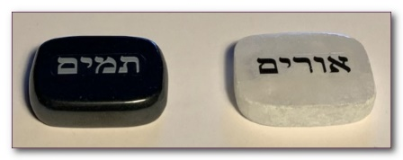
The Urim and Thummim
- Set of two objects (stones) used by the High Priest
- Used to answer a question or reveal the will of God
- More than just chance like rolling dice or drawing straws
Modern replicas available on Etsy
- Kept in the breastplate worn by the High Priest

What and who were to be influenced by the decisions of the Lord rendered through Eleazar?
- Joshua
- Moses
- the community of Israelites
- the whole assembly

How was Moses a positive role model in this incident?
- obedience to the Lord
- had Eleazar commission Joshua
- gave his personal affirmation of Joshua as the leader

How can we encourage people to fulfill God’s calling in their lives?
- pray for them
- notice their gifts – involve them in ministry
- support with advice, positive comments
- give constructive criticism
- provide opportunities for them to serve God
- give positive support before others
Use the last page as a handout so your learners can take home the application points of this week’s lesson.
Application
Seek.
- Pray and seek God’s direction regarding someone you might help and encourage.

Affirm.
- Everyone needs encouragement.
- Write a note to someone you see is beginning to grow and serve others in some capacity.
- Thank this person, encourage this individual, and offer to help as needed.

Equip.
- Consider what role you carry out in the service of church ministries.
- Create a list of things you could pass on about that service to someone else.
- Using the list, begin informally training someone else for a potential role.
Crossword Puzzle
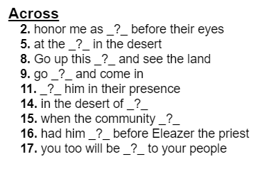
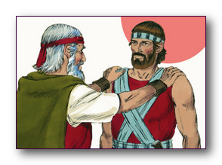
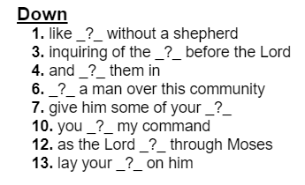
Finally, my favorite, the crossword. Remember, the clues and words come from Numbers 27:12 – 23 (NIV). If you get stuck, go to https://tinyurl.com/5474xsrb And there’s other Family Activities there also.

