1. Motivate

Who has been an example of personal integrity in your life?
- youth worker
- pastor
A video introduction is available. View at
https://watch.liberty.edu/media/1_m408md5z
If no Wi-Fi where you teach, best to download to your computer from https://tinyurl.com/yysdx3de
- school teacher
- parent, grandparent, aunt, uncle
- neighbor
- fellow worker
- fellow soldier
- fellow student

2. Transition

We value those friendships.
- Those were people we could depend on.
- Integrity and contentment in Christ form the foundation for good relationships.

3. Bible Study

3.1 Integrity in Words and Deeds

Listen for how to show respect.

Exodus 20:15-16 (NIV) "You shall not steal. 16 "You shall not give false testimony against your neighbor.

How does respect for one’s property or possessions affect respect for the person who owns them?
- you might think about taking something from an enemy, but not from a close friend
- you wouldn’t want to offend someone you respect by harming them that way
- you know they would be hurt deeply if they knew you had stolen from them
- you feel they don’t deserve to be treated that way

Why is theft an affront to the creative intentions of God?
- God works in your life to supply your needs
- to steal from another person implies that God has not been faithful in providing for you
- theft violates God’s laws … to steal is an “in-your-face” rejection of God’s principles of living

In what settings might the ninth commandment apply?
- theft of actual objects
- robbing an employer of your full time at work by slacking off
- cheating on a school assignment or exam
- taking credit for work that someone else did
- cheating on income tax

In Eph 4:28, Paul stated that the best prescription for thievery was to engage in honest labor. Why do you think this is true?
- you begin to value what you have worked for
- you have a satisfaction of living they way God intended (as seen in the commandments)
- you don’t have time to think up and carry out illegal forms of monetary gain
- if everyone lived that way, we are able to trust each other

Why is truth critical to personal relationships and the fabric of society?
- we need to be able to trust what people tell us
- destroys relationships when people around you think nothing of lying to your face
- if you are the victim of someone who lies to you about a “sure fire investment”, you really cannot trust them ever again for anything
- to live peaceably, we need to be able generally to trust one another
- consider how harmful mass propaganda is to what people understand and believe

Why is it so important for believers to be people of integrity?
- we claim that God has saved us from lives of sin
- we claim to have repented … turned away from lying and cheating
- otherwise we are no different than sinful liars and cheats

How does a person’s conduct reflect their character?
- we act based on who we are and what we believe is acceptable
- “even a child is known by his doings” Proverbs 20:11 (NLT2) Even children are known by the way they act, whether their conduct is pure, and whether it is right.
- we all know people who we don’t trust because we see what they do and know what they say
- how people talk reflects how they think and what they are like

3.2 Contentment in God’s Provision

Listen for God’s admonition on contentment.

Exodus 20:17 (NIV) "You shall not covet your neighbor's house. You shall not covet your neighbor's wife, or his manservant or maidservant, his ox or donkey, or anything that belongs to your neighbor."

The definition of “covet” is to wish, long, or crave for (something, especially the property of another person). What did these Bible characters covet?
- David: with another man’s wife (Bathsheba, wife of Uriah)
- King Ahab: wanted Nabal’s property, had him killed
- Jacob and Esau: Jacob wanted his brother’s birthright, his father’s blessing (the
mother was also complicit in this – coveted something for someone else)
- Abraham: wanted his promised son, not willing to wait

What are dangers of coveting as illustrated in these stories?
- willing to murder
- willing to commit adultery for what you desire
- end up sinning more to cover up the original act
- willing to deceive (Jacob went to some great lengths)
- God told Abraham, “This son of yours will be a wild man, as untamed as a wild donkey! He will raise his fist against everyone, and everyone will be against him. Yes, he will live in open hostility against all his relatives.”
- we’re still living with the results of that today

How is coveting not only an offense toward others but an offense toward God?
- shows a definite attitude of dissatisfaction with what God has provided
- this in turn shows a lack of faith that God’s sufficiency is not enough
- it can distract you from what God wants you to do and be
- causes you to squander your resources on things, not use them for the kingdom of God

Why is it difficult in today’s world to be content with what God has provided us?
- bombarded with advertising
- western culture values owning more and more stuff
- we are told what we have is obsolete and we ought to have the latest
- clothing styles change so fast, we need to have what is current
- new things are available all the time, making what we have obsolete
- we live in a “throw away” culture – Bic pens, Timex watches, cell phones, etc. – when they quit working, throw them away and get a new one
- that attitude can carry over to most anything (or anyone) we have

How can we overcome the temptation to covet, to long for what someone else has?
- daily express to God thanks and praise for His provision
- take care of what you do have
- value what God has provided you
- trust God to be a generous person … tithing, giving beyond tithe, helping others in need

3.3 All We Desire Rests in God

Listen for a challenge to trust God.

Psalm 37:1-6 (NIV) Do not fret because of evil men or be envious of those who do wrong; 2 for like the grass they will soon wither, like green plants they will soon die away. 3 Trust in the LORD and do good; dwell in the land and enjoy safe pasture. 4 Delight yourself in the LORD and he will give you the desires of your heart. 5 Commit your way to the LORD; trust in him and he will do this: 6 He will make your righteousness shine like the dawn, the justice of your cause like the noonday sun.

What issue is the psalmist addressing in these verses? How would you summarize his challenge?
- don’t worry about how evil in our culture seems to be prevailing
- God is in charge
- God’s justice will prevail
- you should live by faith and obedience to God

Why did the psalmist urge those he instructed not to allow the wicked to influence the direction of their lives?
- trust in God and obedience are what really count
- realize that you can delight in what God wants to do in your life
- a humanistic focus seems to offer happiness, but it is temporary

What alternative did he encourage them to take?
- trust in the Lord
- do good
- dwell in the land and enjoy safe pasture
- delight yourself in the Lord
- commit your way to the Lord

What does the psalmist say will result in trusting God.
- as you delight yourself in God, He gives you the desires of your heart
- your desires match what God wants to be doing in your life
- He will make your righteousness shine like the dawn
- the justice of your cause will be as bright as the noonday sun
- God will accomplish good things for you and through you

Use the last page as a handout so your learners can take home the application points of this week’s lesson.

Application
Check your words.
- Be mindful of your words and actions this week.
- If you are tempted to say or do anything that is not honest and truthful, stop yourself.
- Commit to being a person of integrity.

Memorize.
- Commit to memory 2 Corinthians 9:8: “And God is able to make every grace overflow to you, so that in every way, always having everything you need, you may excel in every good work.”
- Let this verse continually remind you that you already have all that you need to live fully in Him.

Encourage.
- We could all use some positive affirmation and encouragement in the area of integrity and contentment.
- The things we view on TV or social media can bring us down or cause us to become dissatisfied with our own lives.
JUSTICE
LAND
MAIDSERVANT
MAKE
MANSERVANT
MEN
NEIGHBOR
NOONDAY
NOT
OX
PASTURE
PLANTS
RIGHTEOUSNESS
SAFE
SHALL
SHINE
SOON
STEAL
SUN
TESTIMONY
TRUST
WIFE
WITHER
WRONG
- Choose to be a source of encouragement to those who struggle with discontentment.
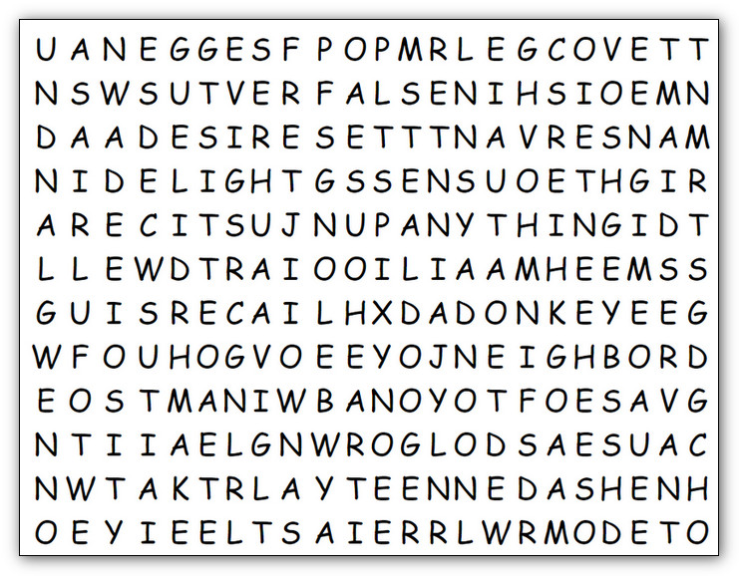
Well, Humph! Why are you just sitting there? Get to work. Someone has to find these words, and it isn’t going to be me. Humph! I’ve got book reports to grade. And you better look in all directions for these words … up, down, right, left, and diagonal, And remember, “Thou shalt not steal” answers from thy neighbor! If you have to go to https://tinyurl.com/yysdx3de for help, you owe me another book report.

AGAINST
ANYTHING
AWAY
BELONGS
CAUSE
COVET
DAWN
DELIGHT
DESIRES
DIE
DONKEY
DWELL
ENJOY
ENVIOUS
EVIL
FALSE
FRET
GIVE
GOOD
GRASS
GREEN
HEART
HOUSE

