1. Motivate

If you could hear a tape recording of everything you said last week, what would you want to edit out?
A video introduction for the lesson is available. View it at https://watch.liberty.edu/media/t/1_mcr67pss If you have no wi-fi where you teach, best to download to your computer from https://tinyurl.com/35nmdmac
- Yelling at the kids
- fudging on a business interchange
- the excuse I made for being late
- the gossip stories I told
- how I bragged and exaggerated on my accomplishments
- all the complaining I did
- what I said under my breath when that car cut me off
- when I yelled at the referee’s call at the ballgame

2. Transition

Maybe you remember your parents saying “If you don’t have anything good to say, don’t say anything at all”
- Today we look at how what we say needs to be more carefully controlled
- When you rely on God, your words reflect His character.

3. Bible Study

3.1 There is Power in Your Words

Listen for small things controlling big things.

James 3:1-5a (NIV) Not many of you should presume to be teachers, my brothers, because you know that we who teach will be judged more strictly. 2 We all stumble in many ways. If anyone is never at fault in what he says, he is a perfect man, able to keep his whole body in check. 3 When we put bits into the mouths of horses to make them obey us, we can turn the whole animal. 4 Or take ships as an example. Although they are so large and are driven by strong winds, they are steered by a very small rudder wherever the pilot wants to go. 5 Likewise the tongue is a small part of the body, but it makes great boasts.

Why do you think teachers are subject to a stricter accountability before the Lord?
- they are charged with communicating God’s Truth (or important academic concepts)
- they have opportunity to shade what they communicate with their opinion
- they can decide what is “truth” as they teach
- God holds them accountable to teach what is actually His Truth according to what He has said
- we see abuse of teachers’ responsibility in our culture today, with introduction of critical race theory and with distortion of gender issues

What images did James employ to describe the power of the spoken word?
- small things which control much larger things
- bits in the mouths of horses
- rudders which steer a ship
- analogous to our speech – tongue is small but there is power (to do either great good or bad) in what we say

When have you seen the power of words impact someone in positive ways?
- a word of encouragement helps someone get past a down time
- a word of direction sets someone on the right path
- explanation of a topic helps someone understand
- example – a child learning to read is told how to use phonics principle to learn to read a whole class of words – you can almost see the light go on in their minds

What does it mean to “control” something (for example a radio-controlled model airplane)?
- limit what it does
- specify what it should do, should not do
- to direct where it goes,
- direct what it does

Why are the things we say hard to control?
- we speak without really thinking
- you speak out of the emotions of your heart (anger, excitement, despair, etc.)
- you don’t make the effort to consider the implications or effects of what you say
- you are often concerned only with your own problems, not outside issues

Consider the practice of chewing gum … What is the role of the tongue as you chew gum?
- positions the gum for next chomp
- prepares gum wad for blowing a bubble (flatten, position, start the bubble)
- holds the gum in your mouth
- keeps you from swallowing your gum

Maybe there are some parallels between gum chewing and tongue mastery!
I know, this is somewhat of a “stretch” (no pun intended).
Chewing Gum | Mastering Speech
- keeping gum in mouth  - chewed gum sticks to things  - aid in blowing a “beautiful” bubble  - positioning gum | - keeping harmful words in  - harmful words stick in people’s minds  - aid in saying beautiful things  - declaring our position on an important issue

3.2 Inconsistent Words

Listen for the incongruity of use of the tongue.

James 3:9-10 (NIV) With the tongue we praise our Lord and Father, and with it we curse men, who have been made in God's likeness. 10 Out of the same mouth come praise and cursing. My brothers, this should not be.

Why is our blessing God and cursing others inconsistent?
- consider the fact that we are all made in God’s image
- if we curse someone (who is made in God’s image), we are in effect cursing God

How do inconsistencies show up in what we verbalize?
- you can offer praise
- you can sing beautiful hymns
- at the same time, you can use foul language
- you can curse others
- you can use God’s name in vain

What can James’ mention of a “curse” mean?
- a curse can be an expression of anger (profanity, vulgarity)
- a curse can be a wish for bad things for the person being cursed
- “I hope you fail the test … lose the game … fall flat on your face … rot in hell.”
- “May the fleas of a thousand camels infest your car sofa.”

How has technology amplified the power of words in recent years?
- when you send an email or text message, you don’t have to face the person
- you are at a distance, and they can’t get at you
- you might not even know who they are so you don’t have to worry about being nice
- you can express anger to a whole bunch of people at once (in a Facebook post)

Consider the word sins of criticism, gossip, and arguing. What should we do which are the opposite … things we say which result in praise and blessing, not evil and cursing?
Instead of arguing ?
- learn to agree to disagree
- look for points of agreement
- ask God for an attitude of peacemaking

Instead of criticism?
- words of encouragement
- expression of thankfulness
- offers of help, support

Instead of gossip ?
- keep your mouth shut … if you cannot say anything good, don’t say anything
- maybe go directly to the person involved and dialog with them (not with the rest of the world)
- don’t talk about problems … pray about them, talk to God about them
3.3 Wise Words

Listen for different forms of wisdom.

James 3:13-18 (NIV) Who is wise and understanding among you? Let him show it by his good life, by deeds done in the humility that comes from wisdom. 14 But if you harbor bitter envy and selfish ambition in your hearts, do not boast about it or deny the truth. 15 Such "wisdom" does not come down from heaven but is earthly, unspiritual, of the devil. 16 For where you have envy and selfish ambition, there you find disorder and every evil practice. 17 But the wisdom that comes from heaven is first of all pure; then peace-loving, considerate, submissive, full of mercy and good fruit, impartial and sincere. 18 Peacemakers who sow in peace raise a harvest of righteousness.

How can a truly wise person be identified?
- good life
- deeds of kindness done in humility, without intent of reward (agape love)
- able to do or say something that is really helpful, more than just mouthing nice platitudes

Let’s list what James says about the traits of earthly wisdom.
- unspiritual
- of the devil
- bitter envy
- selfish ambition
- disorder

Now list the traits of wisdom from above.
- pure
- peace-loving
- considerate
- submissive
- full of mercy
- good fruit (Fruit of the Spirit)
- impartial
- sincere

How do these instructions relate to the instructions concerning the use of the tongue?
- what we say are driven by the traits from either of these lists
- if we have traits from both lists, then we are living like James warns about in verse 9
- also speaks to what Jesus taught about that the speech that comes out of our mouth is showing what is really in our hearts
Use the last page as a handout so your learners can take home the application points of this week’s lesson.
What life experiences increase our heavenly wisdom?
- exposure to God’s Word
- daily communication with God
- godly teaching, preaching … and heading of those teachings
- practice the lessons you learn (if you don’t use it, you lose it)
Application
Memorize
- Philippians 4:8. “Finally brothers and sisters, whatever is true, whatever is honorable, whatever is just, whatever is pure, whatever is lovely, whatever is commendable—if there is any moral excellence and if there is anything praiseworthy—dwell on these things.”

Keep a gratitude journal.
- Research shows that keeping a gratitude journal for two weeks decreased gossip in the workplace.
- Spend a few minutes each day writing about people you are grateful for.

Apologize to someone you know you have hurt through gossip or sarcasm.
- Do what you can with a letter, phone call, or face-to-face meeting to seek forgiveness for words you have spoken.
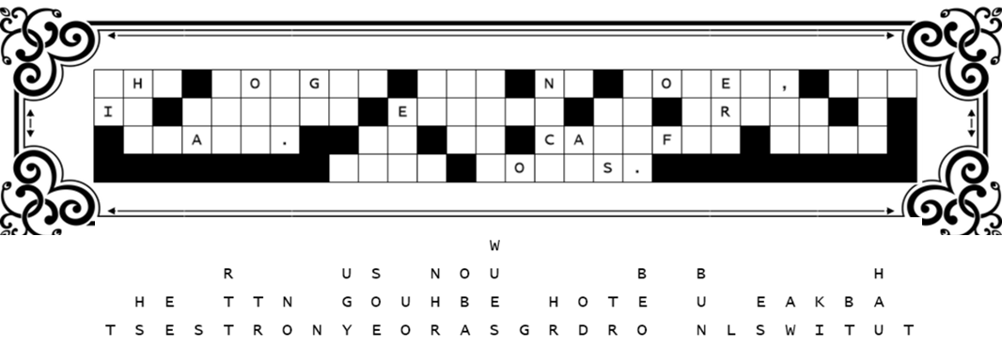
We have some wind damage here. We need you on the ladder to replace the letters. Luckily, they fell straight down. So, some columns will be easy, with only one or two missing letters. Go for the short words first and figure out which letters make words which make sense. Don’t let punctuation marks confuse you. Let your Bible Study leader know the proper message when you finish so he can go on with the upcoming lessons. If you get stuck, check at https://tinyurl.com/35nmdmac for help.

Fallen Phrases Puzzle

