1. Motivate

What do families and friends commonly fight about?
- money
A video introduction is available. View at https://watch.liberty.edu/media/t/1_74oqtwll . If you have no wi-fi where you teach, best to download to your computer from https://tinyurl.com/4x4nj7xb
- being offended by what the other person said
- not having your own way
- feeling slighted by being left out
- not living up to expectations
- constant nagging by parents/spouse
- young people’s choice of music or choice of friends
- who is Mom’s favorite
- barking dogs, loud music next door, rowdy kids

2. Transition

Today we look at James’ answer to this question … and his recommendations for the solution.
- You can stand triumphantly in Christ over sin, the world, and Satan.

3. Bible Study

3.1 Repent of Living in Conflict

Listen for causes of conflict.

James 4:1-3 (NIV) What causes fights and quarrels among you? Don't they come from your desires that battle within you? 2 You want something but don't get it. You kill and covet, but you cannot have what you want. You quarrel and fight. You do not have, because you do not ask God. 3 When you ask, you do not receive, because you ask with wrong motives, that you may spend what you get on your pleasures.

According to this passage what causes difficulty between people?
- from your inner desires
- you want something and don’t get it
- murderous attitudes
- coveting
- self-centeredness

What does James say how people react to not being able to get what they want?
- kill
- covet
- quarrel
- fight
- ask of God with wrong motives
- spend your resources on personal pleasures

What kinds of desires or cravings often lead us into conflict?
- desire for material goods
- we selfishly want our own way, never giving in to someone else’s preferences
- a desire to have the best team, no matter what the means
- we want to be the one in charge … to be the “boss”
- “No one’s going to tell me what to do”

What evidence can you give from history that wars and fights are caused by selfish ambitions?
- 1930’s Germany and its desire for expansion space, similar for Japan in SE Asia
- consider Israeli, Palestinian, Arab conflict
- how about the paparazzi trampling on privacy of famous people just to get a photo
- parents who fight over little league rivalries
- Consider the reality shows – they make a big deal about selfishness in participants
- not to mention World Federation of Wrestling!!! (an unreality show?)
- people who want to win at any cost

James says “you cannot have what you want . . . You do not have, because you do not ask God.” He is talking about things that
    - We want,
    - But cannot , do not have,
    - And could have if we prayed?

What could we be praying for that down deep we want?
- peace
- joy … actually the rest of the Fruit of the Spirit
- excitement in life
- loving friends
- satisfaction in our job
- happy families

Then he says that when we do pray, it’s wrong … how so?
- incorrect motives
- you just want to pamper your own self, to pad your own nest
- our prayers can be very selfish

We should realize that this too can be a source of conflict … our whole outlook on life and the purpose for which God is working in our lives
Our lives are meant to be lived to God’s glory … not our own pampering

3.2 Reject the World View – Hostility to God

Listen for what happens to friends of the world.

James 4:4-5 (NIV) You adulterous people, don't you know that friendship with the world is hatred toward God? Anyone who chooses to be a friend of the world becomes an enemy of God. 5 Or do you think Scripture says without reason that the spirit he caused to live in us envies intensely?

How might the term “adulterous people” be understood as a comment on people’s flawed relationship to God?
- we use the terms to refer to people who have abandoned their spouses and gone after other relationships
- they are unsatisfied with original relationships, pursue other relationships
- we sometimes treat God that way
- we think our relationship with God is not exciting enough, not satisfying enough
- we pursue other things, other activities … substitutes for God
- we end up with idols in our lives that are more important to us than knowing and serving the living God

What kinds of friendships with the world alienate us from God?
- desires for material things
- entertainment choices
- what we do for recreation
- priorities in how we spend our money and our time
- choice of who we pal around with
- agreeing with and aligning with a worldly attitude and philosophy

Where do you see evidence that the world is hostile to God?
- rejecting biblical Truth
- abandoning spiritual worship
- decline of church attendance
- political action against biblical teaching
- Bible teaching accused of hate speech

Consider the warped view of today’s culture, even among some believers.
- We too easily rationalize our behavior
- From West Side Story, “I’m depraved on a ‘count of I’m deprived!”
- “It’s not my fault” … “I have the gene for anger” … or “I was abused”
- This is my besetting sin – you need to adjust to me

3.3 Resist Your Enemy, Satan

Listen for how to walk humbly with God.

James 4:6-10 (NIV) But he gives us more grace. That is why Scripture says: "God opposes the proud but gives grace to the humble." 7 Submit yourselves, then, to God. Resist the devil, and he will flee from you. 8 Come near to God and he will come near to you. Wash your hands, you sinners, and purify your hearts, you double-minded. 9 Grieve, mourn and wail. Change your laughter to mourning and your joy to gloom. 10 Humble yourselves before the Lord, and he will lift you up.

Let’s list all the crucial elements, the imperatives James gives for overcoming conflict.
- resist the devil
- submit to God
- come near to God
- wash your hands
- purify your hearts
- grieve, mourn, wail, mourn for your sin … repentance
- humble yourselves

What promises are attached to these imperatives?
- the devil will flee
- God will come near to you
- God will lift you up

James mentions “double-mindedness” … how does that pull us away from God instead of drawing near to God?
- we have split loyalties
- sometimes we try to please God, other times try to please self
- shows that we think we know better than God how to handle a situation
- demonstrates that we are really only giving lip service to God’s authority over us
- we submit go God only when it is convenient
- either God is Lord of all … or … He is not Lord at all!

What are some ways in which we can resist the devil?
- obeying God
- draw near to God
- cleanse your hands
- purify your hearts
- joining forces with other resisters (instead of people who go along with Satan)
- remove yourself from situations where the devil’s temptations are strong
- be reading and applying God’s word (remember Jesus use of scripture when He was tempted)

Use the last page as a handout so your learners can take home the application points of this week’s lesson.

Application
Confess.
- If this passage has convicted you of self-centeredness, covetousness, or a worldly attitude, confess and repent.
- Use Psalm 51 as the structure for your prayer.

Retreat.
Spend half a day in prayer.
- Begin with confession and submission.
- Ask God to guide you in planning a course of action to avoid the temptation of materialism.
- Evaluate the effects of what you read or watch on encouraging a worldly mindset.

Clean house.
- Take inventory of what you possess that reflects a worldly mindset or was purchased from a heart of materialism.
- This may need to be done with a spouse or family member, but consider removing those things from your life.
- Sell them if necessary and give the money to support mission work through your church.
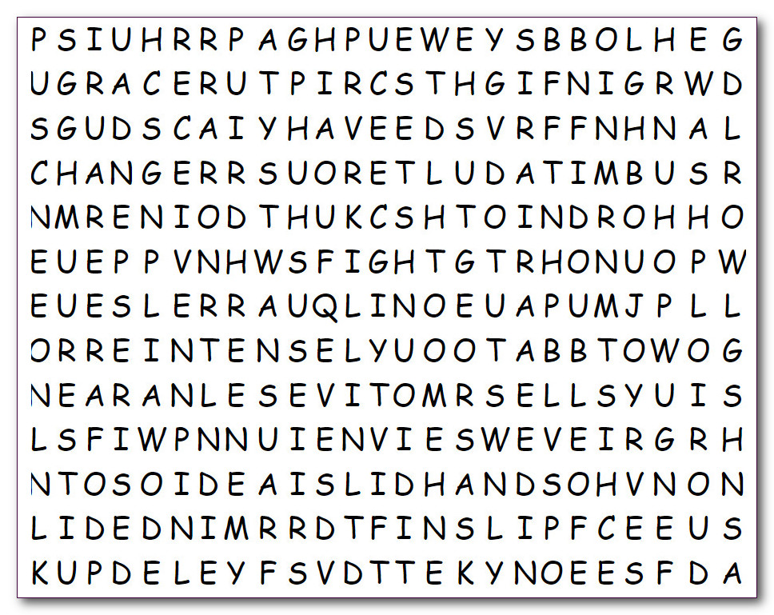
Word Search
KILL
LAUGHTER
LIFT
MINDED
MOTIVES
MOURN
MOURNING
NEAR
OPPOSES
PEOPLE
PLEASURES
PROUD
PURIFIY
QUARRELS
RECEIVE
RESIST
SCRIPTURE
SINNERS
SPEND
SPIRIT
SUBMIT
WAIL
WANT
WASH
WORLD
WRONG
ADULTEROUS
ASK
BATTLE
CHANGE
CHOOSES
COVET
DESIRES
DEVIL
DOUBLE
ENEMY
ENVIES
FIGHT
FIGHTS
FLEE
FRIENDSHIP
GIVES
GLOOM
GRACE
GRIEVE
HANDS
HATRED
HAVE
HEARTS
HUMBLE
INTENSELY
JOY
Don’t argue or quarrel, just find the words! Humph! They go up, down, right, left, and diagonal. If you wimp out, you can get help at https://tinyurl.com/4x4nj7xb Other Family Activities are also found there.

