1. Motivate

When have you seen someone undergo a complete transformation?
- after sickness, up and active
- got a good grade at school and very happy now
- after winning the game, happy and positive
- after having a good day fishing, no longer doubting his skills
- much happier after a good night’s sleep
- after morning coffee
- when a person find’s Christ as Savior
A video introduction to the lesson is available. View at https://watch.liberty.edu/media/t/1_817c0p5q If you have no wi-fi where you teach, best to download to your computer from https://tinyurl.com/mrx2u2ya
- after a fun or relaxing vacation

2. Transition

God wants to transform our lives.
- God’s desire is to conform us to the image of Christ.

3. Bible Study

3.1 Hearts Set on Things Above

What kinds of things can change your perspective on an issue?
- new glasses!
- hearing firsthand description of someone else’s experience
- “Walk a mile in someone else’s shoes”
- a good night’s sleep or time away (as in a vacation)

Listen for why to have a new perspective.

Colossians 3:1-4 (NIV) Since, then, you have been raised with Christ, set your hearts on things above, where Christ is seated at the right hand of God. 2 Set your minds on things above, not on earthly things. 3 For you died, and your life is now hidden with Christ in God. 4 When Christ, who is your life, appears, then you also will appear with him in glory.

What are Christians to desire (seek)?
- set your hearts on things above
- your focus is on Christ and His rule in your life
- set your minds on things above
- your thoughts and your emotions are focused on knowing Jesus better and serving Him more faithfully

What is the significance of Christ being at the right hand of God?
- Jesus is in a place of power and authority
- He can plead our cause before the Father
- as we surrender to His authority in our lives He will guide and direct our thoughts and actions

What are these “things above” that we should set our minds on?
- knowing God’s Truth
- reading and heeding God’s words to us
- attributes of God which the Holy Spirit reproduces in our lives
- knowing what God wants us to be
- knowing the power and authority of God – learning to depend on that power
- the assurance of God’s love for us

Paul said in verse 3 “you died,” your “old self” is dead. That is true, but its influence is still often felt.
- It is part of our physical, emotional make up
- As long as we are still physically alive, these desires still exist
- Experientially, we still live with a sinful nature
- Positionally, we stand before God as “new creations” – forgiven, justified, righteous
- God promises freedom from both the penalty and the power of sin in our lives
- Only when we get to heaven will we be free from the presence of sin

What evidence would cause people to say someone is more focused on things above and not on what’s here on earth?
- how you spend your time – ministry, worship, investing in family
- how you spend your money – spending under control, faithful in tithing and giving beyond
- unsolicited words and actions of kindness to others
- joy and peace predominate one’s life … not anger or grumpiness

How did God change your perspective, your focus after you became a Christian?
- gave up pursuits and interests from BC (Before Christ)
- changed friends
- got rid of some bad habits
- was kinder to spouse, to kids
- changed vocabulary
- attitude towards, treatment of the opposite sex
- Saved as a teenager
- Saved as an adult
- Saved as a young child

3.2 Earthly Nature Put to Death

Listen for what to remove from your life.

Colossians 3:5-9 (NIV) Put to death, therefore, whatever belongs to your earthly nature: sexual immorality, impurity, lust, evil desires and greed, which is idolatry. 6 Because of these, the wrath of God is coming. 7 You used to walk in these ways, in the life you once lived. 8 But now you must rid yourselves of all such things as these: anger, rage, malice, slander, and filthy language from your lips. 9 Do not lie to each other, since you have taken off your old self with its practices

List the things which the believer is to put off, put to death?

- whatever belongs to earthly nature
- sexual immorality, impurity, lust
- evil desires
- greed (which is idolatry)
- anger, rage, malice
- slander
- filthy language
- lying

Why do you think Paul equated greed with idolatry?
- idols are something or someone which become more important to you than God
- the greedy person is always wanting more and more of something … to the point of becoming a consuming attitude
- the “stuff” we pursue greedily becomes an idol

How/why do we sometimes justify holding on to aspects of our earthly nature?
- it’s my “besetting sin”
- I’m stuck with it
- it doesn’t hurt anyone
- if no one knows about, it’s not hurting anyone (BUT … it’s hurting you)

How do you “put to death” things like lust or greed?
- it becomes a spiritual exercise
- you must confess it to God … agree with Him that your attitudes and actions are sinful
- repent of these things … declare that you are giving them up, you are turning around and heading your life in the opposite direction
- depend on God’s strength to leave those things behind
- both here and in Romans 6 Paul says since your old nature died with Christ, those practices and attitudes died also
- you must reckon or consider them to be, sure enough, dead
- a dead person does not respond to temptations

3.3 Cultivate Godly Character

Listen for how to clothe ourselves .

Colossians 3:10-14 (NIV) and have put on the new self, which is being renewed in knowledge in the image of its Creator. 11 Here there is no Greek or Jew, circumcised or uncircumcised, barbarian, Scythian, slave or free, but Christ is all, and is in all. 12 Therefore, as God's chosen people, holy and dearly loved, clothe yourselves with compassion, kindness, humility, gentleness and patience. 13 Bear with each other and forgive whatever grievances you may have against one another. Forgive as the Lord forgave you. 14 And over all these virtues put on love, which binds them all together in perfect unity.

What instructions do we see in verse 10?
- we are to “put on” the new self
- become renewed in knowledge of God
- become re-created in the image of the Creator

Paul says to “put on” the new self … why would just “putting off” the old self not be enough?
- we might refer to the results as a “power vacuum”
- someone or something must be in charge of our lives
- just getting rid of wrong influences is not enough
- those “authorities” in our lives must be replaced by Christ as the only authority

With what qualities of life should we clothe ourselves, according to this passage?
- compassion
- kindness
Note the similarity of this list with the Fruit of the Spirit found in Gal. 5:22
- humility
- gentleness
- patience
- bear with, forgive each other
- love

If these are, indeed, fruit of the Spirit, how do we “put them on” when they are qualities that are produced by God’s Holy Spirit? What is the Holy Spirit’s role? What is my role?
Use the last page as a handout so your learners can take home the application points of this week’s lesson.
The Spirit’s Role | The Believer’s Role
- make me aware of choices/options of behavior  - make me sensitive to what should be done  - work to convict/convince me of the right choice  - prompt me in the right direction  - empower me to do the right thing | - daily submission to the Lord  - daily communication with God  - spending time with Him  - worship Him  - trust in God’s power to enable me do the right thing
Application
Put away.
- Review the list of sins in this passage that you are called to remove.
- Identify any you still need to eliminate, confess those sins to God, and choose to follow Him in obedience.

Put on.
- Review the list of traits in this passage that you are called to put on.
- Identify specific ways you can exhibit these qualities to specific individuals.
- Ask God to empower you to live these traits out for His glory.

Reflect and share.
- Meditate on the fact that you are chosen, holy, and dearly loved.
- Write a paragraph describing how these three truths ought to influence how you live.
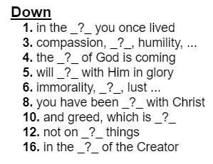
- Share it with someone this week.
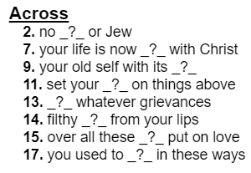
Crossword Puzzle
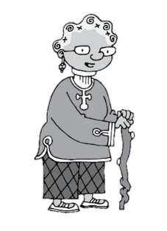
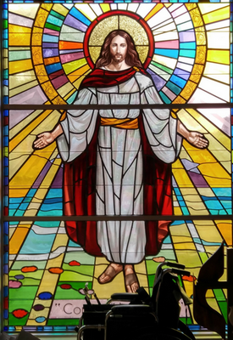
Remember, the words and clues come from Colossians
3:1 – 14 (NIV). Help and other Family Activities are at https://tinyurl.com/mrx2u2ya

