1. Motivate
A video introduction is available view at https://watch.liberty.edu/media/t/1_husklhxw If you have no Wi-Fi where you teach, best to download to your computer from https://tinyurl.com/87fur6xb

When have you seen best-laid plans fall apart?
- vacation got rained on the whole week
- conference was a bust, poor speakers
- the day of the big party, the swimming pool turned green
- night of the fireworks, I fell and injured both knees – 13 days in hospital
- new car got a scratch on the fender after 10 days
- pedal crank shaft broke on new bicycle, stranded miles from home
- flat tire at beginning of a road trip
- wedding cake collapsed right when they started to cut it
- groomsman/bridesmaid fainted right in middle of ceremony
- minister didn’t show up for wedding, had written the wrong day and in his schedule
- trick football play fell apart when they got an illegal procedure penalty

2. Transition

In the real world not everything happens like we hope and plan for.
- Today we learn that God’s plans do work out in His time and His way.
- Trust God when we don’t have all the answers.

3. Bible Study

3.1 Trust when the Way Isn’t Clear

Listen for encouragement given.

Genesis 15:1-5 (NIV) After this, the word of the LORD came to Abram in a vision: "Do not be afraid, Abram. I am your shield, your very great reward." 2 But Abram said, "O Sovereign LORD, what can you give me since I remain childless and the one who will inherit my estate is Eliezer of Damascus?" 3 And Abram said, "You have given me no children; so a servant in my household will be my heir." 4 Then the word of the LORD came to him: "This man will not be your heir, but a son coming from your own body will be your heir." 5 He took him outside and said, "Look up at the heavens and count the stars--if indeed you can count them." Then he said to him, "So shall your offspring be."

What promises did God make, and to whom did He make them?
- he would have a son to be his heir
- they would have many offspring
- they would be uncountable – like the stars in the skies

What do you know about Abram and his wife that would have made it difficult to believe what God was telling him?
- they were elderly
- Sarai was past childbearing age
- they had not been able to have children for the whole time of their marriage
- they were well past the “people are talking” stage

How do we determine the difference between worry and legitimate concern?
Worry | Legitimate Concern
- keeps you awake at night  - it’s all you can think about  - you try to think of all the possible solutions  - you imagine all the bad consequences of the problem and play them over and over in your mind | - aware of the potential problem  - take what steps you can to prevent it  - take care in planning  - trust God to take care of protection, prevention, provision

God took Abram out to view the night sky as an object lesson to encourage him to trust God. What kind of images help or encourage you to trust God?
- similar view of the vastness of the universe
- the intricacy of the creation in size … both large and small … at extreme orders of magnitude
- the design of beautiful flowers
- the events of the past … how God has provided, personally ministered to our family
- the way God has worked in history – even just biblical history
- God’s promises He has kept

Notice that God did not give much detail of His plan and promise to Abram and Sarai. How can we obey without knowing much of the plan?
- must leave the plan to God
- we don’t need to know details
- the details could well be overwhelming, better that we don’t know
- some of the details are outside the realm of our control
- better to see the details as they occur and marvel at God’s actions

We infer that God spoke directly, audibly to Abram. How do Gods intentions and plans come to us today?
- principles and commandments through God’s Word
- guidance of our choices as we submit to the God’s Spirit within our lives
- God opens and closes “doors” of opportunity
- we receive counsel from wise and godly believers

Why can we trust God even if His method of communicating is not as overt as to Abram?
- God is still God
- He loves us and will make sure we have His direction
- He wants us to know His will more than we want to know it … He will be sure that we know and understand what He has for us

3.2 Trusting God Results in Righteousness

Listen for the result of trusting God.

Genesis 15:6 (NIV) Abram believed the LORD, and he credited it to him as righteousness.

What did Abram do that pleased God so much?
- he believed God
- he believed what God said, what God told him
- he set aside his doubts and questions
- it was not a collection of good deeds done

We are told that Abram believed God and God credited to him as righteousness. How does that relate to believers today?
- Abram was not necessarily righteous (we see various examples throughout his life)
- yet He believed God
- we also are sinners … we are made righteous in the same way
- we believe what God tells us – (our sinful condition, God’s provision in the death and resurrection of Jesus)
- when we receive by faith what God says and how it applies to us personally, God counts that as righteousness to us

In addition to our salvation, what truths about God or from God should we be trusting in?
- attributes of God – omnipotence, omniscience, omnipresence, love, wisdom, sovereignty, …
- all the promises of God
- presence of God’s Holy Spirit dwelling within us as believers
- we are rescued from not only the penalty of sin, but also the power of sin
- the imminent return of Jesus

What obstacles get in the way of believing God? Why is it sometimes hard to trust God?
- the events and circumstances appear in conflict with God’s promises
- God’s timing … we are impatient
- what God promises seems impossible to us we get discouraged
- we listen to the wrong “voices”
- many people in the world just don’t have knowledge of the Gospel message so they can believe
- the obstacles we face seem so great, we think even God cannot conquer them
- our perception of God is too small
- Satan fools us, blinds us to the Truth
- in some situations, we know that if we trust God, we will need to also obey Him and we don’t want to

3.3 Trust God to Work in His Time

Listen for long term promises.

Genesis 15:12-16 (NIV) As the sun was setting, Abram fell into a deep sleep, and a thick and dreadful darkness came over him. 13 Then the LORD said to him, "Know for certain that your descendants will be strangers in a country not their own, and they will be enslaved and mistreated four hundred years. 14 But I will punish the nation they serve as slaves, and afterward they will come out with great possessions. 15 You, however, will go to your fathers in peace and be buried at a good old age. 16 In the fourth generation your descendants will come back here, for the sin of the Amorites has not yet reached its full measure."

To what future events did the Lord allude in assuring Abram that one day the promise of the inheritance of the land would be fulfilled?
- his descendants would be strangers in a country not their own
- they would end up enslaved and mistreated, this would be some 400 years
- God’s punishment of the country
- their release, escape
- they would acquire great possessions as they leave

What are some things that help us build trust in God?
- reading God’s Word, God’s Truth, studying and meditating on attributes of God
- worshiping as a group, as an individual
- recalling God’s answers to prayer, God’s meeting of needs
- looking back and remembering how God guided and protected

What makes it so hard to wait for God’s timing?
- we are stuck in time
- we cannot make it speed up or slow down
- as we wait, we see all the situations that seem to deny God’s ability to deal with the problems
- we are impatient

When have you experienced the reliability of God’s timing?
- providing a job, providing the right place to live
- God opening doors for opportunities that seemed impossible
- God guided children in their choices of colleges, friends, eventual spouses
- God sometimes shuts doors of opportunities and keeps us from bad situations, accidents, catastrophic failures

How has the Lord communicated to you to reassure you that His plan and promises are best and trustworthy?
- read a verse that jumped out at me
- heard a sermon that spoke to the issue … seemed like the preacher was talking directly at me
- a Bible study that dealt with the issue
- heard a podcast that described the problem I was struggling with
- God sent someone to speak to me, spoke directly to the issue of my concern
Use the last page as a handout so your learners can take home the application points of this week’s lesson.
Application
Look at your hands.
- Uncertainty has the ability to make us act irrationally and take matters into our hands.
- Take some time and evaluate where you might need to let go and place something back into the hands of God.

Look at the stars.
- Uncertainty can make us forgetful.
- Before the day is over go outside if possible and look up in the sky.
- Be reminded of the many promises of God that you may have forgotten over time.

Look at your faith.
- Uncertainty in our faith affects the way we respond to uncertainty in life.
- Take some time and assess the foundation of your faith.
- Then share your faith with someone else.

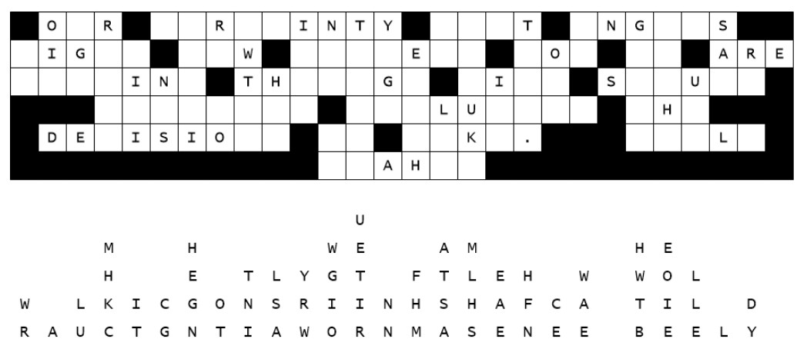Fallen Phrases Puzzle
This tragedy just in from local sources. Half the letters on the church sign fell down … straight down. The youth pastor needs your help to put them back in the right place. This is not the first time it has happened, and he tells us that you should start out with single letters in columns, then look for two and three letter words and figure out which letters make reasonable words. If you’re stuck, go to https://tinyurl.com/87fur6xb . Sources report more fun occurring there.

