Welcome to Starfish®
Starfish gives you a convenient way to keep track of your students – raising flags when you observe a pattern of behavior that concerns you, ensuring that the people on campus who can intervene are aware. It also allows your students to easily book an appointment with you or someone else who can help.
Getting started is easy. Accessible through your existing systems (often your Learning Management or Student Information system), Starfish will automatically display all students that you have been assigned or are enrolled in your courses.

There are two primary locations where you can find a Starfish login link. These include Canvas and the LETU Starfish web page. When logged in to Canvas and within your class’s profile, in the left-hand side column, you should be able to see a Starfish link. Direct links to Starfish and the LETU Starfish Web Page are also included below:
Starfish: https://letu.starfishsolutions.com/starfish-ops
LETU Starfish Web Page: https://www.letu.edu/online-and-graduate-students/starfish.html

From there, you can raise flags about students, review flags that have been raised about your students, and provide additional information.

This guide highlights the steps for completing four common tasks in Starfish:
Setup your Profile 2
Setup your first Office Hours block 4
Respond to a Progress Survey for your Students 5
Raise a Flag on one of your Students 6
Frequently Asked Questions 8
How do I change how I am emailed by Starfish? 8
How do I get more detail on a student? 8
How do I cancel office hours? 8
What if I need more help? 9

Setup your Profile

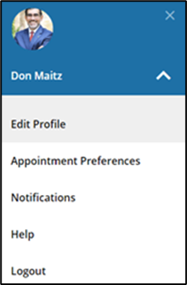
Some of your profile, such as your contact information, is imported from your LMS or SIS.
- Click on your name in the Top Navigation bar and select the Edit Profile tab.

- Help students put a face to your name by using the Upload Photo link beneath your existing photo or placeholder to upload a photo.
Browse to a photo file (.jpg, .png, or .gif), and then click the Upload Now button to update your photo.
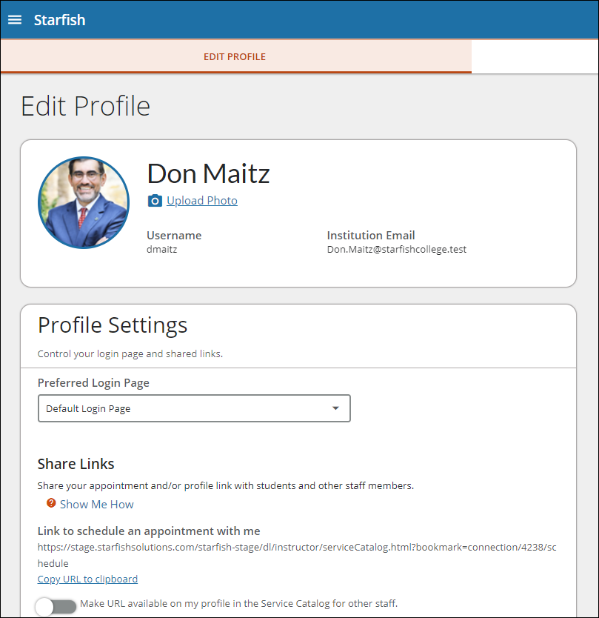
- Select the Preferred Login Page from the dropdown.
- Toggle the Share Links option(s) if you would like to share your appointment and/or profile link with students and staff.
- View and update your Contact Information.
- Double check that the Time zone selected matches your time zone. This time zone will be used when including appointment times in emails from Starfish.

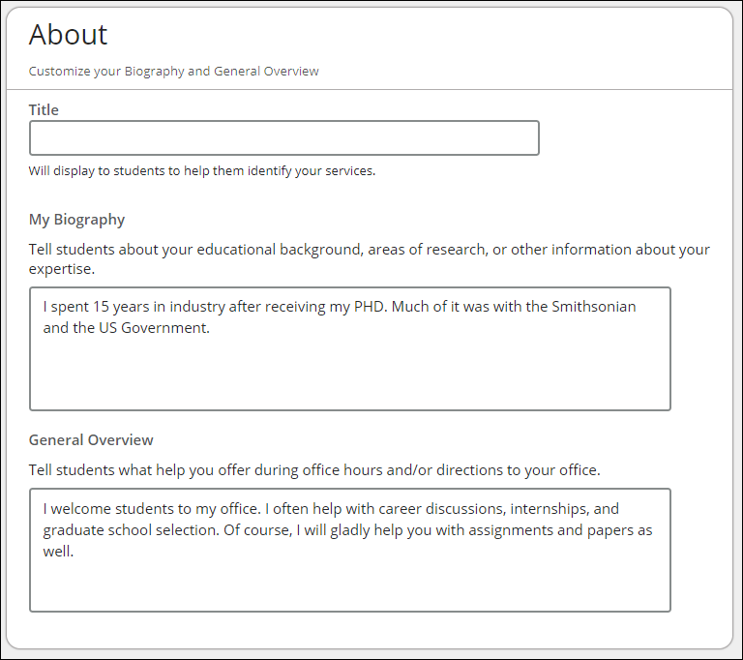
- Add information to the About section to let students know a bit more about you.
This information displays to students who can make appointments with you in Starfish.
- Click the Submit button to save your changes.

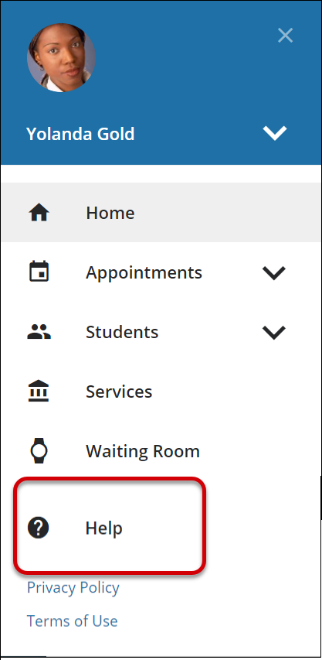
Notes: For more information and additional profile settings, reference the Starfish Help Center.

Setup your first Office Hours block
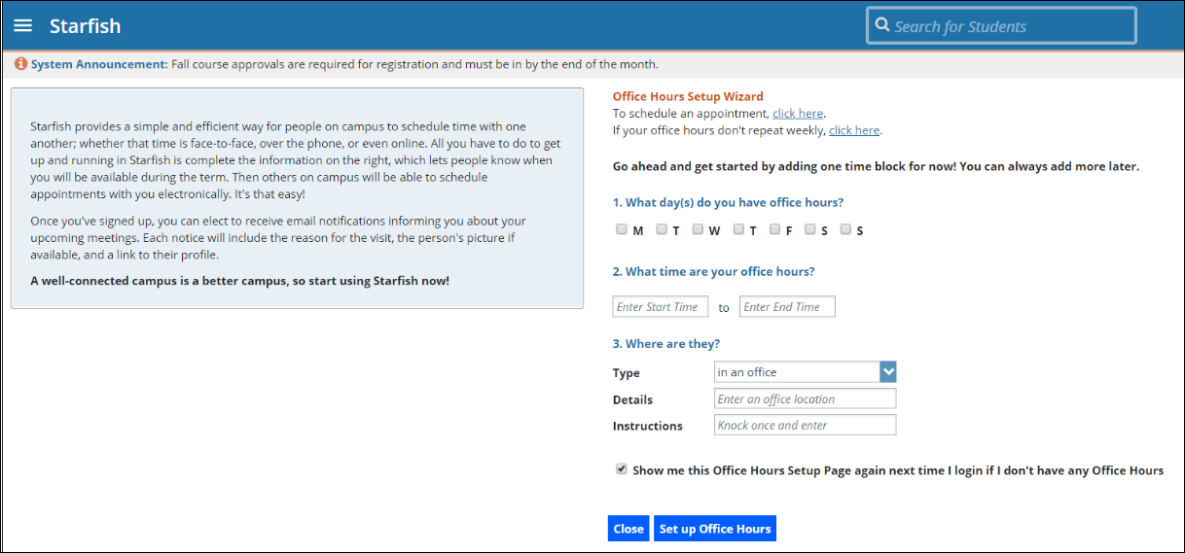
The first time you log in to Starfish, Starfish will provide a ‘wizard’ to walk you through setting up your office hours, which enables students to schedule time with you. If you do not wish to complete the wizard just yet, check the box labeled “Show me this Office Hours Setup Page again next time I login if I don’t have any Office Hours”, and then click the Close button.
If your office hours are different week to week, follow the “If your office hours don’t repeat weekly, click here” link.
If your office hours recur:
- Complete the fields presented to specify:
- What day(s) do you have office hours? - check the boxes for each day.
- What time are your office hours? - enter a start and end time.
- Where are they? - select the Type of setting and enter the Details in the field provided (e.g. the building and room number of your office). If relevant, provide Instructions for students who make appointments with you.
- Click the Set up Office Hours button to save your office hours.
Notes:
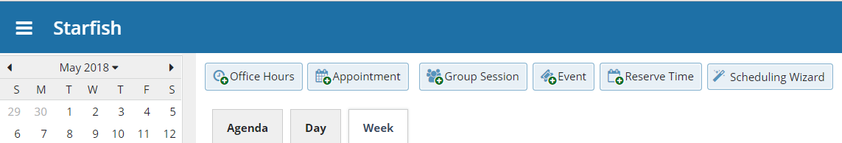
To setup additional office hours or make any changes, use the buttons on your Home or Appointments page to Add Office Hours, Add Appointment, Add Group Session, Event, Reserve Time or use the Scheduling Wizard.

Respond to a Progress Survey for your Students

You will receive an email reminder when there is a new survey for you to complete. Each individual survey presents a student roster for one course section on whom you can raise flags.
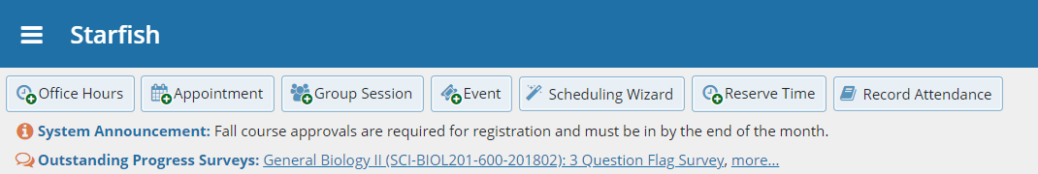
- Select the progress survey link on your Starfish Home page to go the Progress Surveys tab. (only visible when you have active surveys).
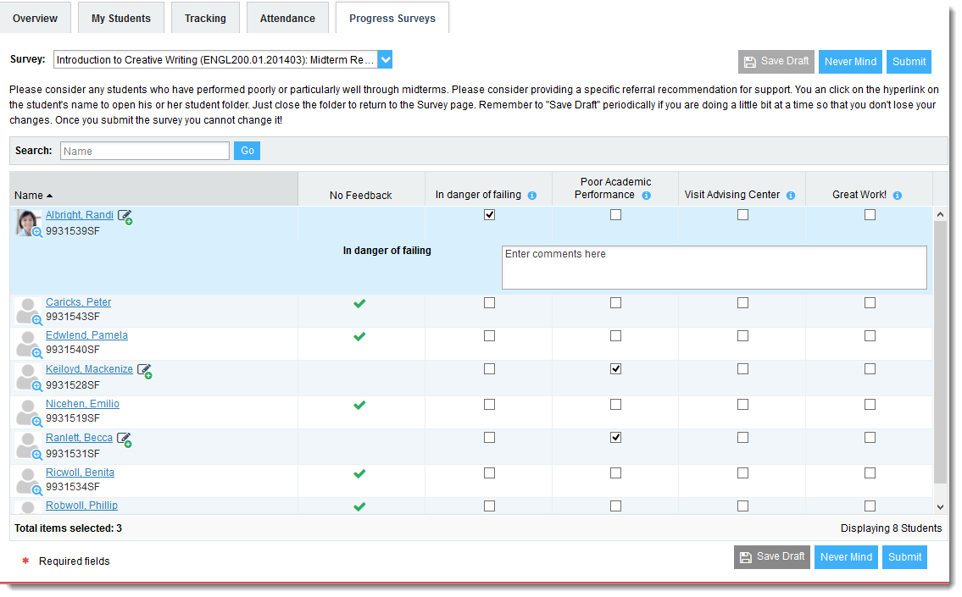
The selected survey opens, listing your students on the left, and items you may raise across the top.

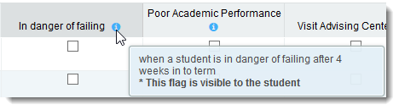
- Check the box for each desired item/ student combination.
Click the comments icon () to open a text box for your notes.
Click the information icon () associated with an item to verify whether the student can view the flag and related comments.
- Click the Submit button only when you are finished providing feedback. The items you selected will be raised on your students when you submit the survey.
Important
Once you have submitted the survey you will not have an opportunity to add to or undo the items you raised. Use the Save Draft option if you are not ready to submit your survey.

Notes:
You may be asked to submit more than one course survey if more than one of your courses has been included in the survey plan for your institution. They will be listed in the drop-down menu on the Progress Surveys tab.

Raise a Flag on one of your Students
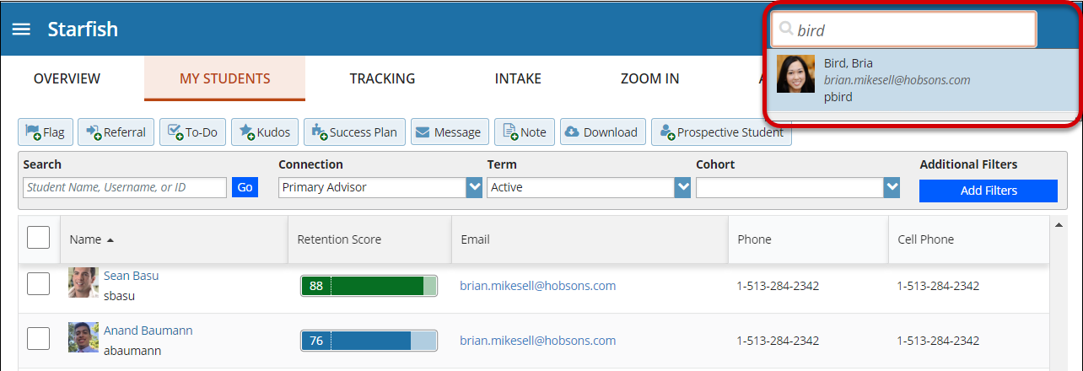
When you have a concern with a student, raise a flag, to-do, or referral to communicate your observations. The appropriate individuals will be automatically notified when you save the item.

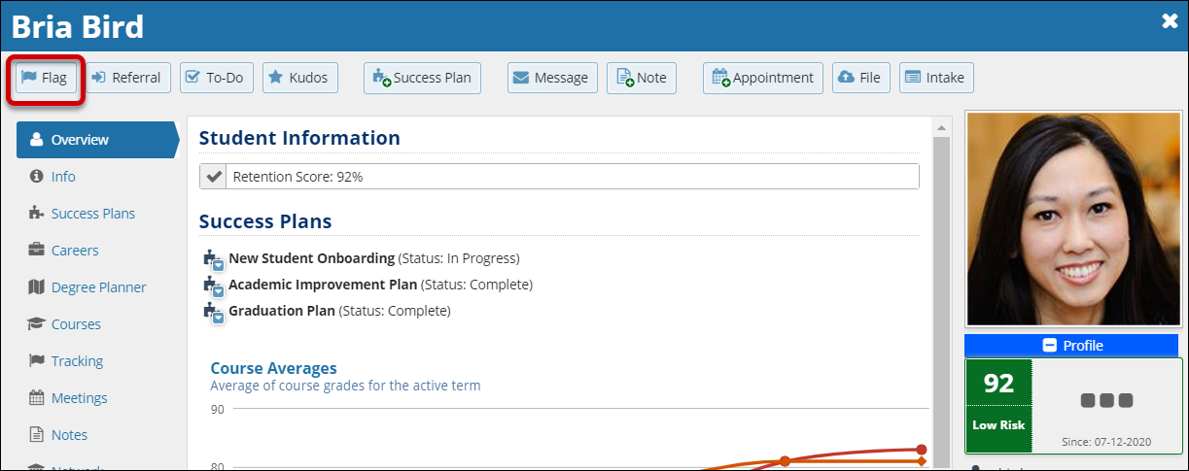
- Click on the Students navigation item to see your list of students.
- Find the desired student by typing the name into the Search box.
- Click on the student’s name to bring up the Student Folder.
- Click the Flag button.
A list of flags that you have permission to raise on this student is displayed.
- Select the desired Flag from the list.
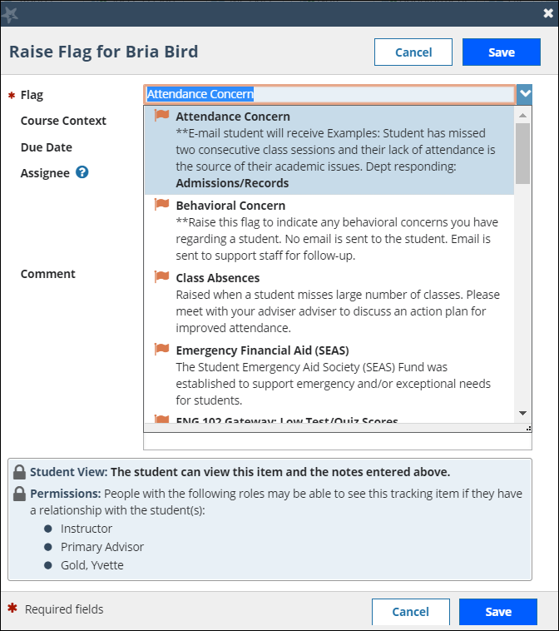
- If relevant, select a course from the Course Context, drop down list, and enter notes in the Comment box.
- Click the Save button.
Notes:
The Student View: indicates whether the student can view the flag and the notes you include in the Comment box.
The Permissions area lists roles that have permission to view the selected flag and the notes you include in the Comment box.

Frequently Asked Questions

How do I change how I am emailed by Starfish?
Starfish will email you a calendar item for each appointment and a summary of flag activity for your students. Use the Notifications tab of your Profile to modify details of how and when you receive these notifications

How do I get more detail on a student?
Click the hyperlink associated with the student’s name wherever you find it to reach the Student Folder. (e.g. in the student list, on an appointment, or in a progress survey).

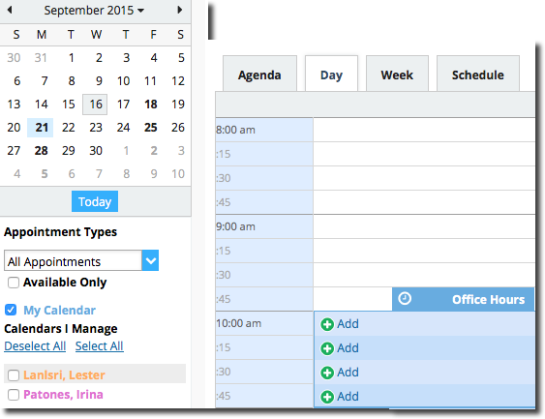
How do I cancel office hours?

Cancel one occurrence
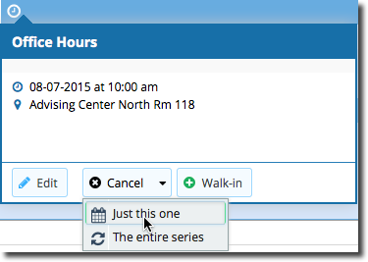
Select the day from the calendar, and hover (don’t click) over the icon associated with the Office Hours on the desired day().
Click the Cancel button and select, “Just this one” from the pop up Office Hours card presented.

Cancel a series
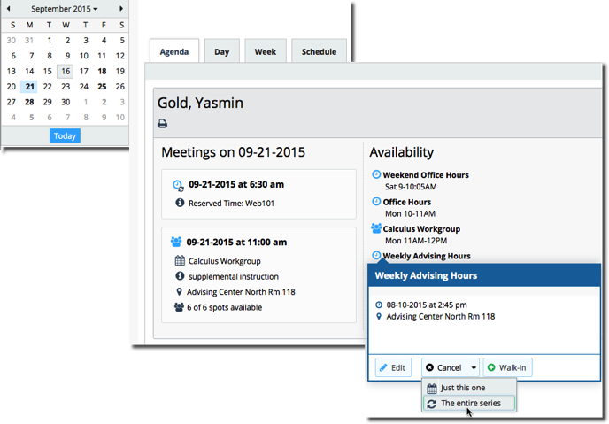
From the Agenda view, hover (don’t click) over the Office Hours icon () next to an office hour title.
Select Cancel from the pop up Office Hours card presented. (If the day you have selected on the calendar includes an occurrence, you will have the option to cancel “Just this one” or “The entire series”)

What if I need more help?
For technical issues, contact the IT Service Desk at (903) 233-3500. For all other questions, please email Starfish@letu.edu.

