Information on how to use the Aspects of Wheelchair Mobility Tests (AWMT)

The AWMT is a way to compare the mobility facilitated by two or more types of wheelchairs, or wheelchair modifications. Each participant does this exercise in two or more types or configurations. For each track in each wheelchair, distance traveled in four minutes is recorded, and the participant answers a question. The AWMT can be used for wheelchair users who can manually self-propel or for assistants pushing manual wheelchairs.

Track set up – any one of the tracks below may be used alone, or all may be used to get a more complete idea of comparative mobility. These four types of tracks were chosen because aspects of wheelchair design impact mobility differently for each of the rolling environments. For example, wheelchairs that roll easily on smooth surfaces may not do so on rough surfaces. See track drawings in figure 1.
- To set up a smooth surface track. On a smooth indoor surface, measure a track in a hallway or around the perimeter of a large room. The track should be between 15 and 50 meters of length. Place cones or a marker at the turning points of the track. Measure the track by measuring around the cones at a distance a wheelchair can turn without bumping a cone. The starting point is beside a cone.
- To set up a tight spaces track. On a smooth indoor surface, place four chairs 1 meter apart and 1 meter from a wall. The track is a “figure eight” around the middle two chairs. Put tape on the floor to mark the location of the chairs and to mark the starting point between the middle two chairs. Measure the track by traveling in a figure eight around the middle two chairs beginning from the starting point between the two chairs.
- To set up a rough surface track. Look for an outdoor surface like surfaces encountered by local wheelchair users in daily life. Set up the track there. The track should be between 15 and 50 meters of length. Put cones or marker at each turning point. Measure the track by measuring around the cones at a distance a wheelchair can turn without bumping a cone. The starting point is beside a cone. For a more controlled and describable surface, consider using Modular Rough Surface Units, as described at www.letu.edu/wheels
- To set up the curb track. If a low curb, 7 to 9 cm tall can be found, this track can be a loop that traverses the curb. Put cones or markers 2 meters from the curb so that a subject will ascend and descend the curb during each circle. Measure the track by measuring around the cones at a distance a wheelchair can turn without bumping a cone. The starting point is beside a cone. For a more controlled and describable curb track, consider building a 7cm tall “curb” with a thick plywood surface. The surface should be 1.5 meters square. With this constructed curb, the track can ascend and descend the curb twice in each loop.

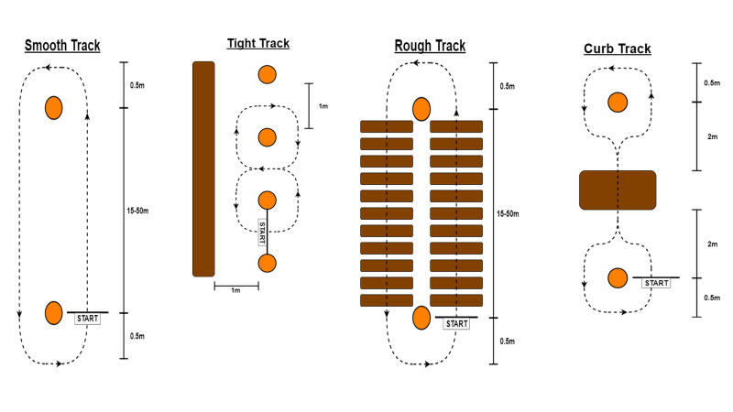
Figure 1. Suggested track configurations.

Equipment needed
- Participant response question for each track used.
- Stop watch or timer to time four minutes accurately.
- Survey wheel or long measuring tape to measure the distance traveled accurately.
Before beginning
- Confirm that each track you will be using is set up correctly.
- Measure the distance around one lap of each track.
- Confirm wheelchairs to be used are in good repair and tires are correctly inflated.
Participant characteristics
- Participants should not be ill or injured.
- Participants should not have eaten heavily within 2 hours – a light meal is acceptable.
- Participants should not have exercised vigorously within 2 hours.
- Participants should have the health, size, diagnosis, skills and characteristics to travel for four minutes over the tracks being used with the wheelchairs being compared.
Data collection instructions (points 4 and 5 below are influenced by directions for the timed walk test)
- The participant should sit quietly for five minutes. During this time explain the purpose of the test and describe what they will be doing.
- If you are going to use more than one track, take the participant's non-exercise pulse when they have been sitting quietly for five minutes. Before you start each track, take the participant’s pulse again. Do not have them begin any track until their heartrate has returned to within 5 beats/min of their original non-exercise heartrate.
- Stand out of the participant’s way, and near the starting line during the test. Do not walk with the subject.
- Say to the participant: “I am going to show you the track you’ll be following. Please watch carefully.” Demonstrate by walking one lap yourself. “The goal of this test is to see how far you roll forward in four minutes while traveling at a comfortable speed. You may slow down or stop to rest as necessary. You should turn around the markers and continue without hesitation. I am going to keep track of the number of laps you complete. Remember that the goal is to roll for four minutes going AS FAR AS COMFORTABLY POSSIBLE in 4 minutes. Are you ready to do this? (Wait and listen for confirmation). Say, “Start whenever you are ready.” As soon as the participant starts to roll forward, start the timer.
- Do not talk to anyone while the participant is rolling. Watch the participant. Do not get distracted and lose count of the laps. Each time the participant returns to the starting line, let the participant see you recording that lap. Exaggerate using body language. Use an even tone of voice when using the standard phrases of encouragement. After the first minute, tell the participant, “You are doing well. You have 3 minutes to go.” When the timer shows 2 minutes remaining, tell participant, “You are doing well. You are halfway done.” When the timer shows only 1 minute remaining, tell the participant, “You are doing well. You have only 1 minute to go.” Do not use other words of encouragement (or body language) that would suggest the participant should speed up. When the timer is 15 seconds from completion, say this: “In a moment I’m going to tell you to stop. When I do, just stop right where you are and I will come to you.” When the four minutes is up, say this: “Stop!” Walk over to the subject. Mark the spot under the rear axle of the wheelchair where they stopped by placing a small marker on the floor or ground. If the participant stops to rest during a test, say, “continue whenever you feel able.” Do not stop the timer. If the participant stops before the 4 minutes are up and does not wish to continue, stop the test. Note the time at which the test was stopped, and record the distance traveled. Record the reason they stopped prematurely.
- Measure the number of meters in the final partial lap. Add the distance traveled in the completed laps to the distance traveled in the final partial lap, and record the total distance traveled.
- As soon as you have finished measuring distance traveled in four minutes, read the instructions for the response question aloud. Read the question aloud and have the participant complete the response question for that test. Ask them to provide a comment.
- To obtain a numerical score from a visual analogue scale question, measure the distance in centimeters from the left hand side of the line to the vertical mark the participant has made. The nearest grade to the participant’s mark gives one an idea of what the rating meant to the participant.

Tips for using the Aspects of Wheelchair Mobility Tests in a comparative study with multiple participants

If you are doing a comparative study with multiple participants, based on variability we have seen in several studies, ideally you should have 30 or more participants.

If you are using more than one track type, it is important that the order of tracks and wheelchairs is not always the same. Wheelchair and track tests should be done in a pattern that ensures that each is done first or last at about the same frequency. When all four tracks are being used, tests for different types of wheelchairs should be done on different days so as not to tire the participants.
Immediately before data collection:
- Confirm that you know the order in which you should use wheelchairs
- Confirm that you know the order in which you should complete tracks
- Confirm participant consent (children provide assent and their guardians provide consent)

Data analysis: Several characteristics of the AWMT are designed to increase discriminatory validity, or the ability to discern meaningful differences accurately.
- The AWMT is designed to produce data suitable for sensitive parametric statistical analysis tools. The first step of analysis is to confirm that this is indeed the case.
- It is a within-subjects protocol, meaning it is designed to compare a person only to themselves. This type of study reduces the blurring impact of individual variation.
- It is a mixed-methods protocol. It collects numerical data from distance traveled and the visual analogue question response scores. It also collects qualitative data from the comments that can shed light on the reasons for the score.
- Quantitative data can be entered to a statistical analysis program and checked for suitability for analysis of variance (ANOVA). Multifactor within-subjects ANOVA can then be done to see if the different wheelchairs or configurations are significantly different, or respond significantly differently to different tracks. Qualitative comments can be used to shed light on the reasons behind statistical differences by using conventional qualitative analysis: comments are sorted into categories and counted by the times each comment category occurs for each wheelchair type.

