1. Motivate

Here are some surprising facts that are really true
- Snakes can predict earthquakes.
- Lego mini figures have the largest population on earth (more than China).
- Astronauts grow taller in space.
- There’s a 50% chance that two people will share a birthday in a group of 23 people.
- Sea lions are the only animals that can clap to a beat.
- Glass balls bounce higher than rubber balls.
- It snows metal on Venus.

2. Transition

These are interesting, but somewhat inconsequential to our daily lives.
- Truths about God are much more important.
- Knowing the Truth of Christ is the only way we can experience freedom.
A video introduction to the Bible Study is available. View at https://watch.liberty.edu/media/t/1_vgajx2dt . If you have no wi-fi where you teach, it is best to download the file to your computer from https://tinyurl.com/murbsuhv
3. Bible Study

3.1 The Light of Jesus

Listen for facts about light.

John 3:19-21 (NIV) This is the verdict: Light has come into the world, but men loved darkness instead of light because their deeds were evil. 20 Everyone who does evil hates the light, and will not come into the light for fear that his deeds will be exposed. 21 But whoever lives by the truth comes into the light, so that it may be seen plainly that what he has done has been done through God."

What words and phrases characterize the works of those who love and live in darkness?
- men love darkness instead of light
- their deeds are evil
- hate the light
- don’t want their evil deeds exposed

Now, what words and phrases characterize those who live by Truth?
- come into the light
- their lives can be seen plainly
- obvious that they have trusted and obeyed God

What do we mean when we use the word “darkness” in this way?
- rejection of God and His Truth
- attitude and actions are evil
- disobedience of God’s commands
- live for self
So, what then is the contrasting meaning of “light”?
- God’s commands
- the Truth of the Gospel message
- the reality that we can be forgiven of our sinfulness
- the Truth that we can be set free from slavery to sin

Why do some people love darkness rather than light?
- hides their evil deeds
- reject the Truth about their own sinful condition
- reject the whole idea about God and what He communicates to us
- they think no one (like God) sees what they do
- feel they can get away with whatever actions they want to
- evil attitudes and actions don’t really matter

How does the loss of truth in our culture produce more darkness?
- rejection of idea of a God who might hold us responsible for our deeds
- if there is no God who is just and righteous, then it doesn’t matter what I do
- then one’s motivation is to advance self
- they advocate this attitude, publish it, advancing their cause
- Examples
  - growth of the drug culture
  - culture’s current push towards gender confusion
  - growth of pornography
  - materialism becoming an idol

What is the attitude of those who love and live the Truth and the light manifested in Christ?
- want more of God’s Light and Truth
- seek to keep our live exposed to that Truth
- receive and apply God’s Truth to our lives
- stay out of the darkness that avoids God’s Truth

3.2 Set Free to Live

Listen for another famous verse.

John 8:31-32 (NIV) To the Jews who had believed him, Jesus said, "If you hold to my teaching, you are really my disciples. 32 Then you will know the truth, and the truth will set you free."

What did Jesus say to the Jews who had believed in Him?
- if you hold to my teaching
- then you are really my disciples

What will we experience by faithfully obeying God’s Word?
- become disciples of Jesus
- you know Truth
- this Truth will set you free

Just what is this “Truth” Jesus is talking about?
- who Jesus is
- He is the Son of God – He is the God/Man – 100% God AND 100% man
- during His live on Earth He lived a sinless existence
- He was crucified to receive the punishment of death that we deserve for our sinful lives
- He was resurrect from death to give us new life which is forgiven and can be set free from the slavery to sin
- this Truth must be accepted by faith

What are some ways the truth that Jesus reveals brings freedom to our lives?
- freedom from the penalty of sin
- freedom from slavery to sin, from the power of sin over us
- eventually, freedom from the very presence of sin
In the PPT slide, Adam Savage actually made that statement (maybe jokingly)
What’s the problem with everyone having their own truth?
- by definition, “truth” is that which aligns with reality
- it is true/real for everyone
- it is true/real in every situation
- it is true/real at any time – past, present, future, even in eternity
- so … two different “truths” (or “realities”) that disagree cannot both exist simultaneously
- logically it doesn’t hold

3.3 Set Free from Sin

Listen for how Jesus sets us free.

John 8:33-36 (NIV) They answered him, "We are Abraham's descendants and have never been slaves of anyone. How can you say that we shall be set free?" 34 Jesus replied, "I tell you the truth, everyone who sins is a slave to sin. 35 Now a slave has no permanent place in the family, but a son belongs to it forever. 36 So if the Son sets you free, you will be free indeed.

What claim did the Jews make to deny their need to be set free? How were the Jewish believers confused about Jesus statement of becoming free?
- they were direct descendants of Abraham
- that made them free men as promised in the covenant
- how could they be set free from slavery they had never been subjected to
- (note their convenient omission of a couple hundred years in Egypt)

According to Jesus, what kind of slavery was He talking about? What was Jesus’ line of reasoning?
- if you are sinning, you are a slave to sin
- if you are slave to sin, you are not in God’s family
- if you are in God’s family, you are a child of God, not a slave
- God has set you free from both the penalty and the power of sin
- when God sets you free, that guarantees it

In what way are people enslaved to sin today? Where do we see the enslaving effects of sin?
- substance abuse
- materialism … got to have the new gadget, the new car, the new computer
- power … must be in control (of someone, of a situation)
- fear, anger, depression

According to the passage, what will set us free from this kind of slavery?
- God’s Truth
- read it, apply it
- claim it for your own

How does Truth set someone free?
- gives you the information of what Jesus has accomplished for us
- Jesus said “I am the way, the TRUTH, and the life
- the reality of who Jesus is and what He has accomplished is the Truth that is offered
- it is ours to receive by faith and make effective in our lives

Consider John 16:8 (NIV) When he comes, he will convict the world of guilt in regard to sin and righteousness and judgment:
- The Spirit convicts (convinces) us of the provision of righteousness.
- By God’s power, He offers the possibility to live a life of righteousness, set free from slavery to sin

What is the contrast Jesus offered between a servant and a son?
- a slave has no permanent place in the family – no permanent authority
- a son belongs to the family permanently

What affirmative statement did Jesus make about the way and the actuality of being set free from sin?
- the Son (of God, Jesus) – a permanent (eternal) Son,
- He has the authority and power to set you free from slavery to sin
- the believer has the very presence of the Son dwelling within his person
- He is there to guide, to empower, to free you from the bondage to your sinful tendencies
Use the last page as a handout so your learners can take home the application points of this week’s lesson.
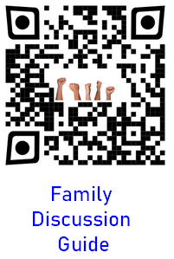
Application
Identify.
- Acknowledge any doubts you may have about the truth of the gospel of Christ.
- A lot of people feel uncertain about the objective truth of the gospel, and modern society with its relativistic moral beliefs can amplify those doubts.
- Admit where your struggles lie.

Seek.
- The Christian faith is the truth, thus we need to determine to resolve our personal doubts.
- Find people or resources that can help you think through those doubts and don’t stop until you have found the answers. They do exist.

Help.
- Help someone with his or her doubts.
- Talk to your friends about the doubts they may have concerning the truth of the gospel of Christ and help them to get those doubts resolved.

Cryptogram Puzzle
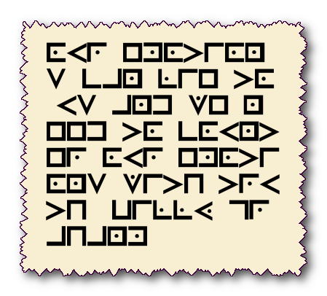
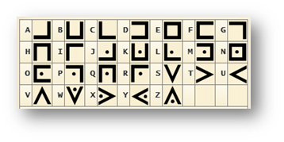
We just received this coded message from one of our operatives in Tarca Retadesh. Our decoding crew is busy with Jr. Hi Video Game competition. Spiros the Spy needs your help to decrypt the message using the key below. The “Hello World” example shows how it works. Technical help (and the color page) is available at https://tinyurl.com/murbsuhv

