1. Motivate

What are some things that easily distract us?
- television
- Facebook
- our phones dinging
A video introduction is available. View at https://watch.liberty.edu/media/t/1_2l2znu1i If you have no Wi-Fi where you teach, best to download to your computer from https://tinyurl.com/2dev7b7p
- the weather
- our hobbies
- our kids and grandkids
- traffic
- conversations we overhear
- worries about upcoming events
- health
- being too cold, too hot
- our aging parents

2. Transition

It seems that life is full of things that distract us from our priorities.
- Today we consider God’s call to stay alert and focused on our relationship to Him.

3. Bible Study

3.1 Guard Against Complacency

Listen for an exhortation.

Revelation 3:1-2 (NIV) "To the angel of the church in Sardis write: These are the words of him who holds the seven spirits of God and the seven stars. I know your deeds; you have a reputation of being alive, but you are dead. 2 Wake up! Strengthen what remains and is about to die, for I have not found your deeds complete in the sight of my God.

How did the Lord identify Himself to the believers in Sardis and what does it say about His character?
- Him who holds the seven spirits of God and the seven stars
- He could see their deeds, what they were doing
- He is omniscient, omnipresent, omnipotent
- He sees all, knows all, is in control of all

What was the reputation of the church to those who viewed it from outside?
- they had a reputation of being alive
- apparently, they had lots of activities that people could see
- they were busy “doing church”

What was the Lord’s assessment?
- despite appearances, they were dead
- they were spiritually asleep … He tells them to “Wake up!”

What was the two‑pronged appeal of the Lord if the church was to be more of what He expected it to be?
- wake up
- strengthen what remains
- there must have been some remnants of spiritual life there
- however, if they didn’t strengthen what remained, they would be totally dead spiritually

What are some symptoms of spiritual complacency in an individual?
- lack of church attendance
- no communication with God – lack of Bible reading, prayer
- spiritual activities become a lower priority
- we’ll make it to church if it is convenient
- no participation in church ministries

What are some ways a church today may be demonstrating spiritual complacency?
- people just going through the motions
- “worship” is a performance
- no concern for the lost
- the church becomes more of a religious “club” with religious activities
- outreach is mainly humanitarian – help the needy

How can a church appear to be alive and thriving and yet be dead?
Appear to Be Alive | Yet Actually Dead
- church calendar full  - lots of activities  - church campus looks good  - nicely appointed worship center  - good sound system | - preaching is lack luster  - Bible study classes are mostly just conversation (gossip?) … no real teaching happens  - people just going through the motions  - church growth is not from new converts, only from families having children

3.2 Maintain Vigilance

Listen for Jesus’ warnings.

Revelation 3:3 (NIV) Remember, therefore, what you have received and heard; obey it, and repent. But if you do not wake up, I will come like a thief, and you will not know at what time I will come to you.

The Lord called for change in the church. What were the verbs used to exhort the church? (Note the different words used in different versions of the Bible.)
- remember what you have received, what you have heard
- go back to what you heard and believed at first
- obey those teachings
- hold fast
- hold to those teachings
- repent, turn to me again
- wake up

What warning is issued for failing to remember, obey, and repent?
- if you don’t wake up
- I will come like a thief
- you won’t know when I will come

God is not a thief; how does the “thief” analogy apply to the Lord’s coming?
- we won’t know when it will happen
- it will be unexpected
- people will be totally surprised
- people will be so distracted by other things they won’t even be thinking of the possibility

What does that “thief” analogy mean for our disposition (our attitudes and actions) while we wait for Him?
- expect Him to come any time, any day, any night
- know that it is a certainty and be ready
- be involved in spiritual ministries
- work and plan like Jesus might not come for many more years
- live like it might be TODAY

What are some things we can do to keep our focus on Jesus? What advice would you give to a young Christian who asked, "How can I keep from sinning?"
- daily reading, studying God’s Word
- thinking about what we read … don’t just watch the words go by
- apply to your life the Truth you read
- obey God’s commands
- be encouraged by God’s promises
- talk to God … praise, worship, declaring your faith in His power, love, sovereignty
- tell God even your discouragements, hurts, and disappointments (confession)

What are some consequences of not being spiritually alert?
- physical atrophy is the progressive degeneration or shrinkage of muscle or nerve tissue
- due to disease or just not using those muscles
- spiritual atrophy would be the progressive degeneration of our spiritual strength
- we would be easily discouraged, easily distracted, easily tempted to sin
- surprised by Christ’s return (like a thief in the night)
3.3 Reflect the Worth Christ Gives

Listen for who is “awake” in Sardis.

Revelation 3:4-6 (NIV) Yet you have a few people in Sardis who have not soiled their clothes. They will walk with me, dressed in white, for they are worthy. 5 He who overcomes will, like them, be dressed in white. I will never blot out his name from the book of life, but will acknowledge his name before my Father and his angels. 6 He who has an ear, let him hear what the Spirit says to the churches.

How do we know that not all the Christians in Sardis were "asleep"?
- there are a few people who have not soiled their clothes
- people who have not been stained by dabbling in sin
- people who have remained true to God
- their lives are clean, they have been obedient
- they have overcome
- they are worthy
- they have overcome

What imagery is used to describe the faithful?
- people who have not soiled their clothes
- people who have not been stained by dabbling in sin
- people who have remained true to God
- their lives are clean, they have been obedient
- they have overcome

What do white and white raiment symbolize?
- purity
- lives lived in faith and obedience
- their lives demonstrate their vibrant relationship to God

What promise of assurance does the Lord offer to the faithful?
- they will walk with the Lord
- names not blotted out of the Book of Life
- names acknowledged before God the Father and the heavenly hosts
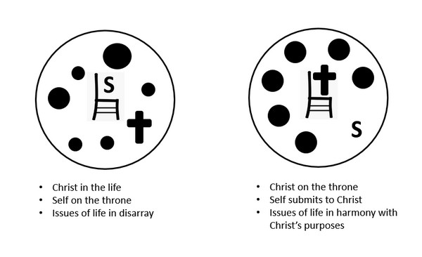
What does it mean to "overcome" as a Christian?
- not enslaved to sin
- realize we are rescued not only from the penalty of sin (fire escape from hell)
- experience the reality that we are also rescued from the power of sin over us
- submit to Christ as both Savior and Lord

Use the last page as a handout so your learners can take home the application points of this week’s lesson.

Application
Celebrate.
- Thank God for salvation and the way He has worked in your life.
- Celebrate what He has done but ask God to keep you from resting on what He has done in the past.

Create a timeline.
- Chart out your spiritual progress beginning with the moment you placed your trust in Christ.
- Note the high points and times you faltered in your walk with Christ.
- Use this to challenge yourself to continued growth in Christ

Stand together.
- God never meant for the Christian life to be lived alone.
- Partner with another Christian to help each other stay faithful and focused on Christ.
- Set aside specific times when you can meet, discuss victories and challenges, and pray for each other.
Fallen Phrases Puzzle
Oh, no … I’m in trouble. I need your help. The letters fell off my marquee …. straight down. Some are easy to figure out, where there is only one letter in the column. Then look at two and three letter words … what letters make meaningful words. Please don’t be complacent about helping! If you’re stuck, go to https://tinyurl.com/2dev7b7p You’ll find other great activities for the whole family there.

