1. Motivate

When have you needed to wear protective gear?
- knee pads when working in a kneeling position
- leather gloves for handling wood or stone, working in the garden,
- ear protection when in noisy environment (in the shop, at car races)
- special chaps for using a chainsaw
- safety glasses or goggles in a chemistry class or sawing wood
- bicycle or motorcycle helmet
- breathing mask when working in dusty environments or when fumes are present
- helmet, elbow, knee, wrist protection when skating
A video introduction to the lesson is available. View at https://watch.liberty.edu/media/t/1_29x8vuhf If you have no wi-fi where you teach, best to download to your computer from https://tinyurl.com/5n7j278d
- protective vest as a policeman, soldier, or bull rider
- steel toed shoes in factory or on construction site

2. Transition

Today we consider spiritual protective gear provided by God.
- God equips us to stand our ground against temptation.

3. Bible Study

3.1 Spiritual Battle

Listen for how we are at war.

Ephesians 6:10-13 (NIV) Finally, be strong in the Lord and in his mighty power. 11 Put on the full armor of God so that you can take your stand against the devil's schemes. 12 For our struggle is not against flesh and blood, but against the rulers, against the authorities, against the powers of this dark world and against the spiritual forces of evil in the heavenly realms. 13 Therefore put on the full armor of God, so that when the day of evil comes, you may be able to stand your ground, and after you have done everything, to stand.

What would have to be their source of strength if the Ephesians were to be victorious in spiritual battle?
- strong in the Lord’s strength
- strengthened by His mighty power
- put on the full armor of God
- then you can stand against the devil

Who was (and was not) their and our enemy?
Not the Enemy | The Spiritual Enemy
- not against humans  - not against “flesh and blood” | - spiritual forces  - powers of this dark world  - rulers and authorities of worldly mindsets

When might you experience a battle in your Christian life?
- when physically and emotionally exhausted
- during times of discouragement
- when distracted by worldly influences
- when involved in an important, strategic spiritual ministry

What is the key to being “strong in the Lord and in his mighty power?”
- learn to depend on God
- don’t depend on self
- don’t depend on other people
- realize that His power is available
- realize that His power is sufficient, even superior

What are some actions, words, attitudes that help you “be strong in the Lord and in His mighty power” before or during spiritual warfare?
- tell God every day that you are depending on Him
- memorize and/or study scriptures which remind you of God’s power, strength
- get into the habit at the beginning of each activity of asking for God’s strength as you begin
- listen to Christian music which keeps those themes running through your mind (instead of the drivel and/or evil lyrics of secular music)
- find a prayer partner with whom you can share needs and support for one another
- be quick to give God glory for answers to prayer, supply of needs

3.2 God Given Armor and Weapons

Listen for specific equipment.

Ephesians 6:14-17 (NIV) Stand firm then, with the belt of truth buckled around your waist, with the breastplate of righteousness in place, 15 and with your feet fitted with the readiness that comes from the gospel of peace. 16 In addition to all this, take up the shield of faith, with which you can extinguish all the flaming arrows of the evil one. 17 Take the helmet of salvation and the sword of the Spirit, which is the word of God.

What defensive and offensive equipment do you see in the passage?
Defensive | Offensive
- belt of truth  - breastplate of righteousness  - shield of faith  - helmet of salvation | - shoes of the gospel (you can advance!)  - sword of the Spirit (the word of God)

For each of the pieces of equipment, what part of the body does it protect, what spiritual ability does it provide?
Armor | Physical area protected or capability provided | Spiritual protection or capability
- Helmet of salvation | the head, the brain | the mind
- Breastplate of righteousness | the chest, the heart | the emotions
- Shoes of the gospel | feet protected, firm footing, ability to advance, kick! | stand firm, enable attacks, advancement against Satan’s territory
- Sword of the Spirit (Scripture) | stab, slash, close infighting | use God’s word in teaching, preaching, witnessing
- Belt of truth | strap on armor, hold everything in place | truth anchors and holds everything in place
- Shield of faith | overall, all around protection | protection from whatever angle Satan attacks, keep an attitude of faith

You would not want to leave out any one piece of physical armor. What would happen if we left out one or more of the elements of spiritual armor?
Spiritual armor element | Problem when missing
- Truth/scripture/gospel | Absolute necessity; enables preaching, teaching, encouragement, promises
- Faith | Absolute necessity; only way of salvation
- Righteousness | God’s righteousness protects our heart/emotions  Unprotected emotions can get us down, allow Satan to discourage
- Salvation | God’s salvation protects our minds, our intellect  Unprotected mind can cause confusion, misdirection, allow Satan to easily fool us

How do we consciously “put on” this spiritual armor?
- choose to read, study, apply God’s word
- daily declare your faith in what God is telling you each day
- thank God for His righteousness, confess your inability to live a righteous life in your own strength
- daily tell God that you are receiving, applying His armor for your spiritual victories over Satan’s attacks

3.3 Prayer Is Communication

Listen for how to communicate.

Ephesians 6:18-20 (NIV) 18 And pray in the Spirit on all occasions with all kinds of prayers and requests. With this in mind, be alert and always keep on praying for all the saints. 19 Pray also for me, that whenever I open my mouth, words may be given me so that I will fearlessly make known the mystery of the gospel, 20 for which I am an ambassador in chains. Pray that I may declare it fearlessly, as I should.

What connections exist between these verses and verses 10-17?
- consider that soldiers need communications capabilities
- along with armor and weapons you would need communications
- prayer is that communication

What characteristics of prayer does Paul give us? How should we pray?
- in the Spirit
- on all occasions
- with all kinds of prayers
- with all kinds of requests
- pray with alertness
- always keep on praying

What do you think it means to “pray in the Spirit?”
- let your prayers be guided by the Spirit
- allow God’s spirit to direct you what to pray about
- to pray over true Spiritual issues, not just selfish wants
- to pray concerning the spiritual battles (in the context of the passage)

How does prayer help you stand against temptations?
- you can tell God you are struggling
- you can ask Him for His strength to be at work in confronting the temptation
- you can claim His promises
- you can pray for others you know who are struggling with similar temptations
- you can ask others to be similarly be praying for you

What kinds of things could we pray about for other people, praying in the Spirit?
- for their salvation
- for spiritual struggles they have
- for their ministries
- for wisdom, boldness, peace
- that they would be victorious in their Christian lives

Use the last page as a handout so your learners can take home the application points of this week’s lesson.
Application
Take your stand.
- Through prayer, commit yourself anew to standing firm in the strength of the Lord in spiritual battle.

Identify.
- Make a list of temptations Satan often uses against you.
- Identify Scripture passages that will help you do battle against these specific temptations.
- Over the next few weeks, commit these verses to memory.

Stand together.
- Even as Roman soldiers would often stand back-to-back in battle, you can do the same with other believers.
- Discuss ways to support and encourage each other in the spiritual battles you face.
Double Puzzle
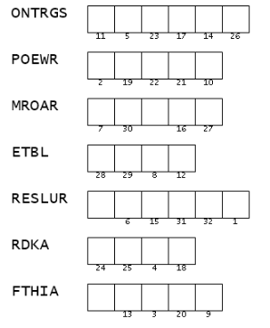
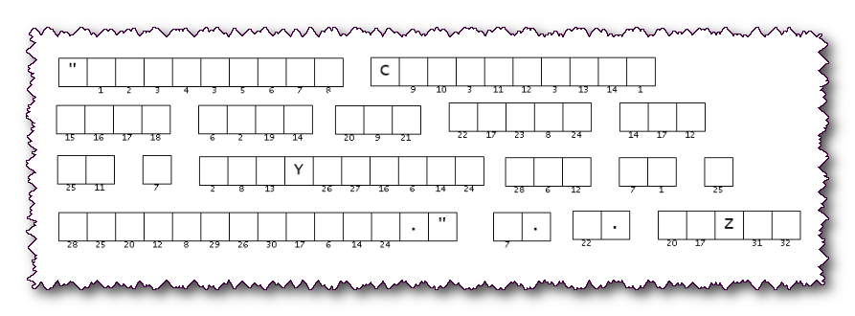
It is I, the Word Ninja. These two documents came to us from different operatives in Bulswenanonpit to the Southern International Baptist Security Services. We believe they are related. The list of scrambled words will provide the key to decrypting the message below. The words are taken from the passage noted above. When you decode the message, forward the results to your Missions Committee. Technical help and further fun Family Activities are available at https://tinyurl.com/5n7j278d

