1. Motivate

When was the last time you were stuck, either literally or figuratively?
- doing math homework
- trying to find the leak in a tire
- with the car in the snow
- with doing the stack of dishes after a family get together
- with the bill at a restaurant
- teaching as a substitute on a Sunday morning
A video introduction to the lesson is available. View it at https://watch.liberty.edu/media/t/1_1is4sjz3 . If you have no wi-fi where you teach, best to download to your computer from https://tinyurl.com/59e49994
- running out of gas
- having to run to the store for something for dinner
- ran out of an ingredient for a recipe

2. Transition

It is possible to be stuck spiritually,
- Making no progress, falling for the same temptation.
- We can only move forward when we embrace God’s forgiveness.

3. Bible Study

3.1 Guilt vs. Grudges

Listen for fear of revenge.

Genesis 50:15-18 (NIV) When Joseph's brothers saw that their father was dead, they said, "What if Joseph holds a grudge against us and pays us back for all the wrongs we did to him?" 16 So they sent word to Joseph, saying, "Your father left these instructions before he died: 17 'This is what you are to say to Joseph: I ask you to forgive your brothers the sins and the wrongs they committed in treating you so badly.' Now please forgive the sins of the servants of the God of your father." When their message came to him, Joseph wept. 18 His brothers then came and threw themselves down before him. "We are your slaves," they said.
What did the brothers fear from Joseph following their father’s death?
- Joseph may have been holding a grudge for these several years
- he was just waiting for Dad to be out of the picture
- he would pay them back for all the bad things they did to him

What words or phrases describe the depth of their pleas for forgiveness?
- they sent word … did not come personally
- come up with an alleged message from their father
- sins, wrongs committed
- treated you so badly
- we are your slaves

What may have prompted Joseph to weep upon hearing the message asking for forgiveness?
- they didn’t believe he had forgiven them
- they didn’t understand that God had used their evil actions to accomplish good
- did they really think he was that vindictive?
- did they think he could hold a grudge that long?
- did they think he was faking all the good things he had done for them?

What’s really going on when we hold a grudge?
- we are hanging on to the anger
- we cultivate that attitude … bring up the hurt again and again
- hold on to the negative feelings too long
- relive multiple past acts every time you think of or are with the person
- end up hurting you as much as the person who inspired the feelings
- can impact you emotionally, physically, socially
- can result in a cycle of bitterness, anger, blame
- you end up hurting yourself more than the person you are mad at
- inhibits ability to cope with or resolve the issue
- you end up trapped in the initial unpleasant event

What makes forgiving someone who has wronged us so difficult?
- they done me wrong … they don’t deserve forgiveness
- you wish to retaliate, not forgive
- you wish to get revenge
- if you forgive them, the are getting away with the harm done
- they might do the same thing or worse the next time
- they need to learn a lesson, not be let off

What part does admitting guilt play in seeking forgiveness? Is that all that is needed?
- it is absolutely necessary
- if we make excuses or blame someone else, we’re not seeking forgiveness, we are seeking justification
- it is not enough, however
- the person seeking forgiveness must also communicate regret or sorrow for the wrong inflicted
- if we are not sorry for our offense, then we are not seeking forgiveness, we have no desire for reuniting or repairing the relationship

Be aware …
- Those who have done wrong need to confess their sins, seek forgiveness
- Guilt can be so strong that some people have trouble believing they have been forgiven
- Forgiveness is necessary for ongoing personal relationships

3.2 Focus on God’s Providence

Listen for God’s providence.

Genesis 50:19-21 (NIV) But Joseph said to them, "Don't be afraid. Am I in the place of God? 20 You intended to harm me, but God intended it for good to accomplish what is now being done, the saving of many lives.
How does Joseph’s reply to them demonstrate his attitude of submissiveness before God?
- realizes and declares that he cannot stand in judgement over them
- God is still in charge, even when people intend bad things
- God can accomplish His purposes both with and in spite of men’s free will

What perspective did Joseph offer to explain the actions of his brothers and the things that had happened to him?
- remembering that what they intended as harm, God used for good
- as events transpired, God accomplished good
- what they did triggered events that resulted in the saving of many lives

What can it cost us to leave justice in God’s hands?
- may not happen soon, even in your lifetime
- doesn’t seem to be sufficient
- people say, “I just want closure”, what they often want is revenge
- you feel they didn’t suffer like you did, no matter what God does

Agree or disagree … “It is possible to both forgive and forget.”
Possible | Not Possible
- when we forgive, we lift the burden of guilt  - we choose to not hold the offense against the offender  - by an act of your will, you choose to think of something else  - in that sense you “forget” | - you still feel the hurt, the negative results  - you do not hold the offense against the person  - our brains still hold the data, the facts of the offense  - we might remember in that sense, but we don’t choose to act on the memory

How is this passage an Old Testament parallel to Romans 8:28?
- Joseph declares that God is in control, even when bad thing happen
- When Satan or evil men do God's people wrong, God has the power to turn the tables and make good things happen
- God accomplishes good things for those who trust Him and obey Him, despite the events of life
- God is not the author of evil; instead, He works to bring good out of evil

3.3 Receive Forgiveness

Listen for forgiveness and comfort.

Genesis 50:21 (NIV) So then, don't be afraid. I will provide for you and your children." And he reassured them and spoke kindly to them.
Because he believed that God had been in control all along, what actions was Joseph able to take toward his brothers and their families?
- provide for them
- provide for succeeding generations
- reassured them
- spoke kindly to them

It is often hard to offer forgiveness. Why is it sometimes hard for us to accept forgiveness from others?
- we know our own attitudes when we wronged them
- we know we don’t deserve forgiveness
- we are afraid they might not mean it
- we know how we would feel if the situations were reversed and our own tendency hold on to the grudge, to not forgive

What are some principles you’ve learned from Joseph’s life?
- trust God no matter what is happening in our lives
- allow God to use you as a positive force in whatever role you find yourself
- don’t get trapped by temptations
- be quick to forgive
- accomplish good things for even those who have may have wronged you

What parallels do you see between the life of Joseph and the life of Jesus? How is Joseph’s life a foreshadowing of the life and ministry of Christ?
- both were rejected, hated
Use the last page as a handout so your learners can take home the application points of this week’s lesson.
- both were given up to die
- Joseph lived on to save his family
- Jesus was resurrected from death to give us eternal life
- God worked a miracle for both … rescuing them from death

How can our group help one another become people of forgiveness?
- practice forgiveness with one another
- pray God’s blessing on each other … even if we feel we might have been slighted by someone
- minister to fellow members of the Body of Christ
- refuse to be caught up in retaliation or holding on to hurts from others
- be quick to forgive
Application
Stay humble.
- God is stronger than you know. You are weaker than you know.
- He’s in control so you can stop trying to be. Make a list of ways you have tried to be in control.

Stop the hate.
- Stop hating people for hurting you.
- In the end, we punish ourselves for the actions of others.
- This is not the grace of God at work in us.
- Make a list of those for whom you hold a grudge and make it a prayer list.

Seek grace.
- Seek the grace of God anew.
- We go back to bondage. We forget that we are forgiven.
- Because of Him, we are enough. We do measure up.
- Make a list of reasons you have to celebrate God’s grace.
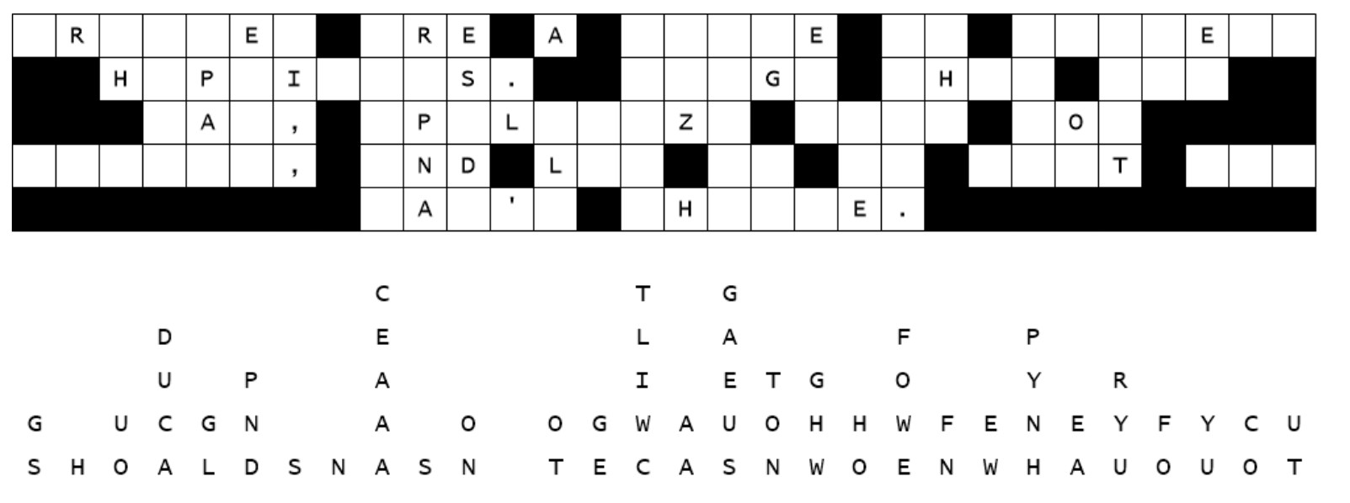
Our decoding staff was using their middle school glue when they placed the letters in the grid. As a result, some of the letters fell off … straight down. We need some more mature help. Find the columns with only one letter fallen, then work on two or three letter words, using combinations that make sensible words. Pass your results along to your head deacon. Technical aid is available at https://tinyurl.com/59e49994 along with further items of intrigue for your family.

Fallen Phrases Puzzle

