1. Motivate

What kinds of dreams and expectations do people typically have for their children?
- do well in school
- have nice friends
A video introduction is available. View it at
https://watch.liberty.edu/media/t/1_sch5u52q. If you have no wi-fi where you teach, best to download to your computer from https://tinyurl.com/2p93n7sa
- follow Jesus at an early age
- popularity
- get into a good college
- be good in sports
- land a good job after college
- become involved in church activities
- raise nice grandchildren

2. Transition

Consider what God’s expectations were when He sent Jesus to earth … as a baby … then as an adult.
- God’s plan was for Jesus to come to us as God in person.
- Jesus is the King who rules His kingdom now and forever.

3. Bible Study

3.1 Birth of a King Foretold.

Listen for lyrics from Handel’s Messiah.

Isaiah 9:6-7 (NIV) For to us a child is born, to us a son is given, and the government will be on his shoulders. And he will be called Wonderful Counselor, Mighty God, Everlasting Father, Prince of Peace. 7 Of the increase of his government and peace there will be no end. He will reign on David's throne and over his kingdom, establishing and upholding it with justice and righteousness from that time on and forever. The zeal of the LORD Almighty will accomplish this.

What are the names given to the child of whom Isaiah spoke?
- Wonderful (or Wonderful Counselor)
- Counselor
- Mighty God
- Everlasting Father
- Prince of Peace
What further descriptions are given of the Ruler who will be provided by God for His people?
- government on his shoulders
- His government will increase continuously
- peace will likewise increase
- will reign on David’s throne, over his kingdom
- rule with justice and righteousness
- rule forever

Let’s consider the names. | What are the implications or characteristics suggested by the titles?
Wonderful Counselor  Mighty God  Everlasting Father  Prince of Peace | - gives wisdom, gives direction, guides – in a wonderful way  - powerful, in charge, able to handle all situations, sovereign  - can always be approached as a loving father, always watches over, always protects  - brings peace to situations, ends conflicts, brings peace between God and men, helps us to live at peace with one another

The Jews anticipated a political or military leader. What did they hope He would do?
- at that time to free them from Roman rule
- protect them from all other national threats
- enlarge their borders
- make them a powerful nation
- make them victorious against all enemies

In actuality, what kind of ruler was (is) Jesus?
- a spiritual leader
- the Leader, the One in charge, the Ruler of the whole universe
- He is the King of Kings – the ultimate ruler of all things
- He wants to rule (for our good) in our hearts and minds
- every knee will bow to the Messiah, the Sent One, the Anointed One, the Chosen One

In what ways do we need God’s counsel?
- decisions about the future
- how to change our lives for the better
- things present in our lives which we should avoid

How do we hear or experience the wonderful counsel of God?
- faithfully reading and applying God's Word
- applying the teaching and preaching to which we are exposed
- being careful to listen to the convicting, the convincing of the Holy Spirit

In what ways does the Messiah want to rule in our lives?
- guide and direct our decisions
- empower us to live victoriously
- lead us to conquer the influence of the world
- guide us to take the Truth of the Gospel, the Good News to the whole world
- make the Church (we are members of the Body of Christ) the victorious force in the world

3.2 Birth of a King Divinely Announced

Listen for a birth announcement.

Luke 1:26-31 (NIV) In the sixth month, God sent the angel Gabriel to Nazareth, a town in Galilee, 27 to a virgin pledged to be married to a man named Joseph, a descendant of David. The virgin's name was Mary. 28 The angel went to her and said, "Greetings, you who are highly favored! The Lord is with you." 29 Mary was greatly troubled at his words and wondered what kind of greeting this might be. 30 But the angel said to her, "Do not be afraid, Mary, you have found favor with God. 31 You will be with child and give birth to a son, and you are to give him the name Jesus.

Let’s list the who, when, where, etc. that are covered in a news story.
Who: God, Gabriel, Mary (a virgin), Joseph (the future husband)
When: In the sixth month (of Elizabeth’s pregnancy)
Where: Nazareth, a town in Galilee

What was the message of the angel?
- greetings
- you are highly favored, you have found favor with God
- the Lord is with you
- don’t be afraid
- you will become pregnant, give birth to a son, and name him Jesus

What emotions do you think Mary was feeling?
- fear, surprise, embarrassment
- excitement, honor, worry

How was this divine announcement life-changing for Mary and for all of us?
- she would give birth to the long-awaited Messiah
- this was the fulfillment of a prophecy all Jews knew about
- it was to be an awkward situation with Joseph, with the community
- life changing for the whole world in that this was the beginning of the culmination of God’s plan of salvation for all peoples

Why is it important that Jesus was both fully God and fully man?
- Fully God:
  - God the Son entered time and space
  - limited Himself to the same existence we experience
  - only God could take the initiative to solve the sin problem
  - only God could live a perfect life on earth
- Fully Man:
  - Jesus became man so that he could die for our sins.
  - He had to be human in order to pay the penalty for humans.
  - because Jesus is human like us, he is able to be a merciful and faithful High Priest.
  - His humanity enables him to sympathize with us more fully and identify with us.

3.3 The King Is Jesus

Listen for claims made.

Luke 1:32-33 (NIV) He will be great and will be called the Son of the Most High. The Lord God will give him the throne of his father David, 33 and he will reign over the house of Jacob forever; his kingdom will never end."

Identify the various claims made concerning Jesus in these verses.
- will be great
- known as “Son of the Most High” … the Son of God
- will be given the “throne of David” … He is a King, THE King
- He will reign/rule over Israel forever – including us, God’s People in the Church Age
- His kingdom will never end … God rules eternally

What is the significance of the names and titles given to this child?
Name | Significance
Son of the Most High | - contrast to “prophet of …” title given to John  - Most High ⇒ God  - Jesus would be God, divine … at the same time, human
Given throne of David | - born of the line of David, recall the Davidic covenant  - would be a king with a throne – not a literal or political kingdom, but a spiritual kingdom
Kingdom include House of Jacob | - A Hebrew patriarch  - name changed to Israel – for whom the nation was named

Why is it so important that we remember the “forever” part of this passage?
- God is in charge of not only our lives and our individual congregations
- God is in charge of history
- He is accomplishing His purposes towards the culmination of His plans for eternity
- He rules in history (despite what politicians and dictators think)

What responsibilities do we have as members of the kingdom of God?
- the Kingdom of God is the Realm where God rules
- we are called to submit to his rule
- we pay attention to His Truths written in Scripture, we apply them to our lives
- we allow God to rule in our lives

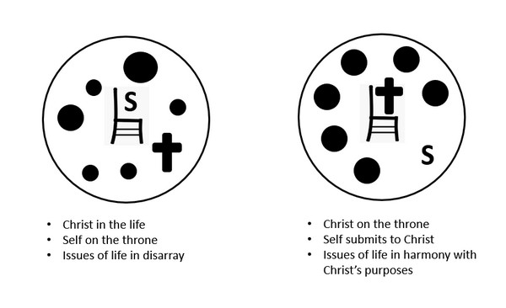

Application
Use the last page as a handout so your learners can take home the application points of this week’s lesson.
Reflect:
- Take a moment and reflect on your life.
- How do you struggle with humility or being obedient to the Lord?
- How can you walk more in humility and obedience?

Remember:
- As you put away Christmas decorations, replace them with a visible reminder of Jesus’ current reign as King,
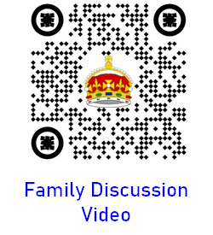
- for example: a ceramic church or a small globe as a reminder to pray for missionaries.

Reveal:
- Thinking about how Jesus is the King who reigns forever, how can you share this truth with someone this week?
- Plan to share the gospel with someone this week.

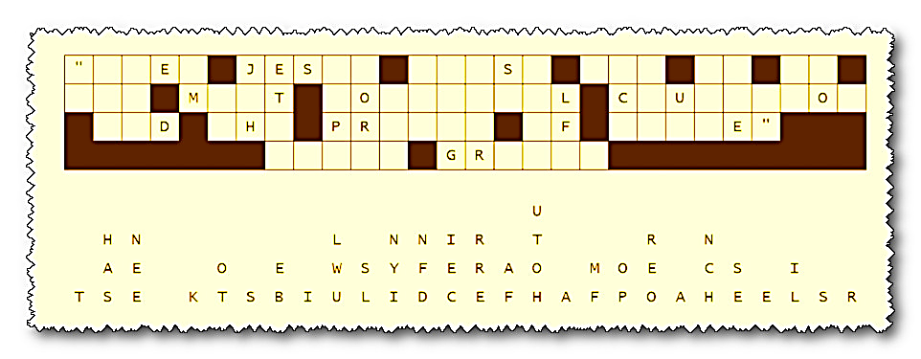
Fallen Phrases Puzzle
Our third assistant Landscaping Attaché from the consulate in Tishmidalandmark found this paper in a hidden message drop. Unfortunately, the letters had been initially glued on and when the paper was drenched by rain, some slid out of their cells, straight down. Our analysts are detained due to a last-minute Sunday School Junior Choir Christmas party. So, we need your help. Go for columns where only one letter is missing. Then work on two or three letter blanks, finding letters that make sense. Forward your results to the chairman of your Christmas Candy Committee. If you get stuck, go to https://tinyurl.com/2p93n7sa You can find other Christmas type activities there, also.

