1. Motivate

When have you appreciated someone’s honesty?
- the guy who put a dent in my car in a parking lot
- one of my kids admitted coming in late
- wife let me know there was a stain on the back of my pants that I couldn’t see
- when one’s spouse admits he/she was wrong
- a student admitted he/she really didn’t do the homework (the dog really didn’t eat it)
- your teacher admits he/she graded your paper incorrectly
- your boss admits he/she made a mistake on your timecard
- when you were in an accident, the other person admits he/she was at fault, not you

2. Transition

Sometimes being honest can be hurtful to the other person.
- We might call it “hard truth” or “tough love”
- Being a bold witness for God sometimes means speaking hard truth.
A video introduction to the Bible study is available. View at https://watch.liberty.edu/media/t/1_s9dzhgjs If you have no wi-fi where you teach, it is best to download the video to your computer from https://tinyurl.com/3r2z3cvm
3. Bible Study

3.1 Integrity and Godly Wisdom

Listen for Daniel’s reputation.

Daniel 5:13-16 (NIV) So Daniel was brought before the king, and the king said to him, "Are you Daniel, one of the exiles my father the king brought from Judah? 14 I have heard that the spirit of the gods is in you and that you have insight, intelligence and outstanding wisdom. 15 The wise men and enchanters were brought before me to read this writing and tell me what it means, but they could not explain it. 16 Now I have heard that you are able to give interpretations and to solve difficult problems. If you can read this writing and tell me what it means, you will be clothed in purple and have a gold chain placed around your neck, and you will be made the third highest ruler in the kingdom."

What questions did Belshazzar ask to affirm some background about Daniel?
- Are you Daniel?
- Is it true you are an exile from Judah?
- You were captured by my father’s army there, right?

What had he heard about Daniel and his amazing skill?
- the spirit of the gods is in you
- you have insight, intelligence
- you are outstandingly wise
- you are able to give interpretations
- you can solve difficult problems

He hoped Daniel could do what his own court counselors were unable to accomplish.
- Read the writing on the wall
- Tell him what it means
- Explain the message

He promised to reward Daniel if he was successful.
- Clothed in royal purple
- Have a gold chain placed around your neck
- Be made 3rd highest ruler in the kingdom

Daniel had a good reputation. How would you describe the reputation Christians have in our culture?
- unfortunately, some people see Christians as hypocrites – say one thing and do differently
- believers are accused of hate speech when they declare sin to be sin
- people don’t want to hear the message of the Gospel because it conflicts with their lifestyle
- often accused of foolishness in rejecting popular goals of current society

Why is it hard to sometimes be honest when someone asks for your opinion?
- you know the truth or reality will not be well received (“does this dress make me look fat?”)
- you don’t really want to offend the person
- you have a hard time phrasing the response in a way that is not hurtful
- they might really need to hear the truth, but you are afraid they will reject it anyway
- sometimes the issue is complicated and it’s hard to give a complete answer that will be understood and well received
- you know what the person wants to hear, but your opinion does not agree with that

How might a life of integrity provide a believer the opportunity to share Christ?
- you become known as a “straight shooter”
- people can depend on you to tell the truth
- what you say is always meaningful and worth hearing
- you don’t say things just to be heard or just to make people feel good

3.2 Exalting Self Over God

Listen for how Daniel responded.

Daniel 5:17, 22-23 (NIV) Then Daniel answered the king, "You may keep your gifts for yourself and give your rewards to someone else. Nevertheless, I will read the writing for the king and tell him what it means. …22 "But you his son, O Belshazzar, have not humbled yourself, though you knew all this. 23 Instead, you have set yourself up against the Lord of heaven. You had the goblets from his temple brought to you, and you and your nobles, your wives and your concubines drank wine from them. You praised the gods of silver and gold, of bronze, iron, wood and stone, which cannot see or hear or understand. But you did not honor the God who holds in his hand your life and all your ways.

Note Daniel’s attitude toward the rewards the king had offered him.
- Keep your gifts and rewards
- I’m not interested in them
- I don’t need gifts to be able to tell you what the righting means
- I’ll tell you for free

How did Daniel confront Belshazzar’s pride?
- tells it like it is
- You have not humbled yourself, even though you knew the history about your grandfather
- we might say “you are in God’s face with your actions”
- you profaned the goblets from the Most High God’s temple
- you have insulted Jehovah God by using His cups to worship false gods

When is it appropriate to point out the sins of others?
- when they hit bottom and are in such misery or fear that they are ready to listen
- when they ask you what is wrong
- if you are in charge (a parent, teacher, advisor)

Why do people often fail to make the connection between sin and its consequences?
- they ignore the reality that it is what they have done that brought about the result
- sometimes the consequences are delayed, so they just don’t make the connection
- the consequences of their sin are blamed on someone, something else
- our culture is quick to blame our problems on other things, other people
  - the pencil made the mistake on my test,
  - the stairs tripped me,
  - what he/she said triggered my temper, caused me to lash out

What kinds of consequences does sin have in people’s lives?
- physically – substance abuse (even chocolate chip cookies can be substance abuse)
- emotionally – loss of happiness, joy
- spiritually – damage or destroy relation with God
- financially – loss of money wasted on sin, even financial ruin due to gambling or substance abuse

We might experience the discipline of God, but what might be His goals in doing this?
- realize our wrong actions, attitudes
- negative reinforcement (punishment) causes us to avoid that action
- bring us to repentance, confession
- get our attention of our foolishness
- teach us the futility of our bad choices

3.3 Sin Brings Judgment

Listen for what God had to say.

Daniel 5:24-28 (NIV) Therefore he sent the hand that wrote the inscription. 25 "This is the inscription that was written: MENE, MENE, TEKEL, PARSIN 26 "This is what these words mean: Mene: God has numbered the days of your reign and brought it to an end. 27 Tekel: You have been weighed on the scales and found wanting. 28 Peres: Your kingdom is divided and given to the Medes and Persians."

Note from whom did the hand and the written message came.
- “He sent the hand …”
- The “He” is Jehovah God
- The same God whom the king ignored and flaunted

What main points does God make with the message written on the wall?
- God has numbered your days as king
- your actions have been weighed/judged and you did not measure up to God’s standard
- your kingdom is to be divided and given to the Medes and the Persians

Why do you think God communicated in this way to the king?
- got his attention
- made an impression on him and everyone else
- drastic events require drastic measures
- if God sent Daniel or someone else in with a message verbally or in a document, it would have been ignored

How do you think God wants us to respond when He confronts us with our sins?
- to agree with Him that it is sin – this is confession
- to turn away from this sin – this is repentance
- to seek/receive His forgiveness
- to allow His Holy Spirit to direct our actions, to empower us to live a life that honors and pleases Him

How might God confront us today about a casual attitude you had toward sacred things?
- hear a sermon or a Sunday School class about it
- read a verse that seems to jump out at you
- some event occur in your life that highlights the inappropriate attitude
- a comment or observation by someone which all of a sudden makes you realize the wrong way you’ve been acting or thinking

Use the last page as a handout so your learners can take home the application points of this week’s lesson.

Application
Check your ego.
- Examine to see if there are areas in which you have become over-confident in your own abilities and resources.
- Evaluate what’s led to this elevated sense of security. Pray that God will help you have a right attitude about depending on Him.

Spend time alone with God.
- Set aside a couple of secluded hours, taking only a Bible, pen, and paper.
- Spend time in Scripture and prayer.
- Ask God to speak any messages He may have for you.
- Take time to listen silently; take notes on any impressions He gives.

Focus on that which is sacred.
- Make a two-column list.
- Write “Sacred” as the heading of the column on the left; write “Cultural” as the heading of the column on the right.
- Under “Sacred,” list worship-related actions the Scriptures mandate.
- Under “Cultural,” list actions that may seem religious but are instead dictated by cultural expectations and traditions.
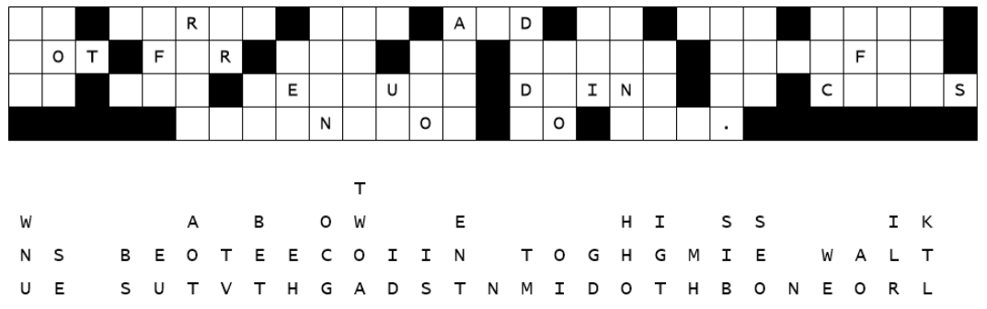
- Focus this week on what God calls sacred.
Looks like the decoding crew is using that glue that was on recall for insufficient stickum. A bunch of the letters slid straight down the paper. Spiros the spy doesn’t trust them to fix this. Can you help? Look for single letter columns, then short words. Try letters for them that make sensible words. Hop to it! Help and more Family Fun Activities are available at https://tinyurl.com/3r2z3cvm .

Fallen Phrases Puzzle
fa

