1. Motivate

What endangers our health and safety in today’s world?
- COVID-19 virus
- extended quarantines and isolations
A video introduction for the lesson is available to view at https://watch.liberty.edu/media/1_vnnivsxk If no Wi-Fi where you teach, best to download to your computer from https://tinyurl.com/y3chadje

- abortions
- drunk drivers, careless drivers
- yearly influenza
- substance abuse
- human trafficking
- elderly people falling down
- drive by shootings
- big government intrusion in our lives
- poverty
- weather events – hurricanes, blizzards, forest fires, tsunamis

2. Transition

This has been an especially crazy year for such events.
- But we can rest assured God is our defender no matter what we face.

3. Bible Study

3.1 Trust God’s Power

Listen for names of God.

Psalm 91:1-6 (NIV) He who dwells in the shelter of the Most High will rest in the shadow of the Almighty. 2 I will say of the LORD, "He is my refuge and my fortress, my God, in whom I trust." 3 Surely he will save you from the fowler's snare and from the deadly pestilence. 4 He will cover you with his feathers, and under his wings you will find refuge; his faithfulness will be your shield and rampart. 5 You will not fear the terror of night, nor the arrow that flies by day, 6 nor the pestilence that stalks in the darkness, nor the plague that destroys at midday.

What four names are used to refer to God? Consider the meaning or emphasis of each one?
Name | Meaning
- the Most High  - the Almighty  - LORD -- Jehovah, Yahweh  - my God | - Supreme One, sovereign, superiority  - translates “el Shaddai, powerful, omnipotent  - personal covenant name of God, the I AM, The God Who IS (contrasted to those who are not)  - Elohim – the One true God, note the “my” adjective

What are dangers from which God will protect or rescue those who trust in God?
- the “fowler’s snare”, a trap
- deadly pestilence or plague
- terror of night
- the arrow that flies by day

What are images used in the passage to convey God’s protection over His loved ones?
- dwell in the shelter
- rest in the shadow
- cover you with feathers
- refuge and fortress
- rescue from traps
- be a shield and rampart

How has God helped you through a time or season of fear?
- encouragement when feeling down
- provision – we didn’t starve, we had shelter, we were warm and cared for
- protection – in an accident, in a dangerous situation,
- assurance – reminded that He is powerful, He is sovereign and can do as He pleases to do, He loves us and will accomplish good things for us
- provided a verse or a promise to remind us of His watch care over us
- healing when severely ill

In what ways do you find that God calms your fears when circumstances around you could leave you frightened?
- Reading God's promises gives peace
- Praying about the situation instead of worrying about it
- Realizing that in actuality I can do nothing to solve the problem … it is only God who can remedy the situation
- Remembering that God is in charge
- remembering times in the past when He answered prayer, solved the problem

Note
- It is easy sitting in Sunday School to describe the calming presence and power of God
- It is much more of a struggle to apply these principles when everything around you is coming apart!

How should we respond when God delivers or protects us from danger?
- praise and thanksgiving
- stand in awe
- continued trust
- each time God delivers or protects increases our ability to trust Him the next time we are faced with fears

3.2 Trust God’s Protection

Listen for God’s protection.

Psalm 91:9-13 (NIV) If you make the Most High your dwelling-- even the LORD, who is my refuge-- 10 then no harm will befall you, no disaster will come near your tent. 11 For he will command his angels concerning you to guard you in all your ways; 12 they will lift you up in their hands, so that you will not strike your foot against a stone. 13 You will tread upon the lion and the cobra; you will trample the great lion and the serpent.

What decision had the godly made that is affirmed by the psalmist?
- make the Most High your dwelling
- take refuge in The God Who IS

What promise was extended to the godly?
- no harm befalls you
- no disaster will come near your tent
- God sends angels to guard you
- the angels protect you from tripping
- you will be protected from dangerous situations (lion, cobra, serpent)

What does it mean to make God our “dwelling place”?
- daily trust, depending on His protection, His supply
- making a practice to declare your trust and faith in the Lord
- you choose to spend time with God, listening to what He says, talking to Him about both your problems and your joys
- regular attendance in God’s House … involvement in a local church congregation
- God’s help is the first solution you seek … not someone or something else

Note the verses misused in the New Testament? [11] For he will command his angels concerning you to guard you in all your ways; [12] they will lift you up in their hands, so that you will not strike your foot against a stone.
- Satan used this verse in tempting Jesus in the wilderness.

What are some ways to describe the difference between faith and presumption (which is what Satan was proposing)?
Faith | Presumption
- believe what God says  - keep it in context  - understand it in the totality of what God says  - trust God and leave the outcome in His hands | - I'll put myself in harm’s way, God said He'd protect me  - I'll max out my credit cards, God said He would provide my needs  - take unnecessary risks and expect God to solve the problems  - I'll live a riotous life, God promises to forgive

How do we know God cares about us when we experience dangerous and difficult times?
- He tells us in His word (which we must be reading to know about His care)
- He provides for us
- He takes us through those times
- He hears our prayers, our cries for help
- He sends angels to help, He brings other believers along to help
- The church, the Body of Believers is present to minister to one another in our times of need
- The Gifts of the Spirit are put to work – edifying one another

3.3 Walk with God

Listen for God’s response to those who trust in Him.

Psalm 91:14-16 (NIV) "Because he loves me," says the LORD, "I will rescue him; I will protect him, for he acknowledges my name. 15 He will call upon me, and I will answer him; I will be with him in trouble, I will deliver him and honor him. 16 With long life will I satisfy him and show him my salvation."

What were the human actions God attributes to a human?
- he loves me
- he acknowledges my name These are the conditions for
- he calls on God

List the responses of God to these expressions of faith and trust.
- rescue
- protection
- answer
- be with in trouble
- deliver
- honor
- satisfy with long life
- show salvation

What are some ways in which God has ministered to you in one of these ways recently?
- protection in driving
- given healing – physical, spiritual, emotional
- given peace in the midst of a hectic week
- provided strength to go on another day
- given assurance of His presence through a scripture passage

What are some ways we can call out to God when we feel afraid?
- when surprised by a fearful or dangerous situation, we can immediately call out to Him, sort of a “flash message”
- read the Psalms … David so often recorded his ups and downs, his fears and his praise for God’s rescue
- sometimes the fear is over a longer time frame … we can daily declare our concerns and our ongoing trust in God’s power, authority, and love for us

Be encouraged for your own needs by the reality of God at work in one another's lives
Support one another in prayer for all these kinds of needs

Use the last page as a handout so your learners can take home the application points of this week’s lesson.

Application
Make a list.
- Make a list of things that tend to cause you fear.
- Beside each of those fears, make a note of why trusting God will help you to overcome that fear.

Get counsel.
- If you deal with a long-term deep-seated fear or phobia, talk to your pastor or a trusted counselor.
- Talking to a counselor can help get to the root of such fears and help you get to the place where you can trust God.

Support.
- Walk alongside someone who might be prone to fear.
- Be an example and model of 2 Timothy 1:7: “For the Spirit God gave us does not make us timid, but gives us power, love and self-discipline.”

Fallen Phrases Puzzle
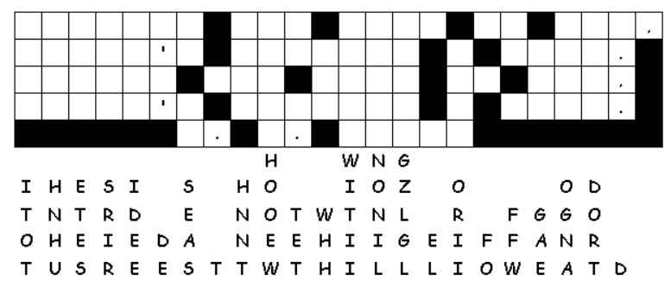
I’ve got a mess, but you’re lucky … the letters fell straight down. This is an important message. Look for single letter columns or rows where there are only two or three letter words. Shake off your fear. Figure out what letters in those columns make sensible words. Watch for squares with punctuation … no letters there. If you get stuck, go to https://tinyurl.com/y3chadje. There’s no mess there, just good Family Friendly Activities!

