1. Motivate

When have you seen hours of training and hard work pay off?
- practicing a musical instrument
- becoming a skilled wood carver
- a speaker who has become a very skilled communicator
- race car drivers
- a baseball pitcher
- a professional football quarterback
A video introduction is available for the lesson. View it at https://watch.liberty.edu/media/t/1_rcp1g2ad If you have no we-fi where you teach, best to download to your computer from https://tinyurl.com/3stwbam8
- people who make very artistic quilts
- a skilled cabinet maker

2. Transition

Consider the daily practice of intercessory prayer.
- We can demonstrate love our neighbors by taking their needs to God in prayer.

3. Bible Study

3.1 Pray for Your Neighbor

Listen for whom to pray.

1 Timothy 2:1-4 (NIV) I urge, then, first of all, that requests, prayers, intercession and thanksgiving be made for everyone-- 2 for kings and all those in authority, that we may live peaceful and quiet lives in all godliness and holiness. 3 This is good, and pleases God our Savior, 4 who wants all men to be saved and to come to a knowledge of the truth.

Why kind of praying did Paul urge Timothy to do? What are different synonyms for prayer used in various translations you have?
- requests, supplications, petitions
- intercession, intercede
- thanksgiving

For whom was he to pray?
- for everyone – those in our life circles and beyond
- kings (presidents, prime ministers, etc.)
- all those in authority (even if we don’t like them)

Consider your neighbors, how can you pray for them?
- their spiritual needs
- their kids, their grand kids
- God would meet their needs
- their jobs
- their physical struggles

What often gets in the way of regular prayer in our lives?
- busy lives
- lack of faith
- don’t make time
- other things are more important
- entertainment is more of a priority
- the chaotic pace of life
- worry about current events – personal, locally, regionally, nationally

What sort of prayers should we make on behalf of our leaders?
- godly wisdom
- for their spiritual needs
- for their protection, their health
- Claim Proverbs 21:1 (NIV) The king's heart is in the hand of the LORD; he directs it like a watercourse wherever he pleases.
- pray for those who advise them
- pray that they will govern well
- pray that they will maintain peace and an environment where the Gospel can be preached, people can worship God, the claims of Christ can be communicated freely

How would Timothy (and we) benefit from praying for those in authority?
- live peaceful and quiet lives
- live in godliness, live as holy people
- live in reverence to God
- live in honesty
- in dignity

Why do you think the greater majority of our public prayer requests have to do with physical needs … instead of spiritual needs?
- the older we get, the more our lives center on dealing with ailments
- usually there’s no shame in admitting a bad knee or a heart ailment or even cancer
- we are reluctant to share a personal battle with pornography or anger or fear or a substance abuse

- It’s not always best to divulge embarrassing personal struggles to a group.
- Seeking prayer support privately from an accountability partner is a much better practice
3.2 Pray for Spiritual Needs

Listen for another reason to pray.

1 Timothy 2:5-6 (NIV) For there is one God and one mediator between God and men, the man Christ Jesus, 6 who gave himself as a ransom for all men--the testimony given in its proper time.

Why should Timothy focus his attention on the Lord God?
- faith is as strong as the One in Whom we put our trust
- when we meditate on Who God really is and on His attributes, our faith increases
- God is the One in whom we are placing our trust … not the government, not the medical community, not ourselves
- God may use those elements of society, but it is He who is accomplishing what will be done

Not the use of the term mediator applied to Jesus. How do we use mediators in our society?
- one that reconciles differences between disputants
- third party, the mediator, assists the parties to negotiate their own settlement
- mediator may express a view on what might be a fair or reasonable settlement

Who are the disputants and how does Jesus facilitate the reconciliation?
- God and sinners who have rebelled against Him
- Jesus took the punishment, the judgment of death which sinful men deserve
- Jesus paid the price for the ransom of our souls
- God’s holiness is satisfied
- Jesus provides forgiveness for those who confess, repent, receive His salvation by faith

Based on this passage, what advice would you give to a Christian who insists he/she cannot pray for the salvation of a person who has hurt him/her?
- you are offended … so was God (by your sin as well as the other person’s)!
- He gave of Himself to accomplish the setting aside of the offense, the forgiveness
- God forgave you
- You can do no less than likewise forgive and pray for their salvation

Paul says here that God wants all men to be saved and come to know Truth. What are some reasons this has not happened?
- some people reject Truth
- Satan works against the understanding and the acceptance of the Gospel message
- in some places the Gospel is banned
- some people have yet to hear the message
- we have yet to take that message to them

Jesus gave the Great Commission … it is our responsibility to be praying, giving, challenging young people to go as He calls them
3.3 Pray with the Right Attitude

Listen for Paul’s primary purpose in life.

1 Timothy 2:7-8 (NIV) And for this purpose I was appointed a herald and an apostle--I am telling the truth, I am not lying--and a teacher of the true faith to the Gentiles. 8 I want men everywhere to lift up holy hands in prayer, without anger or disputing.

What three terms did Paul use to describe his functional role as a follower of Christ?
- a herald, a preacher
- an apostle
- a teacher

Why is prayer an important step in preaching and teaching the gospel?
- we support those who are teaching, preaching
- some plant the seed of the Gospel
- some cultivate
- some water … with our prayers
- some harvest

How can our group pray together for the salvation of others?
- focus our prayers not only on physical needs
- pray also for spiritual needs
- for our families
- for our neighbors
- for those who take the Gospel to places we cannot go
- pray for missionaries by name
- check out web sites of missions organizations for prayer requests

How can we pray for those who take the Gospel where we cannot go?
- their health and protection
- wisdom and skill in communication
- open doors
- for specific contacts they have made
- for new ways to attract people to the Good News
- for their finances
- for dealing with acquiring visas, permissions,
- praying against opposition
- pray that they be salt and light, living lives of integrity and purity

Use the last page as a handout so your learners can take home the application points of this week’s lesson.
Application
Write.
- Write down the four types of prayers Paul listed in verse 1—petitions, prayers, intercessions, and thanksgivings.
- Write at least one name beside each category.

Contact.
- Contact a person for whom you been praying and tell them you prayed for them.
- You can send a text, write a note, or just tell them in person.

Reconcile.
- If you are aware of an unresolved conflict with another believer, go to that person in humility and seek reconciliation.
- Read Matthew 5:21-24; 18:15-19 for Jesus’s specific instructions on how to resolve conflict.
Double Puzzle
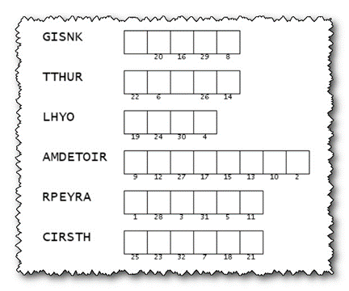
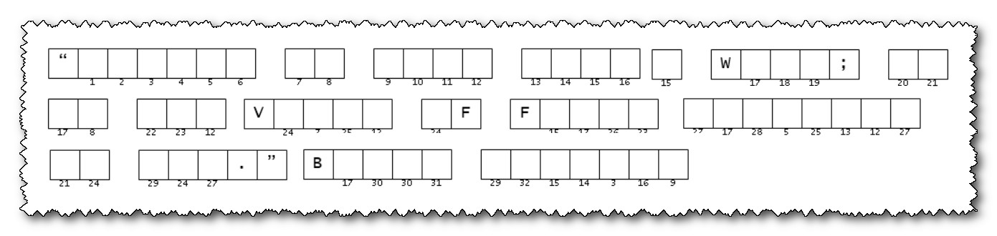
Spiros the Spy is busy with a Wordle message. He needs us to decrypt this two-part message. Our operatives in Masnam Mubev retrieved these in a hollow tree and under a park bench. They offer us a hint that the clue words are from your Bible Study passage this week. When you solve the message, pass it along to the chairman of your prayer committee. Technical assistance and more intriguing Family Activities are available at https://tinyurl.com/3dsbssa7

