1. Motivate

How do you tune out distractions when you really need to focus?
- listen to instrumental music (no lyrics being sung)
- go for a walk in the woods
- get alone somewhere in the house
- go in the study and close the doors
- turn off the phone and leave it in another room
- out in the boat by myself
A video introduction is available to view at https://watch.liberty.edu/media/1_gqpcwi2z If you have no Wi-Fi where you teach, best to download to your computer from https://tinyurl.com/y66wwbmn
- putter in the kitchen (in the garage)
- work in the garden
- mow the lawn, wear ear protection
- go for a drive alone in the country

2. Transition

In today’s world, we have many distractions.
- We need times when we focus on spiritual things.
- We can stay rightly focused on Christ by the practices of fasting and confession.

3. Bible Study

3.1 Focus on More than Physical Needs

Listen for how Daniel approaches God.

Daniel 9:1-4 (NIV) In the first year of Darius son of Xerxes (a Mede by descent), who was made ruler over the Babylonian kingdom-- 2 in the first year of his reign, I, Daniel, understood from the Scriptures, according to the word of the LORD given to Jeremiah the prophet, that the desolation of Jerusalem would last seventy years. 3 So I turned to the Lord God and pleaded with him in prayer and petition, in fasting, and in sackcloth and ashes. 4 I prayed to the LORD my God and confessed: "O Lord, the great and awesome God, who keeps his covenant of love with all who love him and obey his commands,

What events motivated this prayer of Daniel?
- Daniel had been studying scriptures
- He understood them to be the message from Jehovah God
- His study revealed that the exile from Jerusalem would soon be over
- God’s people would soon have the opportunity to return and re-establish the nation of Israel

How did he approach his time of communicating with God?
- turned to the Lord God
- pleaded with God
- prayer and petition
- fasting
- sackcloth and ashes

Identify the various words and phrases that speak of the character of God.
- great and awesome
- keeps his covenant of love
- desires, honors love and obedience to His commands

What do those words say about the attitude of a petitioner who comes before the Lord?
- you are in awe of God’s power, authority
- you believe He is loving
- you know he honors what He promises
- you admit you do not measure up to His standards
- you agree with God that you are sinful and undeserving

What is the significance of fasting, sackcloth, and ashes?
- humility
- unassuming
- realization, admission of sinfulness
- admitting one’s undeserving attention to God
- emphasizing one’s admission of sin

What are some reasons for fasting?
- you forgo normal activities in order to spend time with God
- you are so determined to be with God you are willing to give up regular activities
- you show you are hungrier for God than you are for food or normal pastimes

What are some other activities besides eating that we could set aside or fast from in order to spend time with God?
- watching TV
- being a “news junkie”
- Facebook, Twitter, social media in general
- hobbies, sports and exercise
- video games
- reading

In addition to prayer, what other spiritual disciplines can you engage in during a time set aside for a fast?
- Bible reading/study
- meditation on a verse or passage
- memorization
- journaling

What life events might cause us to seek the Lord through prayer and fasting?
- anticipating a major decision
- experiencing a new awareness of need for God in your life
- a periodic (monthly, yearly) time where you get alone with God for intense focus on knowing Him better
- confronted by a personal failure, you realize you need a time of spiritual renewal
3.2 Focus on God’s Forgiveness

Listen for the need of confession.

Daniel 9:5-7 (NIV) we have sinned and done wrong. We have been wicked and have rebelled; we have turned away from your commands and laws. 6 We have not listened to your servants the prophets, who spoke in your name to our kings, our princes and our fathers, and to all the people of the land. 7 "Lord, you are righteous, but this day we are covered with shame--the men of Judah and people of Jerusalem and all Israel, both near and far, in all the countries where you have scattered us because of our unfaithfulness to you.

What words did Daniel use to describe the state of the people before God?
- we have sinned
- we have done wrong
- we are wicked, rebellious
- we turned away from your commands and laws
- we didn’t listen to those who you sent to speak to us

How did Daniel contrast the Lord and the people?
- Lord, you are righteous – you do right
- You act justly
- we have acted shamefully
- we have been unfaithful

How does our sin become magnified in the presence of a righteous, holy (unique, distinctly different) God?
- we might think we’re “pretty good”
- in contrast to God’s holiness, we are pathetic
- when viewed in contrast to God’s characteristics and attributes, we are puny
- we are definitely NOT omnipotent, omniscient, omnipresent, righteous/just
- sometimes we like to think we approach some of those qualities, but we have to realize we don’t measure up even close

What can we learn about genuine confession from Daniel’s prayer?
- be honest with God
- agree with God concerning your failures
- tell God how you really feel – He knows, but you need to admit it
- if you are angry, worried, confused … admit it to God
- don’t try to bluff
- this is not time for “let’s make a deal”
- we don’t bargain with God

Why should confession be an important part of our spiritual lives?
- like taking a bath or shower often
- we need to be spiritually cleansed
- we need often to come to God and be entirely honest with Him
- only when we confess our sin can we come to a right relationship with God
- it is a declaration that you are depending totally on God’s forgiveness and not your own good efforts
3.3 Focus on the God Who Answers

Listen for Daniel’s appeal for God to hear his prayer.

Daniel 9:17-19 (NIV) "Now, our God, hear the prayers and petitions of your servant. For your sake, O Lord, look with favor on your desolate sanctuary. 18 Give ear, O God, and hear; open your eyes and see the desolation of the city that bears your Name. We do not make requests of you because we are righteous, but because of your great mercy. 19 O Lord, listen! O Lord, forgive! O Lord, hear and act! For your sake, O my God, do not delay, because your city and your people bear your Name."

As Daniel closed his prayer, what various appeals did he make to the Lord?
- hear our prayers and petitions
- look with favor on the need to rebuild the temple
- listen to us, look at us
- Jerusalem is Your city … it has Your name on it
- it is dishonoring to you
- forgive us, for your sake
- don’t delay

What is NOT seen in the reasons why God should hear Daniel’s prayer
- not because he or the people are righteous

What ARE the reasons why God should hear and answer Daniel’s prayer? For whose sake was he raising this prayer?
- because of God's mercy
- for God's sake, because your city, your people bear your Name
- please intervene for the honor of your Name
- when You make things right, everyone will know You did it
- nations will know that Jehovah God has acted in a powerful way
- people will be in awe of your power, your love, your authority

On what basis do we often make requests of the Lord?
- God, I don’t deserve this, I’ve been a good person, why is this happening
- You’ve got to do something, get us out of this mess
- It’s about time you took care of this, I’m sick and tired of it
- This pandemic is not our fault, why are you letting this happen to us

“Mercy” means that someone does not receive what they do deserve.
- it is God's mercy that we are not punished for our sins
- we deserve destruction for our sinfulness, but God withholds it

How does this definition of “mercy” help us pray for ourselves, our families, our nation?
- we know we deserve the opposite of what we are asking for
- yet the Bible tells us that God is merciful – full of mercy
- based on Jesus substitutionary death, we will not receive the punishment we deserve … Jesus took it upon Himself

⇒ Thus, we have every reason to believe that God wants to hear and answer our prayers.
Use the last page as a handout so your learners can take home the application points of this week’s lesson.
Application
Confess.
- Spend time confessing any sin you have not previously brought to God.
- Confession is “agreeing with God” that your actions were sinful.
- Don’t make excuses, confess—and thank Him for His forgiveness.

Fast from technology.
- Choose something that you do daily, such as watching television or connecting on social media.
- Commit to a fast from that activity for the next week.
- Use that time for uninterrupted prayer and focus on Christ.

Fast from food.
- If your health allows, spend next weekend in an extended fast.
- Join others who are doing this Bible study in praying for a spiritual awakening in our nation

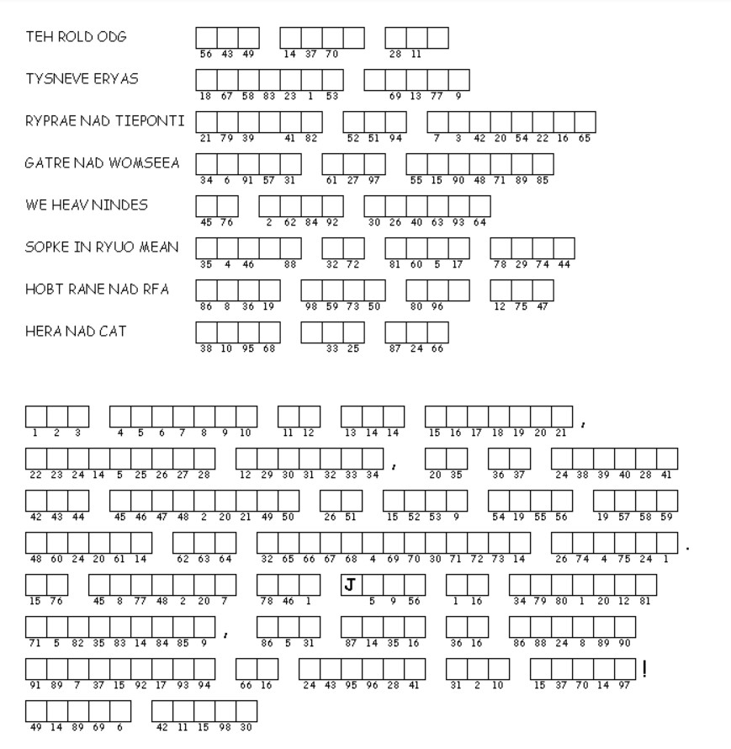Double Puzzle
This is an important message. Channel your Word Ninja skills to unscramble the key phrases from your Bible Study passage. Then, copy the letters in the numbered cells to other cells with the same number. Communicate the results to your Senior Adult Administrator as fast as possible so everyone will know. If you get stuck, help is available by using the QR code above. The camera on your phone will take you to the web site fast. Other Family Adventures are also available.

