1. Motivate

What would a personality test reveal about you?
- patient or impatient
- friendly or grumpy
- welcoming or put-off-ish
A video introduction is available. View it at
https://watch.liberty.edu/media/1_wv87cdwa . If you have no Wi-Fi where you teach, best to download to your computer from https://tinyurl.com/y9gj5wkv
- optimistic or pessimistic
- outgoing or more stay by yourself
- clever or awkward
- like to be busy or like to loaf
- easily scared or always courageous
- frugal or extravagant
- artistic or unimaginative
- musical or toneless

2. Transition

Each of us unique as created by God.
- God values that specific combination that He created.
- He has created each unique individual for a unique purpose.

3. Bible Study

3.1 God’s Purpose for Every Life

Listen for God’s message.

Jeremiah 1:4-5 (NIV) The word of the LORD came to me, saying, 5 "Before I formed you in the womb I knew you, before you were born I set you apart; I appointed you as a prophet to the nations."

What made this event in Jeremiah’s life one he felt compelled to give attention to?
- the “word of the Lord” came to him
- God communicated to him … somehow.
- could have been a dream or a vision
- maybe an angel
- maybe through a wise person

What four actions were attributed to God and what is the significance of each in giving value to a person?
God’s Action | Significance
- knew Jeremiah before birth  - set him apart  - appointed him as a prophet  - a prophet to the nations | - omniscience, foreknowledge of God  - sovereignty of God, God does as He pleases to do  - sovereignty, omnipotence, righteousness/justice  - omnipotence, righteousness/justice, love

What difference can it make to know that God knew us and set us apart even before our birth?
- God doesn’t just look in on things now and then to give us a shove in the right direction
- in awe over the degree of His attention to me as an individual
- shows He is someone who really loves me
- feel you have a purpose in life … not just rolling along with no goal or direction
- feel like you have a responsibility to respond in obedience
- figure that if God directs us to a task, He will give us the resources to accomplish it

God gave Jeremiah a specific task. When have you felt called or drawn to accomplishing a specific task?
- teach a class
- sing a part in the choir
- play an instrument in the church orchestra
- speak to a specific person to encourage or exhort
- guide my children in the right path
- pray for grandchildren who are struggling with life
- help keep the church clean
- help with keeping the church landscaping beautiful
- have a part in keeping a company running smoothly
- work together on a committee to accomplish a task
- donate finances so a specific ministry can go forward

We don’t know how God spoke to Jeremiah … maybe in a dream or vision, maybe from an angel messenger. How can God speak to us and give us specific directions today?
- through scripture we read or hear preached or taught – we come to know what actions or attitudes are right or wrong
- God may specifically challenge us in a preaching service or a Bible study to a task or ministry He has for us
- sometimes a verse or passage seems to jump out at us more specifically for a situation we are in
- God opens and closes doors of opportunity
- as we involve ourselves in a specific ministry, God will bless and multiply that effort … showing His direction in that activity
- other times the activity sort of dead ends and shows us that’s not God’s purpose for now
- even today, God can speak to us in a dream or some sort of “vision”
- other times, God’s Holy Spirit puts specific thoughts and ideas into our minds giving direction

3.2 God’s Enabling for God’s Purpose

Listen for Jeremiah’s initial response.

Jeremiah 1:6-8 (NIV) 6 "Ah, Sovereign LORD," I said, "I do not know how to speak; I am only a child." 7 But the LORD said to me, "Do not say, 'I am only a child.' You must go to everyone I send you to and say whatever I command you. 8 Do not be afraid of them, for I am with you and will rescue you," declares the LORD.

What were Jeremiah’s excuses, God’s responses and promises?
Jeremiah’s Excuses | God’s Responses and Commands
- I don’t know how to speak  - I’m only a child (too young) | - Don’t say you are only a child  - I put my words in your mouth  - don’t be afraid  - I am with you and will rescue you  - go to everyone I send you to  - say whatever I command you  - appoint you over nations and kingdoms

What are some excuses we use for not doing what God commands us to do? What reservations do you have about your ability to serve God according to His call?
- I’m not a good speaker (just like Jeremiah)
- I’m too busy
- no one will listen to me
- I would be embarrassed
- I can’t go to a primitive mission field, I’m afraid of snakes and bugs
- I’m too old/young
- I’d never be able to learn a foreign language
- I don’t know the Bible that well
- I’m scared
- there’s got to be someone around more qualified than me to do that

How do God’s reassurances to Jeremiah (and to us) help and encourage?
- we are not alone in doing the task
- God promises to give the skill we feel like we lack
- if we mess up, God will rescue us … maybe even use the mistake to touch someone’s life in a special way

How do excuses rob us of the blessings that result from faithful service?
- serving the Lord is one of the purposes for which God saved us
- what a privilege to be a “tool” for God, to be his partner in ministering to people’s lives
- if I use excuses and not respond to a task or ministry, then I don’t get to experience God’s power at work through me in that way
- you don’t get to see the Fruit of the Spirit growing, being displayed
- you miss out on seeing the joy of those to whom you would minister

3.3 God’s Equipping for God’s Purpose

Listen for how God equips Jeremiah.

Jeremiah 1:9-10 (NIV) Then the LORD reached out his hand and touched my mouth and said to me, "Now, I have put my words in your mouth. 10 See, today I appoint you over nations and kingdoms to uproot and tear down, to destroy and overthrow, to build and to plant."

What did God do to address Jeremiah’s concern about being able to declare God’s message?
- reached out his hand
- touched Jeremiah’s mouth
- told him “I have put words in your mouth”

What else indicates God’s message has global implications?
- I appoint you over nations and kingdoms
- you will uproot, tear down, destroy, overthrow
- you will build and plant

Note the two contrasting categories. What are negative elements in our culture to work against?
- abortion
- human trafficking
- the attacks on religious liberty
- substance abuse
- hate, divisiveness
- attitude of materialism

On the other side, what are some things that need to be built and planted?
- the Gospel, the good news of salvation – spread locally and worldwide
- 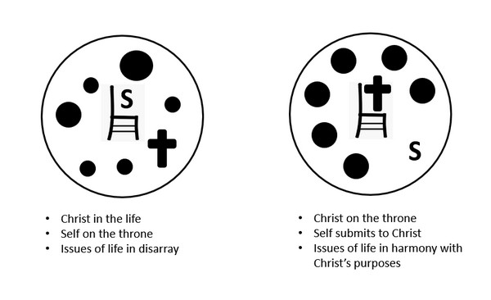kindness
- love
- peace
- justice, righteousness

In what ways does God equip us to do His work?
- give us words to speak
- equip us with skills, Spiritual Gifts
- His Spiritual Armor and Weapons – helmet of salvation, breastplate of righteousness, sword of the Spirit (Word of God), belt of Truth, shoes of the Gospel, shield of Faith
- availability of training for specific skills – sharing our faith, teaching a class, etc.

How do we make ourselves available for God to use us?
- daily reading and meditating on what God says in His Word
- remaining sensitive to God’s Holy Spirit – as He speaks through His Word
- determine to keep Jesus as Lord of your life, keep Him on the throne of your life
Use the last page as a handout so your learners can take home the application points of this week’s lesson.
Application
Seek.
- Pray and seek God’s face.
- Ask Him to show you the ways He can use you for His kingdom.

Surrender.
- Put your “yes” on the table and trust God to empower us for His service.
- Step out in obedience, trusting the power of the Holy Spirit, and carry out God’s calling on your life.

Support.
- Support and encourage people who are forgotten or overlooked by others.
- Find practical ways to help those whom the culture deems helpless because God values them and has a purpose for them.

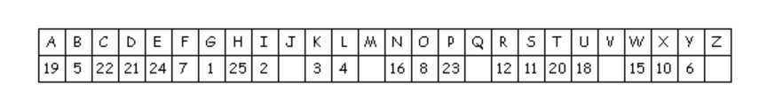Cryptogram Puzzle
Janea Cafolk, our Created Purposes Attaché at the Lypa Guarus Embassy received this message from one of her informants. It was involved in a serious electrical malfunction. Our partial key for that country’s code is shown above. Route it to the HSA through your church’s penultimate deacon. It’s important to determine this information. If you need assistance go to https://tinyurl.com/y9gj5wkv . Other enlightening pursuits can be found there as well.

