1. Motivate

What is something you often find yourself telling others about?
- our team won/lost
A video introduction to the lesson is available. View at https://watch.liberty.edu/media/t/1_qpdpxtxy If you have no wi-fi where you teach, best to download from https://tinyurl.com/yc7647cx
- got a new car
- new grandchild
- the grandchild’s team won
- how about them Cowboys/Buccaneers/Falcons/ …
- can’t believe this weather … hot/cold/wet/dry
- your goofy/fine/ornery neighbor
- new cars for this year
- your great/nasty/stupid/clever boss
- your vacation … plans/where you went/what you did

2. Transition

We are quick to talk about a great variety of subjects.
- How God is at work in our life should be no different.
- Knowledge of God’s Word should not be kept to yourself; pass it on.

3. Bible Study

3.1 Benefits of Obedience

Listen for why to obey God’s Word.

Deuteronomy 6:1-3 (NIV) These are the commands, decrees and laws the LORD your God directed me to teach you to observe in the land that you are crossing the Jordan to possess, 2 so that you, your children and their children after them may fear the LORD your God as long as you live by keeping all his decrees and commands that I give you, and so that you may enjoy long life. 3 Hear, O Israel, and be careful to obey so that it may go well with you and that you may increase greatly in a land flowing with milk and honey, just as the LORD, the God of your fathers, promised you.

What were the attitudes the Children of Israel were to have towards God?
- you and your family and future family will learn to fear (be in awe of) Jehovah God
- that this awe may be an ongoing attitude towards God … as long as you live

How would they benefit from being obedient, keeping His laws, decrees, and demands?
- it will result in a long life
- it will go well with you
- you may increase greatly in this new land
- you will experience the fulfillment of God’s promises

What are the significances of the two commands in verse 3, to “hear” and “obey”?
- more than just know or memorize
- more than letting the words in one ear and out the other
- includes hearing, listening, paying attention with understanding
- heed and apply
- teaching that changes one’s life
- teaching that has an observable effect
- “the learner will … “ example of behavioral objectives in education

What do you think it means to “fear” God? What are some synonyms?
- to be in awe of Him
- not so much to be scared like in a scary movie or a scary nightmare
- reverence, respect, admiration, worship, veneration, astonishment, amazement, devotion

Moses said the promised land was “flowing with milk and honey”. What do you think that means?
- seems like a poetic phrase, some sort of figure of speech
- implies a contrast to a desert or wilderness in which they had been living and trekking
- speaks of a land rich in natural resources
- a land in which livestock and nature provide abundantly

How have you benefited from someone who shared God’s Word with you?
- learned the Good News, the Gospel – found new life in Christ
- Jesus died so I could be set free from the penalty of sin
- Jesus wants to be Lord of my life
- as you follow God’s direction in your life, He guides you in good paths, blesses, provides, protects
- God will open and close doors of opportunity to help guide you in relationships, in vocation,
- understand, experience, put to use spiritual gifts

3.2 Love for God

What is the purpose of the foundation of a building?
- carry the weight of the walls
- keep the building from sinking
- keep the walls straight, the floor level
- keeps cracks from forming in the walls

Why would we need a spiritual foundation?
- something solid to base our lives on
- keep us from being shaken, from sinking
- keeps us straight
- we don’t crack up!
Listen for an important spiritual foundation.

Deuteronomy 6:4-5 (NIV) Hear, O Israel: The LORD our God, the LORD is one. 5 Love the LORD your God with all your heart and with all your soul and with all your strength.

These two verses are what Jews refer to as the Shema, the foundation of their spiritual life

It is called the Shema <=> “Hear” “Pay attention” to this truth, it is the foundation for all we believe and Who we worship.

Consider the pivotal truth of this declaration of faith.
- when you see LORD in caps, it is the word used for the Name of God
- We would think of it as “Jehovah” or “Yahweh”
- it communicates that this is The God Who IS
- in contrast to the many deities who are just the product of man’s imagination
- also in contrast to the evil satanic or demon spirits

What is to be our attitude towards The God Who IS? How are God’s people to respond to Him? To what degree?
- love Him
- submit to Him
- be in awe of Him
- with all your being … heart, soul, strength

When is it challenging to put loving God above all else? What can be idols (replacements for Jehovah God) in our western culture?
- tempted by the materialism of our culture
- things we would like to do come into conflict with weekly (or more often) corporate worship
- busy daily schedules come into conflict with daily communication with God
- tempted by entertainment options so available
- romantic relationships can compete with our ongoing relationship with God
- the anti-Christian opposition of our culture (actually, nothing new) seems to be increasing
- world events cause fear, anxiety

What are some ways we can demonstrate our love for God?
- worship – declare His worth – “worth-ship”
- we praise and worship God for Who He is
- we thank Him for what He has done
- obedience to His commands
- we have the entire Bible to hear/read His words, His message to us
- we read and carefully think about what He is saying

3.3 Compelled to Share God’s Word

Listen for to whom we are to communicate.

Deuteronomy 6:6-9 (NIV) These commandments that I give you today are to be upon your hearts. 7 Impress them on your children. Talk about them when you sit at home and when you walk along the road, when you lie down and when you get up. 8 Tie them as symbols on your hands and bind them on your foreheads. 9 Write them on the doorframes of your houses and on your gates.

What specific opportunities does God suggest people use to talk about God’s truth with their children (and grandchildren)?
- when you sit at home
- when you walk along the road
- when you lie down
- when you get up

What are some other situations that we might include in our modern culture?
- riding down the road in the car
- reading books at bedtime
- commenting on the beauty of creation seen on a vacation trip, or even just in your own yard
- noting a beautiful sunrise or sunset
- choosing nature shows on TV, rather than violence or foolishness
- pointing out how our Biblical worldview differs from that of secular opinions in some of these nature presentations
- memorizing scripture together

Note also three different ways of communication mentioned …
- writing
- talking
- tie them, bind them to wrists or forehead (still seen practiced by Orthodox Jews)

How would written scripture verses or spiritual admonitions posted on the wall in our homes affect us as a family?
- they are repeatedly reminded of a particular Biblical Truth
- while it can become familiar, it is still part of their environment and sticks in their mind (in our minds)
- in some cases these might be something made in VBS or Sunday School or at church camp – it is a child’s own handiwork
- by displaying it, you affirm their work as well as God’s Truth
Use the last page as a handout so your learners can take home the application points of this week’s lesson.
Application
Inward communication.
- Are you anxious in a particular area? Struggling with a specific sin?
- Or do you perhaps need to remember one of God’s promises?
- Identify a relevant Scripture verse, write it down, and take it with you wherever you go this week.

Upward communication.
- As you read the Bible regularly, combine your Scripture intake with prayer.
- Incorporate the words of Scripture into your prayers.
- As you do this, you will learn how to communicate God’s Word back to Him as worship.

Outward communication.
- Ask some friends to read the Bible with you or join you for Bible study.

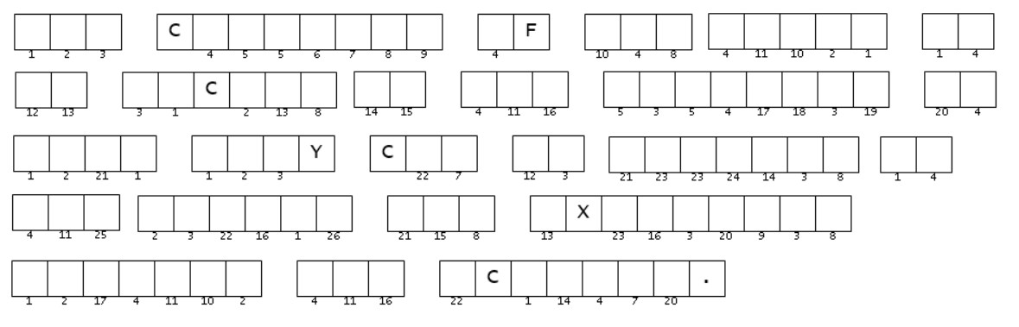
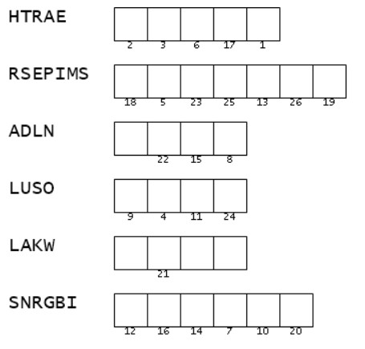
These clues are scrambled. If you can sort them out, you can use the numbers to figure out the important message about communicating God’s Word. The clue words are found in your Bible Study passage. That should help. You might also check out https://tinyurl.com/yc7647cx for technical help and further fun Family Activities

