1. Motivate

When has someone helped you avoid a potential pitfall?
- remind me I was driving too fast
- point out my license sticker was about to go out of date
- stopped me when I was about to step off the curb without looking
- notice I had not signed a check written to pay a bill
- in school, remind you there was a test tomorrow
- let you know of a new IRS rule that changed how you file
- found food in your pantry that was years out of date
- called and said there was a big traffic tie up on the route to work
- someone on our bus route texted our family that the school bus was running early today, better be ready
- spouse found a bill in the stack of mail that was due today

2. Transition

Some of these situations may have only caused an inconvenience.
- In other situations a wrong step may be physically or spiritually dangerous.
- Today we study someone who stepped in to keep a bad situation from getting worse.

3. Bible Study
A video introduction to the lesson is available. View it at https://watch.liberty.edu/media/t/1_axcb9pgs . If you have no wi-fi in the room where you teach, best to download the video from https://tinyurl.com/5377w2wx

3.1 Do What Is Right

Listen for a warning given.

1 Samuel 25:14-17 (NIV) One of the servants told Nabal's wife Abigail: "David sent messengers from the desert to give our master his greetings, but he hurled insults at them. 15 Yet these men were very good to us. They did not mistreat us, and the whole time we were out in the fields near them nothing was missing. 16 Night and day they were a wall around us all the time we were herding our sheep near them. 17 Now think it over and see what you can do, because disaster is hanging over our master and his whole household. He is such a wicked man that no one can talk to him."

Why do you think the servant sought out Abigail instead of confronting Nabal?
- she was approachable
- he was described as wicked, no one could talk to him
- the servant was afraid David’s men would retaliate
- Nabal was the one who told David’s men to get lost
- he had hurled insults at them

How did the servant assess the relationship he and others had with David and his men? What did he urge Abigail to do?
- these men were very good to us, did not mistreat us
- never stole anything from us
- protected us, a “wall around us”
- you should think this over, disaster is hanging over all of us
- see what you can do

How would you feel if you were asked to quickly fix a mess created by someone else? What thought would go through your head?
- what were they thinking
- I don’t have time for this
- I don’t need this aggravation
- I should let this person get him/her-self out of this on their own
- What am I going to do? How can I fix this?

Someone might accuse the servant of “tattling.” What’s the difference between tattling and giving someone information to keep a bad situation from becoming worse?
Tattling | Avoiding a Bad Situation
- just to get the other person in trouble  - try to make yourself look good  - be the “teacher’s pet”  - makes the teacher (authority) not see what you might have done | - if ignored, someone could get hurt  - better if someone knows lest bad things happen  - could save a life, even if accused of being a “fink”

So, what kinds of things prevent us from acting to avoid the bad situation in a person’s life?
- We are too busy.
- We don’t want to get involved.
- We are afraid we might get our feelings hurt
- so called “whistle blowers” can get in trouble in a variety of ways
- We are afraid to hurt someone else’s feelings
- In some cases it requires “immediate action” like Abigail took and we don’t want to act that quickly

What might be some examples of bad situations people face that may require someone to step in to prevent the situation from getting worse?
- someone who is ignoring a health issue
- an elderly person who is being taken advantage of financially (even by relatives)
- when your kids tell you of what is going on with another family’s kids
- someone who is spreading untrue rumors about another person in the church
- you find out a person in leadership (church, school, at work, etc.) is doing something illegal or immoral
3.2 Act Wisely

Listen for an apology.

1 Samuel 25:23-28 (NIV) When Abigail saw David, she quickly got off her donkey and bowed down before David with her face to the ground. 24 She fell at his feet and said: "My lord, let the blame be on me alone. Please let your servant speak to you; hear what your servant has to say. 25 May my lord pay no attention to that wicked man Nabal. He is just like his name--his name is Fool, and folly goes with him. But as for me, your servant, I did not see the men my master sent. 26 "Now since the LORD has kept you, my master, from bloodshed and from avenging yourself with your own hands, as surely as the LORD lives and as you live, may your enemies and all who intend to harm my master be like Nabal. 27 And let this gift, which your servant has brought to my master, be given to the men who follow you. 28 Please forgive your servant's offense, for the LORD will certainly make a lasting dynasty for my master, because he fights the LORD's battles. Let no wrongdoing be found in you as long as you live.

In what ways did Abigail show her respect for David?
- subservient, submissive, deferential
- willing to do what her husband was not
- apologetic for her husband’s boorish behavior
- wanted to make things right to rescue her family

Why did Abigail take responsibility for the insult to David?
- basically apologetic for her family’s (her husband’s) behavior
- the offense was done by someone of her family,
- she accepted the responsibility as part of the head of the family

How can we know whether it is best to intervene in a conflict or to stay out?
- if you are directly involved
- if you or people you know are in danger of harm
- ask for God’s guidance, pray as you go

Some might think Abigail was unsubmissive and rebellious when she did what Nabal refused to do. What was her reason for her actions?
- she saw the reality of the situation
- she acted smart
- if she didn’t her family, her compound could have been attacked, even wiped out

What principles can we learn from Abigail’s approach to the problem?
- you might have to humble yourself and ask forgiveness
- you might have to clear up a mess that someone else made
- say or do something nice to counter the ill will created by another person
- show honor and respect where it is deserved
- Godly wisdom is essential to increase the probability of you being heard and of your suggestions being accepted.
- God does not guarantee a positive outcome when we step in, but in Abigail’s bad situation, her actions paid off in a big way.
3.3 Thank the Lord for Wise Counsel

Listen for a “thank you.”

1 Samuel 25:32-35 (NIV) David said to Abigail, "Praise be to the LORD, the God of Israel, who has sent you today to meet me. 33 May you be blessed for your good judgment and for keeping me from bloodshed this day and from avenging myself with my own hands. 34 Otherwise, as surely as the LORD, the God of Israel, lives, who has kept me from harming you, if you had not come quickly to meet me, not one male belonging to Nabal would have been left alive by daybreak." 35 Then David accepted from her hand what she had brought him and said, "Go home in peace. I have heard your words and granted your request."

For what did David praise the Lord?
- for sending Abigail to intervene
- for her good judgment
- for keeping him from killing and avenging

So how did David view the fact that Abigail came out to meet him?
- this was God’s doing
- it was a good thing she came as she did
- she deserved God’s blessing
- her actions and attitude kept David and his men from attacking Nabal’s farm

Suppose you are in a situation more like David’s. Someone comes to you and asks you to change your actions. Why could that be a hard thing to do?
- “they done me wrong”
- no one knows how much I hurt for what was said/done
It takes courage, wisdom, prayer, God’s guidance, humility to get involved
- if I let it go, I’m going to lose a lot of face
- they don’t deserve to be forgiven
- no one’s going to tell me what to do
- it’s none of their business

What lessons can we learn from Abigail as we seek to make peace today?
- be willing to assume responsibility
- realize that when someone is deeply offended or done wrong, they deserve an apology
- be willing to ask and give forgiveness
- tangible remuneration or making things right is a good idea
- the cost of making things right can be worth it to avoid retaliation

How does resolving conflict honor Christ?
- our sins are an offense against God
- God has taken the punishment we deserved (death)
- He offers forgiveness that is undeserved
- we must also have that same attitude of forgiving, even when it is undeserved
Use the last page as a handout so your learners can take home the application points of this week’s lesson.
Application
Pray.
- If you know others who, like David, are headed down a road that is not good, pray.
- Intercede for the person.

Praise.
- Start a list of ways you can pray for others.
- At the end of each week, look back over the list.
- Follow-up with those you have been praying for to see how God has answered these prayers.
- Praise God for His faithfulness in the lives of His people.

Step in.
- As God gives you the opportunity, step into the lives of others who need “a course correction.”
- Ensure that any words you offer are grounded in God’s Word and are spoken with love and grace.
Crossword Puzzle
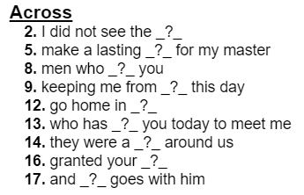
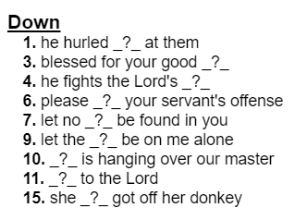
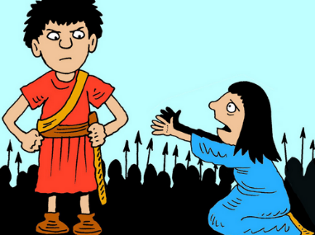
Help and more at https://tinyurl.com/5377w2wx and https://tinyurl.com/23h9nnsk

